JEPA-LLM TUNING FRAMEWORK FOR COMBATING GST AND SALES TAX INPUT TAX CREDIT FRAUD PATTERN DETECTION
(TaxSentinel)
A project report submitted in partial fulfilment of the requirements for the award of the degree of
BACHELOR OF TECHNOLOGY
in
COMPUTER SCIENCE AND ENGINEERING (DATA SCIENCE)
Submitted by
S.No. | Name of the student | Hall ticket no.
1 | B.ASHRITHA | 23K91A6732
2 | B.DIVYA | 23K91A6739
3 | A.KISHORE | 23K91A6716
4 | A.YAGNESH | 23K91A6711
Batch A5 (CSE-DS, Section A)
Under the esteemed guidance of
Dr. N. Ch. Ravi
Professor in CSE (Data Science)
[COLLEGE LOGO]
DEPARTMENT OF COMPUTER SCIENCE AND ENGINEERING (DATA SCIENCE)
TKR College of Engineering and Technology (Autonomous)
[COLLEGE ADDRESS / AFFILIATING UNIVERSITY]
Academic year 2026-2027

[COLLEGE LOGO]
TKR College of Engineering and Technology (Autonomous)
DEPARTMENT OF COMPUTER SCIENCE AND ENGINEERING (DATA SCIENCE)
CERTIFICATE
This is to certify that the project report entitled "JEPA-LLM Tuning Framework for Combating GST and Sales Tax Input Tax Credit Fraud Pattern Detection" is a bonafide record of the work carried out by B.ASHRITHA (23K91A6732), B.DIVYA (23K91A6739), A.KISHORE (23K91A6716), A.YAGNESH (23K91A6711), in partial fulfilment of the requirements for the award of the degree of Bachelor of Technology in Computer Science and Engineering (Data Science), during the academic year 2026-2027, under my supervision.

Project Guide | Head of the Department | External Examiner
Dr. N. Ch. Ravi  Professor in CSE (Data Science) | [HOD NAME]  Department of Computer Science and Engineering (Data Science) | [NAME AND SIGNATURE]

Principal: [PRINCIPAL NAME]

DECLARATION
We hereby declare that the project report entitled "JEPA-LLM Tuning Framework for Combating GST and Sales Tax Input Tax Credit Fraud Pattern Detection", submitted to the Department of Computer Science and Engineering (Data Science), TKR College of Engineering and Technology (Autonomous), in partial fulfilment of the requirements for the award of the degree of Bachelor of Technology in Computer Science and Engineering (Data Science), is a record of original work carried out by us under the guidance of Dr. N. Ch. Ravi, Professor in CSE (Data Science). The results embodied in this report have not been submitted to any other university or institution for the award of any degree or diploma.

B.ASHRITHA 23K91A6732
B.DIVYA 23K91A6739
A.KISHORE 23K91A6716
A.YAGNESH 23K91A6711

Place: [PLACE]
Date: [DATE]

ACKNOWLEDGEMENT
We express our sincere gratitude to our project guide, Dr. N. Ch. Ravi, Professor in CSE (Data Science), for valuable guidance, encouragement and constructive suggestions throughout this project.
We thank [HOD NAME], Head of the Department of Computer Science and Engineering (Data Science), for providing the facilities and support needed to complete this work, and [PRINCIPAL NAME], Principal, for the encouragement given to us.
We thank the project coordinators and all faculty and staff members of the department for their help, and our families and friends for their constant support.
We also acknowledge the authors of the base paper and of the related work cited in this report, the creators of the PaySim dataset and of the open-source software that the project is built on (PyTorch, NetworkX, FastAPI, SQLAlchemy, React and Vite), and the Gemini API used for the written explanations.

B.ASHRITHA
B.DIVYA
A.KISHORE
A.YAGNESH

ABSTRACT
Input Tax Credit (ITC) fraud under the Goods and Services Tax, carried out through fake invoices, circular trading and shell companies, causes large revenue losses. Manual audits and fixed rules are slow and easy to evade, confirmed fraud labels are scarce, and existing systems rarely explain why a claim is flagged. The base paper by Datta, Thakkar and Dabhade (2026) describes these frauds and calls for analytics and network analysis, but proposes no model. This project builds one.
TaxSentinel learns normal GST behaviour without labels using a Joint Embedding Predictive Architecture (JEPA): a 53,420-value model, trained in 11.7 s on a CPU, that predicts the embedding of a taxpayer-month from its history and from the month with one feature layer hidden. Its prediction error is combined, through a noisy-OR, with circular-trading and shared-identity cluster detection and with an eight-signal invoice anomaly score. Taxpayers and invoice chains are ranked, each flag carries a numbered evidence list, and Gemini writes a case note in which every claim cites that evidence; notes are checked automatically for invalid citations and ungrounded numbers. The system is a secured FastAPI and React application.
On a seeded synthetic ecosystem of 600 taxpayers and 64,474 invoices with 79 injected fraud taxpayers, TaxSentinel reaches precision@79 of 0.949, F1 0.955 and ROC-AUC 0.997, against 0.620, 0.432 and 0.876 for a rule baseline, recovers all 5 injected rings and scores invoices with F1 0.924. Ablations show that the JEPA alone is the weakest layer (F1 0.327) and the layers are complementary. On five other generated ecosystems the F1 at the fixed threshold is lower and varies more, so the headline figures are a best case. Six evaluated case notes had no invalid citations. The data is synthetic, the language model is prompted and not fine-tuned, and the output is a risk indication for review, not a finding of fraud.
Keywords: GST, input tax credit fraud, JEPA, self-supervised learning, circular trading, shell entities, network analysis, explainable AI, large language model, FastAPI.

TABLE OF CONTENTS
CHAPTER 1: INTRODUCTION 1
1.1 Domain Overview 1
1.2 Background and Motivation 2
1.3 Problem Statement 2
1.4 Need for the Work 3
1.5 Objectives 3
1.6 Scope 4
1.7 Contributions 4
1.8 Limitations and Assumptions 5
1.9 Organisation of the Report 5
CHAPTER 2: LITERATURE SURVEY 7
2.1 Overview 7
2.2 Base Paper Analysis 7
2.3 Related Work 8
2.4 Datasets and Algorithms Used in the Literature 10
2.5 Strengths and Limitations of the Existing Work 10
2.6 Research Gap 10
CHAPTER 3: FEASIBILITY STUDY 12
3.1 Technical Feasibility 12
3.2 Economic Feasibility 12
3.3 Operational Feasibility 12
3.4 Schedule Feasibility 13
3.5 Advantages and Constraints 13
CHAPTER 4: SYSTEM REQUIREMENTS AND ANALYSIS 14
4.1 Existing System and Its Limitations 14
4.2 Proposed System and Its Advantages 14
4.3 Functional Requirements 15
4.4 Non-Functional Requirements 15
4.5 Hardware and Software Requirements 16
4.6 User Roles and Constraints 16
CHAPTER 5: SYSTEM DESIGN 17
5.1 System Architecture 17
5.2 High-Level Workflow 18
5.3 Data Flow Diagrams 18
5.4 UML Diagrams 21
5.5 Database Design 24
5.6 Module Design 25
5.7 User Interface Design 25
CHAPTER 6: METHODOLOGY AND SOFTWARE IMPLEMENTATION 27
6.1 Overall Methodology 27
6.2 Dataset 28
6.3 Preprocessing and Feature Layers 29
6.4 Algorithm Choice and Justification 30
6.5 Mathematical Formulation 31
6.6 Model Architecture and Training 33
6.7 Network, Invoice and Risk Pipeline 34
6.8 Evidence and Written Explanation 35
6.9 Application Architecture 35
6.10 API Design 36
6.11 Security and Error Handling 36
6.12 Installation and Execution 37
CHAPTER 7: SYSTEM TESTING 38
7.1 Testing Strategy 38
7.2 Unit and Component Testing 38
7.3 Integration Testing 38
7.4 Functional Testing 39
7.5 Security Testing 39
7.6 Validation and Edge Cases 40
7.7 Performance Testing 41
7.8 User Acceptance 42
7.9 Limits of the Testing Done 42
CHAPTER 8: RESULTS AND OUTPUT SCREENS 43
8.1 Output Screens 43
8.2 Model Performance 49
8.3 Explanation Quality 57
8.4 Sample Inputs and Outputs 58
8.5 Success and Failure Analysis 59
8.6 Comparison with the Base Paper 61
8.7 Limitations of the Results 62
8.8 Objectives versus Outcomes 62
CHAPTER 9: CONCLUSION 64
9.1 Summary 64
9.2 Objectives Achieved 64
9.3 Key Findings 64
9.4 Practical Applications 65
9.5 Known Limitations 65
CHAPTER 10: FUTURE SCOPE 66
10.1 Improvements to the Method 66
10.2 Additional Features 66
10.3 Scalability and Deployment 67
10.4 Further Research 67
REFERENCES 68
APPENDIX A: IMPORTANT CODE 70
APPENDIX B: INSTALLATION AND USER GUIDE 76
B.1 Requirements 76
B.2 Set up (once) 76
B.3 Start 76
B.4 Demonstration walkthrough 76
B.5 Command line (optional) 77
B.6 Troubleshooting 77
APPENDIX C: ADDITIONAL SCREENS 78

LIST OF FIGURES
Fig. 5.1: System architecture of TaxSentinel 17
Fig. 5.2: High-level workflow from GST data to a cited case note 18
Fig. 5.3: Data flow diagram, level 0 (context diagram) 19
Fig. 5.4: Data flow diagram, level 1 20
Fig. 5.5: Data flow diagram, level 2: Generate and analyse 21
Fig. 5.6: UML class diagram 22
Fig. 5.7: Sequence diagram of the main flow 23
Fig. 5.8: Use-case diagram 23
Fig. 5.9: Entity-relationship diagram 24
Fig. 6.1: Flowchart of the core algorithm (risk scoring) 28
Fig. 6.2: JEPA training loss over 100 epochs (final 0.1115) 34
Fig. 7.1: API response time per endpoint (median bars, maximum markers) 41
Fig. 8.1: Overview while a run is in progress: the stage stepper shows JEPA training at epoch 10 of 100 (25 %) and the activity log streams the pipeline messages. 43
Fig. 8.2: Overview after the run completes (seed 42, 600 taxpayers): 64,474 invoices, 78 flagged taxpayers, ITC at risk of Rs 25.62 Cr of Rs 187.59 Cr claimed, and precision@79 of 95 % against 62 % for the rule baseline. 44
Fig. 8.3: Taxpayer risk ranking with search, pattern, sector and flag filters and sort order; the top rows are circular-trading and shell-entity taxpayers. 44
Fig. 8.4: Taxpayer profile, Signals tab (Lotus Manufacturing Pvt Ltd, rank 1, risk 0.97): the four risk layers, the rules triggered and monthly ITC available (GSTR-2B) against ITC claimed (GSTR-3B) with the JEPA deviation line. 45
Fig. 8.5: Taxpayer profile, Evidence tab: the numbered evidence list (E1 to E5) with layer, severity and concrete figures. 45
Fig. 8.6: Taxpayer profile, Network tab: the local trading network with the circular-trading loop in red and the main trading partners. 46
Fig. 8.7: Profile of an ITC-spike and shell-entity taxpayer (Ganga Wholesale): the monthly chart shows the claim far above the credit available in GSTR-2B. 46
Fig. 8.8: Fraud rings: the whole buyer-seller network with loop edges in red and shared-identity members ringed. 47
Fig. 8.9: Invoice chain CH-R01: a five-party circular-trading loop of 98 invoices worth Rs 44.65 Cr passing Rs 9.78 Cr of ITC. 47
Fig. 8.10: Invoice chain CH-S37: a shell-supply chain of three linked registrations billing three buyers. 48
Fig. 8.11: Case page with the Gemini case note: every claim ends in an [E#] citation chip that links to its evidence item. 48
Fig. 8.12: Model performance: precision@k, recall@k, F1, ROC-AUC and the JEPA training loss for the current ecosystem. 49
Fig. 8.13: Run history: the last ten generations with status, seed, taxpayers, flagged count and duration, and the ecosystem currently loaded. 49
Fig. 8.14: Precision@k for the full model, the ablations and the rule baseline (seed 42) 50
Fig. 8.15: F1, ROC-AUC and average precision by method (seed 42) 51
Fig. 8.16: Taxpayer-level confusion matrices at the flag threshold (seed 42) 52
Fig. 8.17: Recall by injected fraud pattern, model against rule baseline (seed 42) 53
Fig. 8.18: Invoice-level precision, recall and F1: invoice score against the GSTR-1 mismatch check (seed 42) 53
Fig. 8.19: Precision, recall and F1 against the risk threshold (seed 42) 54
Fig. 8.20: Distribution of the combined risk score for legitimate and injected-fraud taxpayers (log scale) 55
Fig. 8.21: Mean layer scores of injected-fraud and legitimate taxpayers (seed 42) 55
Fig. 8.22: F1 at the flag threshold on five other generated ecosystems, model against rule baseline 56
Fig. 8.23: PaySim transfer check: unlabelled JEPA against ranking by amount 57
Fig. C.1: Landing page: product summary, live health card (API, pipeline and Gemini status) and the call to action. 78
Fig. C.2: Sign-in screen with the API, pipeline and Gemini status panel. 78
Fig. C.3: Sign-in with the demo account filled in by the one-click helper. 79
Fig. C.4: Overview (control room) before a new generation: generate controls, activity log, headline counts and the monthly ITC pulse. 79
Fig. C.5: Full-page overview: detection against the rule baseline, risk histogram, pattern counts, top-ranked taxpayers and top invoice chains. 80
Fig. C.6: Taxpayer profile, Invoices tab: anomalous invoices with value, tax, e-way bill, GSTR-1 reporting status and the signals that fired. 81
Fig. C.7: Profile of a shell-cluster taxpayer (Pioneer Services): the shared-identity cluster S-card and the partners it trades with. 81
Fig. C.8: Fraud rings, full page: the nine trade loops and twelve identity clusters with their scores, and the ranked invoice chains. 82
Fig. C.9: Case page before a note is written: the evidence list is ready and the note is requested on demand. 82
Fig. C.10: Full case page: the three-section note (Summary, Why it was flagged, Suggested next steps) beside the evidence list. 83
Fig. C.11: Full model-performance page: taxpayer-level table with ablations, per-pattern recall, invoice-level and ring results. 84
Fig. C.12: Overview in dark mode (the theme follows the operating-system setting and can be toggled). 85
Fig. C.13: Command palette (key /): search taxpayers or jump to a screen from the keyboard. 85

LIST OF TABLES
Table 2.1: Summary of the surveyed works 10
Table 3.1: Project schedule as recorded in the repository and batch documents 13
Table 4.1: Existing approaches and their limitations 14
Table 4.2: Functional requirements and where each is realised 15
Table 4.3: Non-functional requirements and measured status 15
Table 4.4: Hardware used for development and measurement 16
Table 4.5: Software stack 16
Table 5.1: SQL tables 24
Table 5.2: Modules and responsibilities 25
Table 5.3: Screens and their purpose 25
Table 6.1: Injected fraud in the bundled ecosystem 29
Table 6.2: The 19 features in three layers 30
Table 6.3: JEPA training configuration (experiments/metrics.json) 33
Table 6.4: REST endpoints (all except register, login and health require a bearer token) 36
Table 7.1: Smoke-test checks (all 20 passed) 38
Table 7.2: Authentication, authorisation and security checks 39
Table 7.3: Validation, edge-case and concurrency checks 40
Table 7.4: Read-endpoint latency, 20 sequential calls each (ms) 41
Table 8.1: Taxpayer-level results (seed 42) 50
Table 8.2: Recall by injected pattern at the flag threshold (seed 42) 52
Table 8.3: Invoice-level, ring and chain results (seed 42) 53
Table 8.4: Flag threshold sweep on the seed-42 scores 54
Table 8.5: Cross-seed study (600 taxpayers each; same weights and threshold) 56
Table 8.6: Automatic quality checks over six Gemini case notes 57
Table 8.7: Evidence list for Lotus Manufacturing Pvt Ltd 58
Table 8.8: Legitimate taxpayers flagged at the 0.5 threshold 59
Table 8.9: Injected-fraud taxpayers missed at the 0.5 threshold 60
Table 8.10: Base paper recommendations and this project 61
Table 8.11: Objectives and measured outcomes 62
Table B.1: Common problems 77

LIST OF ABBREVIATIONS
Abbreviation | Meaning
API | Application Programming Interface
AP | Average Precision
AUC | Area Under the Curve
CBIC | Central Board of Indirect Taxes and Customs
CORS | Cross-Origin Resource Sharing
CSV | Comma-Separated Values
DFD | Data Flow Diagram
DGGI | Directorate General of GST Intelligence
EMA | Exponential Moving Average
ER | Entity-Relationship
GELU | Gaussian Error Linear Unit
GST | Goods and Services Tax
GSTIN | GST Identification Number
GSTR | GST Return (GSTR-1 outward supplies, GSTR-2B auto-drafted ITC statement, GSTR-3B summary return)
HS256 | HMAC using SHA-256
ITC | Input Tax Credit
JEPA | Joint Embedding Predictive Architecture
JSON | JavaScript Object Notation
JWT | JSON Web Token
LLM | Large Language Model
MSE | Mean Squared Error
ORM | Object-Relational Mapping
P@k | Precision at k
R@k | Recall at k
REST | Representational State Transfer
ROC | Receiver Operating Characteristic
SPA | Single-Page Application
SQL | Structured Query Language
UML | Unified Modeling Language
UI | User Interface
UX | User Experience

CHAPTER 1: INTRODUCTION

1.1 Domain Overview
The Goods and Services Tax (GST), introduced in India on 1 July 2017, replaced a patchwork of central and state indirect taxes with a single destination-based consumption tax. Its central mechanism is the Input Tax Credit (ITC): a business that pays GST on its purchases may set that tax against the GST it collects on its sales, so that tax is finally levied only on the value added at each stage [1]. The mechanism removes the cascading "tax on tax" effect of the earlier regime, but it also turns the tax invoice into something that carries money. An invoice that never corresponded to a real supply can still hand a buyer a credit that reduces the tax it pays in cash.
GST is self-assessed. Each taxpayer files outward supplies in GSTR-1, receives an auto-drafted statement of the credit available from its suppliers' filings in GSTR-2B, and claims credit and pays tax through the summary return GSTR-3B. The tax administration therefore works with three views of the same trade (what the seller declared, what the buyer may claim and what the buyer actually claimed) and with a very large population of taxpayers whose filings it can compare but rarely verify physically. The base paper of this project describes how this design, together with asymmetric information between taxpayer and administration, makes the system an attractive target for organised fraud [1].
Three patterns dominate the fraud described in the base paper and in the wider literature. In fake invoicing, a network of paper firms issues invoices without any movement of goods, and genuine businesses claim ITC on them. In circular trading, a small group of firms passes the same value around a loop (A to B to C and back to A) to inflate turnover and generate credit without value being added [6]. Shell entities are young registrations, often sharing an address or contact number, that trade mostly with each other, pay almost no tax in cash and stop filing once credit has been passed on. The Directorate General of GST Intelligence reported detected evasion rising from Rs 1.01 lakh crore in FY 2022-23 to Rs 2.01 lakh crore in FY 2023-24, with cases booked rising from 4,872 to 6,084 [1].
This project, TaxSentinel, is a data-science system for this domain. It learns what normal GST behaviour looks like from unlabelled filings with a Joint Embedding Predictive Architecture (JEPA), combines that signal with buyer-seller network analysis and invoice-level checks, ranks taxpayers and invoice chains by risk, and uses a large language model (Gemini) to write an investigator-style note in which every statement cites the evidence behind it.

1.2 Background and Motivation
Tax authorities currently rely on a mixture of return scrutiny, rule-based mismatch reports (for example, credit claimed in GSTR-3B above credit available in GSTR-2B), field audits and investigations launched once a suspicious case surfaces. These tools are necessary, but each has a known weakness. Audits are slow and detect fraud after the revenue has been lost. Fixed rules are transparent and therefore easy to evade: a fraudster who knows that a 20 % mismatch triggers a notice can stay below it. Checks applied to one taxpayer or one invoice at a time cannot see a loop of five firms that each look ordinary in isolation.
Supervised machine learning is the obvious answer, and several recent studies apply it to income-tax and related fraud [2]-[5]. Its difficulty here is the labels. Confirmed ITC-fraud cases are scarce, they are decided years after the filings concerned, and they reflect the cases investigators happened to pursue rather than the fraud that exists. A classifier trained on them learns the past enforcement pattern. Self-supervised learning offers a different starting point: learn the structure of ordinary behaviour from the abundant unlabelled returns and invoices, and treat sustained departures from it as signals to review. JEPA [8], [9] is attractive for this purpose because it predicts the representation of the missing part of an input instead of reconstructing raw values. Raw GST features such as invoice values and turnover are heavy-tailed and noisy, and a model that must reproduce them spends its capacity on noise.
The last motivation is trust. A risk score without a reason is difficult for an officer to act on, and a score that cannot be defended cannot support a notice. The project therefore treats explanation as part of the detection pipeline: every flag is backed by a numbered evidence list computed from the data, and the language model is allowed to say only what that list supports.

1.3 Problem Statement
Input Tax Credit fraud through fake invoices, circular trading and shell companies causes large revenue losses. Manual audits and rule-based checks are slow and reactive, confirmed fraud labels are scarce, which limits supervised learning, and existing systems rarely explain why a claim is flagged. The problem addressed by this project is therefore to design and build a self-supervised, explainable framework that learns normal GST behaviour from largely unlabelled data, ranks taxpayers and invoice chains by their deviation from it, and explains each flagged claim in natural language that an investigator can verify.

1.4 Need for the Work
- Scale. A tax administration cannot audit every taxpayer. A ranking that puts real fraud in the first few dozen cases changes where limited audit effort goes. On the project's evaluation ecosystem the top 50 taxpayers contain no false alarms (Table 8.1).
- Network visibility. Circular trading and shell clusters are properties of groups of taxpayers. They are invisible to checks that look at one return at a time, and need graph analysis over the buyer-seller network.
- Label scarcity. A method that learns from unlabelled behaviour does not depend on a sample of past fraud cases and does not inherit their bias.
- Accountability. Flags that cite their evidence can be challenged, corrected and used as the starting point of an audit file; opaque scores cannot.
- Low cost. The whole system trains in seconds on a CPU and runs on commodity hardware, which matters for adoption by state units without specialised infrastructure.

1.5 Objectives
The six objectives approved for the project, and the section of this report that measures each one, are listed below.
- Build a multi-layer GST dataset covering invoices, taxpayer behaviour and transaction networks (Section 6.2).
- Learn normal GST behaviour with a self-supervised JEPA encoder (Sections 6.5 and 6.6).
- Detect fraud patterns such as fake invoices, circular trading and shell-entity activity (Sections 6.7, 8.2 and 8.5).
- Score and rank suspicious taxpayers and invoice chains by deviation from learned behaviour (Sections 6.7 and 8.2).
- Generate natural-language explanations for flagged claims using an LLM (Sections 6.8 and 8.3).
- Evaluate detection accuracy and explanation quality (Sections 8.2, 8.3 and 8.6).
One clarification applies to objective 5. The approved title speaks of a tuned LLM. The implemented system does not fine-tune any model's weights. It tunes the prompt: a fixed system prompt, a fixed three-section output format, a restriction to facts in the supplied evidence list and a mandatory citation per claim, followed by an automatic grounding check. This choice is explained in Section 6.8 and listed as a limitation in Section 1.8.

1.6 Scope
In scope. A reproducible generator of GST ecosystems with injected, labelled fraud; three feature layers per taxpayer-month; a JEPA behaviour encoder; circular-trading and shared-identity detection; invoice-level anomaly scoring; a combined risk score; ranked taxpayers and invoice chains; evidence lists; Gemini-written case notes with automatic grounding checks; evaluation against a rule baseline with ablations; and a secure multi-user web application (FastAPI and React) that presents all of this.
Out of scope. Connection to the live GST Network or any real taxpayer data; legal determination of fraud (the output is a risk indication for review); e-way-bill and e-invoice (IRN) integration beyond the flag already present in the data; real-time streaming; fine-tuning of language models; mobile applications; and multi-tenant administration. The companion scope-and-limitations document and Chapter 9 of this report list these exclusions in more detail.

1.7 Contributions
- A three-layer, self-supervised behaviour model for GST. A small JEPA (53,420 parameters) over 19 invoice, behaviour and network features per taxpayer-month, trained without labels in about 12 s on a CPU. It uses four mask variants: whole-month prediction from history, and prediction of each feature layer from the other layers, so that a deviation can be attributed to a layer.
- A multi-signal risk model that does not rely on JEPA alone. An explicit noisy-OR combination of JEPA deviation, return-behaviour deviation, network evidence (loops, shell clusters, exposure) and invoice anomalies. Ablations show why: JEPA plus behaviour alone reaches F1 0.327, graph plus invoice reaches 0.887 and all layers reach 0.955.
- Network detectors tailored to ITC fraud. A scored circular-trading detector (balance, recurrence, concentration) that recovered all 5 injected rings, and a shared-identity shell-cluster detector scored from deviation, youth, intra-cluster trade and stopped filing.
- Cited, checkable explanations. Case notes in which every claim cites an evidence ID and which are checked automatically for invalid citations, evidence coverage, high-severity coverage and numeric grounding (0 invalid citations over the 6 notes evaluated).
- An evaluation harness with an honest baseline. Precision@k, recall@k, F1, ROC-AUC, per-pattern recall, invoice-level metrics, ring recovery, a transfer check on PaySim and a rule baseline built from standard scrutiny rules R1-R5.
- A working product. A secured web application with ranking, taxpayer profiles, an interactive fraud graph, invoice-chain drill-down, on-demand case notes, a performance page and run history, tested end to end.

1.8 Limitations and Assumptions
- The data is synthetic. Real GST returns were not available. The generator injects fraud with known labels and also injects legitimate hard negatives (festival seasonality, one-off capital purchases, new registrations, group companies sharing an address, late filers). All accuracy figures are measured against these injected labels and describe the method on this generator; they are not an estimate of performance on real filings.
- Weights and thresholds were set on this generator. The risk weights (0.75, 0.6, 0.7, 0.6) and thresholds (0.5) were chosen on the seed-42 ecosystem. A five-seed study (Section 8.2) shows how stable they are across other generated ecosystems; a real deployment would need recalibration on real returns.
- The LLM is prompted, not fine-tuned. Explanation quality was evaluated on 6 of the 10 planned cases because the free Gemini quota was exhausted for the other four.
- No unit-test suite. Testing consists of a 20-check end-to-end smoke test, 41 black-box edge and security checks and the evaluation harness (Chapter 7). There is no coverage figure and no user-acceptance study.
- Shell entities look normal to JEPA. Twenty-seven similar firms form their own "normal"; JEPA-only recall of shell entities is low and the network layer is what finds them.
- Assumption. The six feature layers described in Chapter 6 are assumed to be derivable from a state's GSTR-1, GSTR-2B and GSTR-3B data and taxpayer registration data; this is plausible but was not verified against real data schemas.

1.9 Organisation of the Report
Chapter 2 reviews the base paper and related work. Chapter 3 assesses feasibility. Chapter 4 sets out the existing and proposed systems and the requirements. Chapter 5 presents the design: architecture, workflow, data-flow diagrams, UML diagrams, database and user interface. Chapter 6 describes the methodology and its implementation, including the mathematical formulation. Chapter 7 reports testing. Chapter 8 presents results and output screens. Chapter 9 concludes and Chapter 10 outlines future scope. The references follow, and three appendices give important code, the installation and user guide, and additional screens.

CHAPTER 2: LITERATURE SURVEY

2.1 Overview
The literature relevant to this project falls into five groups: (i) descriptive and policy studies of GST ITC fraud, including the base paper; (ii) machine-learning studies of tax fraud; (iii) graph methods for circular trading and tax evasion; (iv) self-supervised predictive architectures; and (v) methods for explaining model outputs in natural language with controlled hallucination. The batch's literature survey lists five tax-fraud papers (the base paper and four others). The full texts of the four others were not part of the batch's archived documents and could not be retrieved, so they are discussed only at the level that their titles and venues support, and no results are quoted from them. The base paper [1] and the two graph papers [6], [7] were read in full.

2.2 Base Paper Analysis
The base paper is S. Datta, H. Thakkar and S. Dabhade, "Combating GST Input Tax Credit Fraud in India: Forensic Accounting, Data Analytics, and Legal Enforcement Strategies," International Journal of Management, Public Policy and Research, vol. 5, issue 1, January-March 2026 [1].
What it does. It is a qualitative, evidence-synthesis paper. It explains why the self-assessed ITC design creates room for fraud, using asymmetric information, moral hazard and the Fraud Triangle of pressure, opportunity and rationalisation [29]. It describes how fraud is executed through fake invoices, circular trading and networks of shell companies, and it quantifies the problem using published government figures. Using data attributed to the Directorate General of GST Intelligence (DGGI) and the Central Board of Indirect Taxes and Customs (CBIC), it reports that detected evasion rose from Rs 1.01 lakh crore in FY 2022-23 to Rs 2.01 lakh crore in FY 2023-24, that cases booked rose from 4,872 to 6,084, that arrests rose from 97 to 140 and that voluntary payments rose from Rs 20,713 crore to Rs 26,605 crore. It also reports the special drives against fake registrations (21,791 fake GSTINs and Rs 24,010 crore of evasion detected in May-July 2023, and about 10,700 fake GSTINs and Rs 10,179 crore in August-October 2024, partial data).
What it recommends. It concludes that compliance-focused responses must give way to forensic, technology-enabled ones, and recommends a unified economic intelligence grid shared between agencies, dynamic AI-based risk modelling at GST registration, continuous capacity building of officers in forensic accounting and data analysis, faster prosecution and recovery, and forensic due diligence by businesses in vendor selection.
What it does not do. By its own account the study relies on public government and media sources, is qualitative, contains no primary empirical data and does not implement or evaluate any detection model. It lists quantitative, AI-supported fraud detection as future work.
What this project adopts. The three fraud patterns, the central role of fake registrations and invoicing, the call for data analytics and network analysis, and the recommendation of AI-based risk modelling are taken from the base paper and become this project's detection targets. What the paper leaves open (a concrete, evaluable model; learning from unlabelled data; machine-readable evidence; explanation) is what the project builds. Because the base paper reports no model metrics, a like-for-like numerical comparison with it is not possible; Section 8.6 compares the system with the paper's recommendations and with a rule-based baseline instead.

2.3 Related Work

A. Machine learning for tax-fraud detection
Four further papers in the batch survey apply AI and machine learning to tax compliance and fraud detection in India: an overview of the role of AI and ML in tax compliance and fraud detection [2], two conference papers on income-tax fraud detection using machine learning and AI [3], [4], and a study of boosting-based learning for income-tax fraud [5]. Judging by their titles and venues, they use supervised classifiers on labelled taxpayer records (the boosting paper explicitly so). They share the strength of showing that tabular taxpayer data carries a learnable fraud signal. They also share the limitation that motivates this project: they need labelled fraud, they score taxpayers or returns individually and they offer no account of how taxpayers are connected. Neither GST invoice networks nor explanation is addressed in their titles.

B. Graph methods for circular trading and tax evasion
Mehta et al. [6] study circular trading in GST on real data from the Department of Commercial Taxes, Government of Telangana: 77,837,538 invoices among 388,448 taxpayers. They build a sales-flow graph, learn node embeddings with node2vec [18] and cluster them with DBSCAN to find communities of circular traders, then isolate illegitimate transactions within them. The work shows that graph representation learning scales to a state's data. It reports communities found rather than accuracy against labels, targets one pattern, and produces no explanation. Xu et al. [7] model the tax scenario as a heterogeneous graph with more than ten node and relation types and propose TED, a graph neural network that uses related-party transaction groups and hierarchical attention. On two real tax datasets it reports F1 scores between 76.35 % and 94.96 % depending on the dataset and the share of positive samples in the training set, and F1 up to 8.50 % higher than the best earlier method. TED is supervised and needs labels for training; it is a classifier, not an explainer. Graph convolutional networks [19] underlie much of this line of work.

C. Self-supervised predictive architectures
LeCun's proposal for joint-embedding predictive architectures [9] argues that prediction should be made in a learned representation space so that unpredictable detail can be ignored. I-JEPA [8] realised this for images by predicting the embeddings of masked blocks from a visible context block, with a target encoder updated as an exponential moving average, an idea inherited from BYOL [11]. V-JEPA [10] extended it to video. A variance term, as in VICReg [12], keeps representations from collapsing. These works are on images and video; this project transfers the same recipe to the very different setting of monthly tax behaviour vectors, where masking a whole month tests predictability from history and masking a feature layer tests consistency across layers.

D. Anomaly detection and network structure
Chandola et al. [13] survey anomaly detection; isolation forests [14] are the usual tabular baseline. Such methods score each record independently of its network. For graph structure, short directed cycles can be enumerated with Johnson-style algorithms [17] (the implementation in NetworkX [16] supports a length bound), and Louvain modularity optimisation [15] finds trade communities. The project uses these building blocks and adds fraud-specific scoring of loops (balance, recurrence and concentration).

E. Grounded explanation with large language models
Large language models write fluent text but can state unsupported facts [24]. Retrieval-augmented generation [23] reduces this by supplying source passages. TaxSentinel follows the same principle in a stricter form: the model receives only a numbered list of computed evidence items, must cite one per claim, and the output is checked automatically for invalid citations and for numbers absent from the evidence. The model used is Gemini [25].

2.4 Datasets and Algorithms Used in the Literature
Table 2.1: Summary of the surveyed works
Work | Approach | Data | Reported result | Limitation for this problem
Datta et al. [1] (base paper) | Forensic accounting, data analytics and legal strategy review | DGGI and CBIC statistics, case studies | Detected evasion Rs 1.01 lakh crore (FY23) to Rs 2.01 lakh crore (FY24) | Qualitative; no model or metrics
[2] | AI/ML in tax compliance (overview, per title) | Not available to the team | Not quoted | Full text unavailable; no GST network or explanation in title
[3], [4] | ML / AI for income-tax fraud (per title) | Not available to the team | Not quoted | Supervised on labelled records (per title); no network; income tax, not GST ITC
[5] | Boosting-based learning for income-tax fraud (per title) | Not available to the team | Not quoted | Supervised; per-taxpayer scoring
Mehta et al. [6] | node2vec + DBSCAN communities of circular traders | Telangana GST: 77.8 M invoices, 388 k taxpayers | Communities of circular traders identified; no accuracy metric | Circular trading only; no labels, no explanation
Xu et al. [7] (TED) | Heterogeneous graph neural network with related-party groups | Two real tax datasets (T20H, T15S) | F1 76.35-94.96 %; up to +8.50 % F1 over best baseline | Supervised; needs labels; no explanation
Assran et al. [8] | I-JEPA: predict masked-block embeddings | Images (ImageNet) | Strong linear-probe transfer | Not applied to tax or tabular behaviour

2.5 Strengths and Limitations of the Existing Work
Strengths. The base paper gives an authoritative, numerate picture of the problem and a convincing argument for technology-enabled forensics. The machine-learning studies show that fraud is learnable from taxpayer data. Mehta et al. show that graph methods work at state scale on real GST data and TED shows that heterogeneous graphs improve supervised detection. The JEPA line of work gives a mature recipe for learning without labels.
Limitations. The policy paper offers no model. The supervised studies need labelled fraud, which is scarce, and score entities in isolation. The graph studies look at one pattern or need labels, and none of the surveyed GST work explains its output in language an officer can check.

2.6 Research Gap
Existing GST fraud work is largely descriptive or rule-based. Few systems (i) learn behavioural patterns from unlabelled tax data, (ii) combine invoice, return-behaviour and network evidence in one score, (iii) recover circular trading and shell networks without labels and (iv) explain every flag with cited evidence. This project addresses that combination. Its claims are limited by the data it was evaluated on (Section 1.8), and it does not claim to outperform supervised graph methods such as TED on real data, which it was not compared against.

CHAPTER 3: FEASIBILITY STUDY

3.1 Technical Feasibility
Every component of the system is available as mature open-source software: PyTorch [20] for the JEPA, NumPy for the features, NetworkX [16] for graph analysis, FastAPI and SQLAlchemy with SQLite for the service, React and Vite for the interface and the Gemini API [25] for explanations. Feasibility was demonstrated rather than assumed: the complete system was built and run. On a mid-range desktop without a GPU (an Intel Core i5-12500 with 15.7 GB of RAM), generating an ecosystem of 600 taxpayers and 64,474 invoices, training the JEPA and running the full analysis takes about 19 to 29 s end to end in the application's run history, with the JEPA training alone taking 11.7 s. The risks that were real were the scarcity of real data (met by a synthetic generator with hard negatives, Chapter 6) and the availability of the LLM service (met by model fallbacks, retries and on-demand generation of notes).

3.2 Economic Feasibility
All software is free and open source and the project needed no licence purchases. The only external service is Gemini; the free tier was sufficient to develop the system and to generate and check notes, but it ran out of quota for 4 of the 10 planned notes during evaluation, so a deployment that produces notes at volume would need a paid tier or a locally hosted model. Compute needs are minimal: training and scoring run on a CPU in seconds, so no GPU server is required. The expected benefit is the reallocation of scarce audit effort towards the cases most likely to be real fraud; the system's value in rupees was not measured and no saving is claimed. On the synthetic ecosystem, the Rs 25.62 Cr of ITC attached to flagged taxpayers is a measure of what the ranking puts in front of an investigator, not of recovery.

3.3 Operational Feasibility
The intended users are analysts and investigators in a tax-administration analytics unit, forensic accountants and compliance teams. The interface follows the workflow they already have (rank, open a case, read the evidence, decide), uses plain language, offers keyboard shortcuts and a command palette, and keeps every number traceable to evidence. Set-up on Windows needs two double-clicks (setup.bat and run.bat) and ports 8105 and 5105. Operation depends on the quality of the input returns; the system gives a prioritisation, not a decision, and the notes say so.

3.4 Schedule Feasibility
The work followed a short, staged schedule recorded in the project's version-control history and batch documents (Table 3.1). The schedule was feasible because the model is small and the stack is familiar; the main schedule risk was the evaluation of explanations, which depended on external quota.
Table 3.1: Project schedule as recorded in the repository and batch documents
Date | Milestone
06 Jul 2026 | Phase-I project abstract submitted (Major Project Phase-I, A.Y. 2026-27)
19 Sep 2026 | Batch details, abstract, base paper, introduction, literature survey, objectives and problem statement finalised
21 Sep 2026 | Project folder initialised; master prompts prepared
28 Sep 2026 | Backend pipeline and API; evaluation, documentation and README; frontend screens and run script; Gemini models and explanation evaluation
14 Oct 2026 | Frontend redesigned (control-room interface with dark mode, activity log, command palette)
15 Oct 2026 | Screenshots, diagrams, edge and security tests, cross-seed study and this documentation set produced

3.5 Advantages and Constraints
Advantages. The method needs no labelled fraud; it uses three kinds of evidence and so is robust to a fraudster changing one behaviour; it recovers rings and clusters, not just single entities; it is explainable; it is small, fast and cheap; and the whole pipeline is reproducible from a seed. Constraints. The data is synthetic, thresholds need recalibration on real returns, notes depend on an external service, and the system supports prioritisation, not legal findings.

CHAPTER 4: SYSTEM REQUIREMENTS AND ANALYSIS

4.1 Existing System and Its Limitations
In the current practice described in the base paper and the batch's literature survey, tax authorities rely on manual audits and investigations after fraud is suspected, on rule-based checks that flag mismatches between returns and invoice data, on supervised models that classify fraud from labelled historical cases, and on forensic and network analysis applied case by case by investigators [1]-[5].
Table 4.1: Existing approaches and their limitations
Existing approach | How it works | Limitation
Manual audit and investigation | Officers examine a taxpayer after suspicion arises | Slow; detects fraud after revenue is lost; effort goes where suspicion already exists
Rule-based mismatch checks | Fixed thresholds on returns, e.g. ITC claimed above ITC available | Easily evaded by staying under thresholds; 236 flags with 168 false alarms in this project's baseline test
Supervised ML on labelled cases | Classifier trained on past confirmed fraud | Labels are scarce, late and biased by past enforcement
Per-entity or per-invoice checks | Each return or invoice scored on its own | Cannot see loops and shell networks, which exist only across taxpayers
Score-only systems | Return a number or a flag | No explanation an officer can verify or defend

4.2 Proposed System and Its Advantages
TaxSentinel replaces the single-view, label-dependent, unexplained approach with a pipeline of four cooperating parts: a JEPA behaviour encoder trained without labels, network analysis that finds circular-trading loops and shared-identity clusters, an invoice-level anomaly score, and a noisy-OR risk model that combines them. Flagged taxpayers receive an evidence list and, on request, a case note written by an LLM from that list alone.
- No labels needed to learn normal behaviour. The encoder is trained on all 6,977 taxpayer-months without labels; labels are used only to evaluate.
- Several kinds of evidence. A fraudster who hides one behaviour is still exposed by another layer; ablations show that the layers are complementary (Chapter 8).
- Group-level detection. Rings and clusters are scored and shown as an interactive graph, and become ranked invoice chains.
- Explainable. Every flag has a numbered evidence list; every claim in a note cites an item; notes are checked for invalid citations and ungrounded numbers.
- Light and fast. A 53,420-parameter model trains in about 12 s on a CPU.
- Operationally complete. Accounts, history, a performance page and an activity log make it usable and auditable.

4.3 Functional Requirements
Table 4.2: Functional requirements and where each is realised
ID | Requirement | Realised by
FR1 | A user can register, sign in and sign out; sessions expire | routes/auth.py, JWT (720 min), Login page
FR2 | Generate a seeded GST ecosystem (150-1500 taxpayers) with injected fraud and labels | scripts/generate_gst_data.py, POST /api/pipeline/run
FR3 | Build invoice, behaviour and network features per taxpayer-month | ml/features.py
FR4 | Train and apply a self-supervised JEPA behaviour encoder | ml/jepa.py, ml/train.py
FR5 | Detect circular-trading loops and shared-identity clusters | ml/graph.py
FR6 | Score each invoice and each taxpayer; flag at risk >= 0.5 | ml/pipeline.py
FR7 | Rank taxpayers and invoice chains; filter and search | routes/investigate.py, Taxpayers and Overview pages
FR8 | Show a taxpayer profile with layer scores, monthly chart, evidence, partners and invoices | TaxpayerProfile page
FR9 | Draw the buyer-seller graph with loops and clusters; drill into a chain | FraudGraph and ChainDetail pages
FR10 | Write a cited case note on demand and check its grounding | routes/explanations.py, services/explainer.py, CaseDetail page
FR11 | Report precision@k, recall@k, F1, ROC-AUC, ablations and per-pattern recall against a rule baseline | ml/eval.py, Performance page
FR12 | Keep a history of generation runs and show the loaded ecosystem | Runs page, pipeline_runs table

4.4 Non-Functional Requirements
Table 4.3: Non-functional requirements and measured status
Quality | Requirement | Status
Performance | Interactive responses; full analysis in under a minute | API median 1.7-12.1 ms per read endpoint; full run 18.6-29.0 s typical (Chapter 7)
Security | Passwords hashed; protected API; tamper-proof sessions | bcrypt, HS256 JWT, 401 on missing, garbage or altered token (tested)
Reliability | One generation at a time; graceful failure of external service | 409 on concurrent run; 502 with a clear message if Gemini fails; fallback models
Usability | Keyboard access, readable in light and dark, reduced motion respected | Command palette, shortcuts, theme toggle, reduce-motion fallback
Portability | Runs on a standard Windows PC without GPU | Tested on Windows 11, CPU only
Maintainability | Separated layers; configuration in .env | ml/, backend/, frontend/ split; settings in backend/app/config.py
Reproducibility | Same seed gives same data and same results | Seeded generator, torch and numpy seeds; seed 42 reproduces the reported figures
Explainability | Every flag backed by evidence | Evidence lists E1..En; cited notes; grounding checks

4.5 Hardware and Software Requirements
Table 4.4: Hardware used for development and measurement
Item | Specification
Processor | Intel Core i5-12500 (6 cores, 12 threads)
Memory | 15.7 GB RAM
Graphics | Intel UHD Graphics 770 (integrated); no GPU used
Operating system | Windows 11 Pro
Note | Smaller machines were not tested. Training takes 11.7 s on this machine, so a GPU is not needed; the API process held about 0.5 GB (503 MB working set measured) while serving the ecosystem.

Table 4.5: Software stack
Layer | Software (as installed in the project)
Language and runtime | Python 3.11.9; Node.js v24.19.0
Machine learning | PyTorch 2.14.0 (CPU build); NumPy 2.4.6; NetworkX 3.4.2
Backend | FastAPI 0.115.6; SQLAlchemy 2.0.36 with SQLite; PyJWT and bcrypt; python-dotenv; google-genai
Frontend | React 18.3, Vite 6, Tailwind CSS 4, react-router 6, axios, recharts 3, react-force-graph-2d, framer-motion, three
Data tools | kagglehub (PaySim download); matplotlib, python-docx, python-pptx (documentation only)
External service | Google Gemini API through the google-genai client (key in .env)
Ports | API 8105, web 5105

4.6 User Roles and Constraints
There is a single role in the implemented system, the analyst: any registered user who can sign in, generate ecosystems, browse and investigate and request notes. A seeded demo account (demo@taxsentinel.app) is provided for demonstrations. Role separation (for example, a read-only reviewer or an administrator who manages users and thresholds) is not implemented and is listed under future scope. The constraints on the solution are: synthetic data only; a Windows-oriented set-up; reliance on the Gemini free tier for notes; one generation at a time; and the interpretation of every output as a risk indication, not a legal finding.

CHAPTER 5: SYSTEM DESIGN

5.1 System Architecture
TaxSentinel is a four-tier system (Fig. 5.1). A React single-page application presents the screens. A FastAPI service exposes a JSON API behind a JWT bearer guard. An analytics layer in the ml/ package turns a dataset into scores, rings, chains and evidence. Persistent state is kept in SQLite (users, runs, notes), in the pickled pipeline state, in the CSV ecosystem and in the saved model weights. Gemini is the only external service.
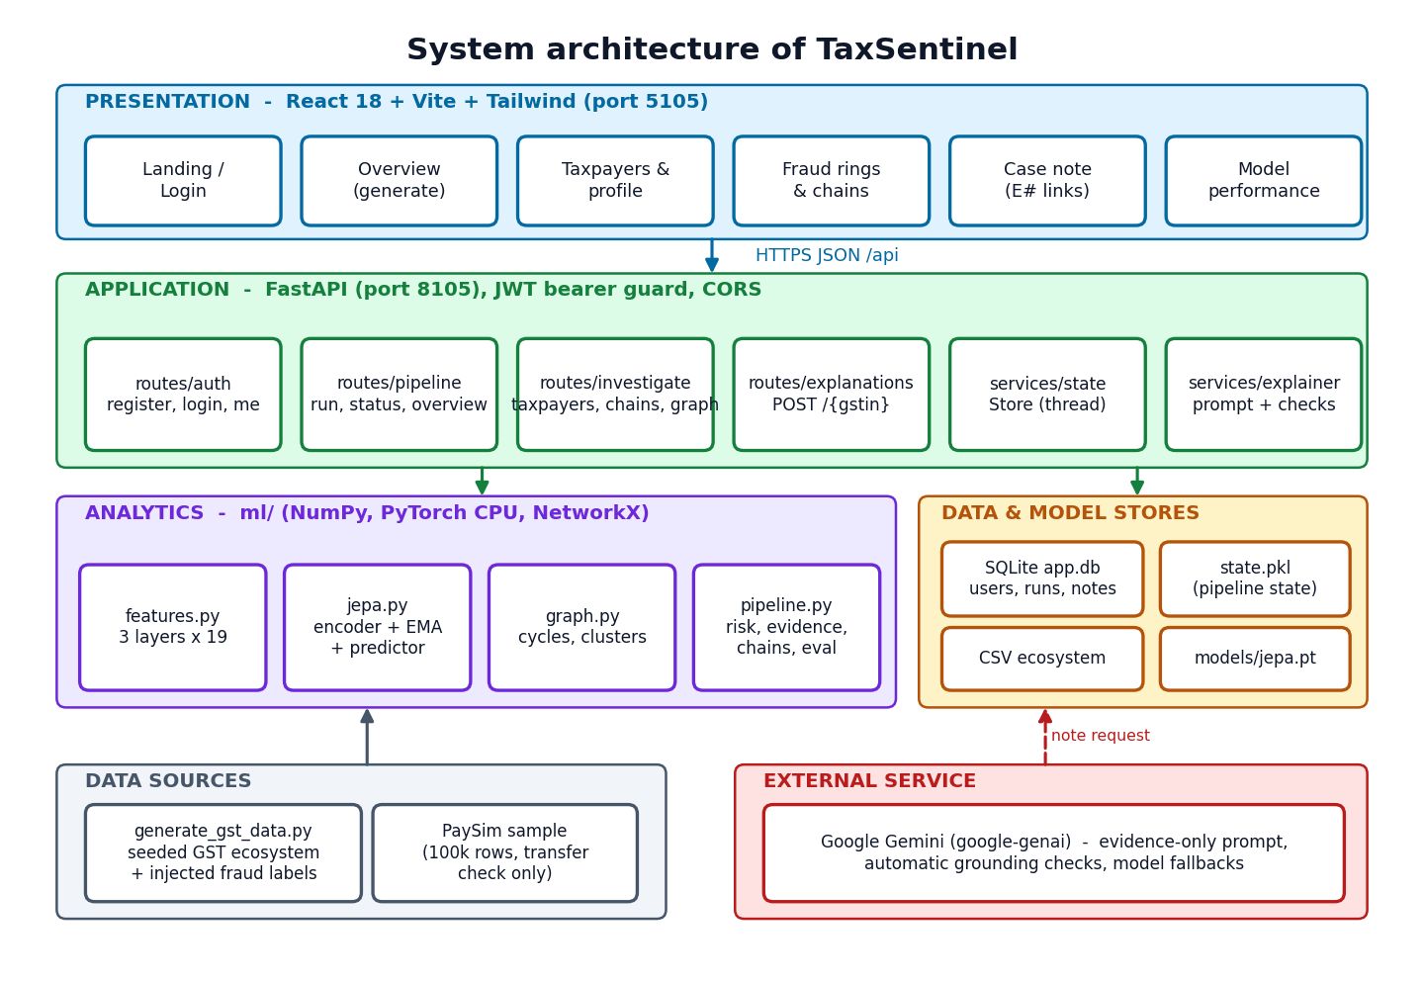
Figure 5.1: System architecture of TaxSentinel
Two design decisions shape the architecture. First, the analytical result is computed once per ecosystem and held in memory (and pickled to data/workspace/state.pkl), so every read endpoint is a lookup rather than a computation; this is why the read endpoints respond in milliseconds. Second, long computations never run in a request: a generation is started on a background thread and the interface polls a status endpoint, which also feeds the stage stepper and the activity log.

5.2 High-Level Workflow
The workflow in Fig. 5.2 has eight steps. Data are generated or loaded (1); nineteen features per taxpayer-month are computed in three layers (2); the JEPA encoder scores the deviation of each month (3); the trade graph is analysed for loops and clusters (4); every invoice is scored (5); the four layer scores are combined into a risk (6); evidence and invoice chains are built for the flagged taxpayers (7); and on request a case note is written and checked (8). Evaluation against injected labels and the rule baseline runs on the same scores.
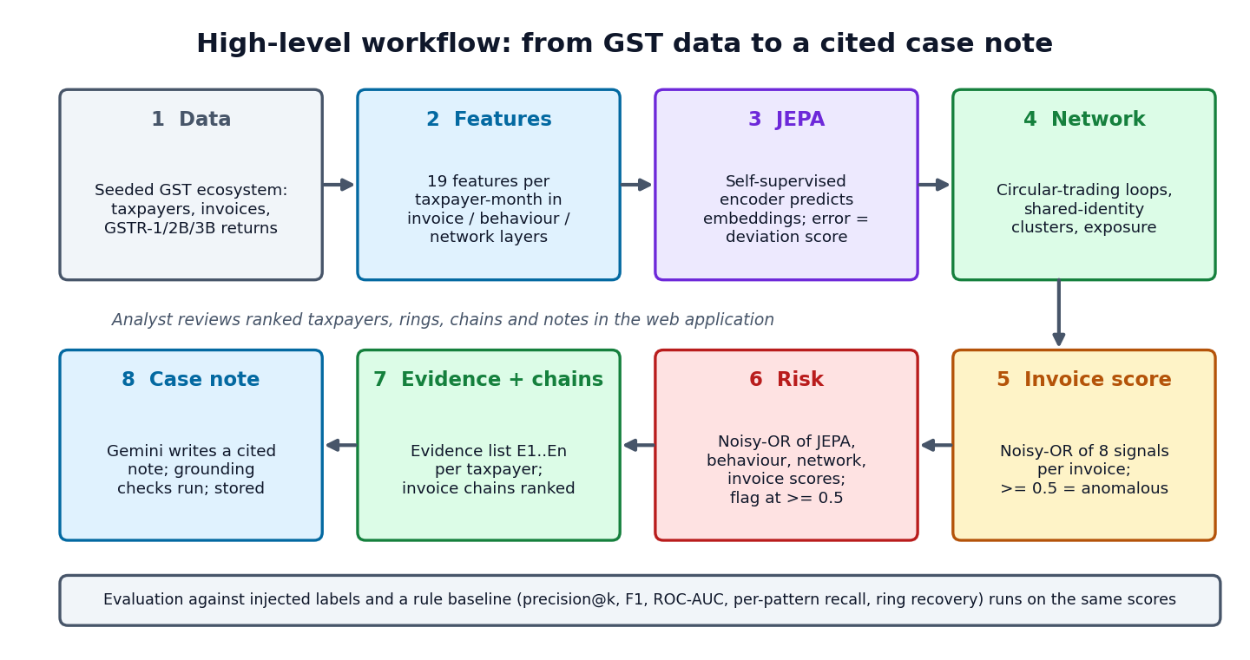
Figure 5.2: High-level workflow from GST data to a cited case note

5.3 Data Flow Diagrams
The context diagram (Fig. 5.3) shows one system, three external entities (the analyst, the Gemini API and the data generator) and the data crossing the boundary: credentials, seeds and queries in; rankings, rings, chains, notes and metrics out; evidence prompts to Gemini and cited notes back; and the generated ecosystem in.
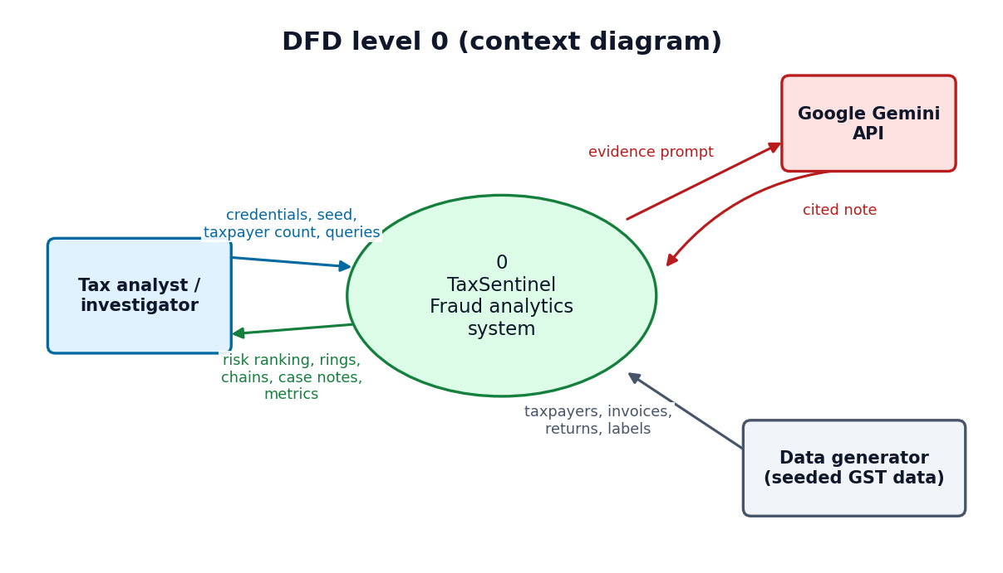
Figure 5.3: Data flow diagram, level 0 (context diagram)
Level 1 (Fig. 5.4) divides the system into five processes: authentication (1.0) against the users store; generation and analysis (2.0), which reads the CSV ecosystem and model, writes the run row and produces the pipeline state; investigation (3.0), which reads the state to serve rankings, profiles, graphs and chains; evaluation (4.0), which reads the evaluation held in the state and the training and evaluation reports; and case explanation (5.0), which reads evidence from the state, exchanges a prompt and a cited note with Gemini and stores the note and its quality checks.
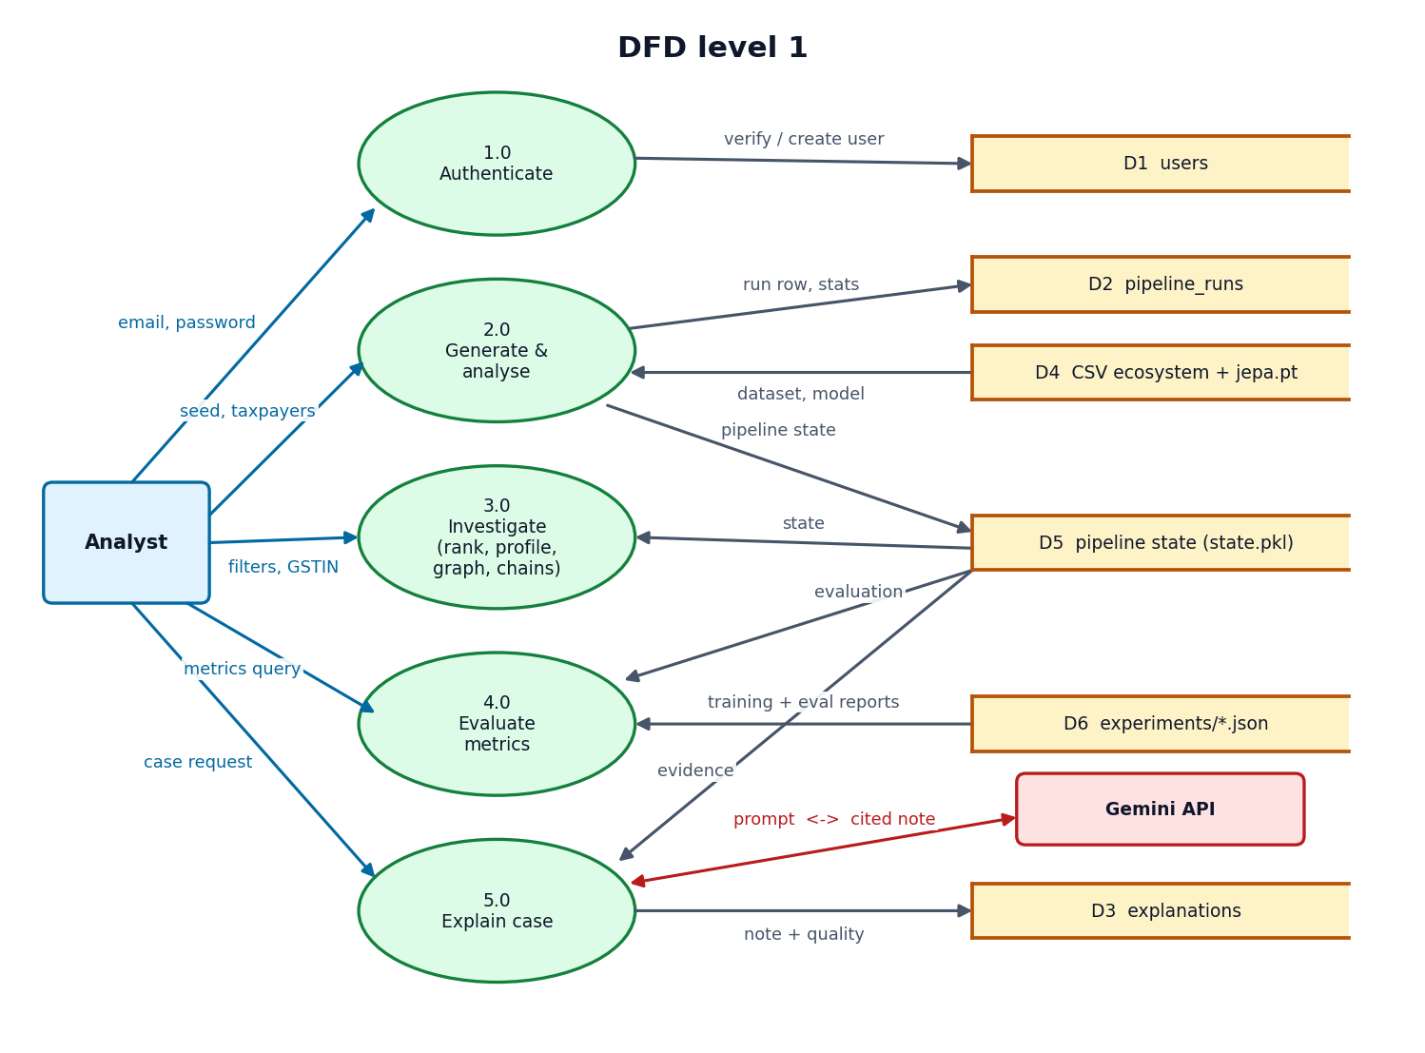
Figure 5.4: Data flow diagram, level 1
Level 2 (Fig. 5.5) expands process 2.0 into its eight internal steps. Each step reads the output of the one before it, and the network score and the JEPA and behaviour scores meet in the risk combination (2.6). The ecosystem and the model weights are read from and written to their stores, and the finished state is pickled.
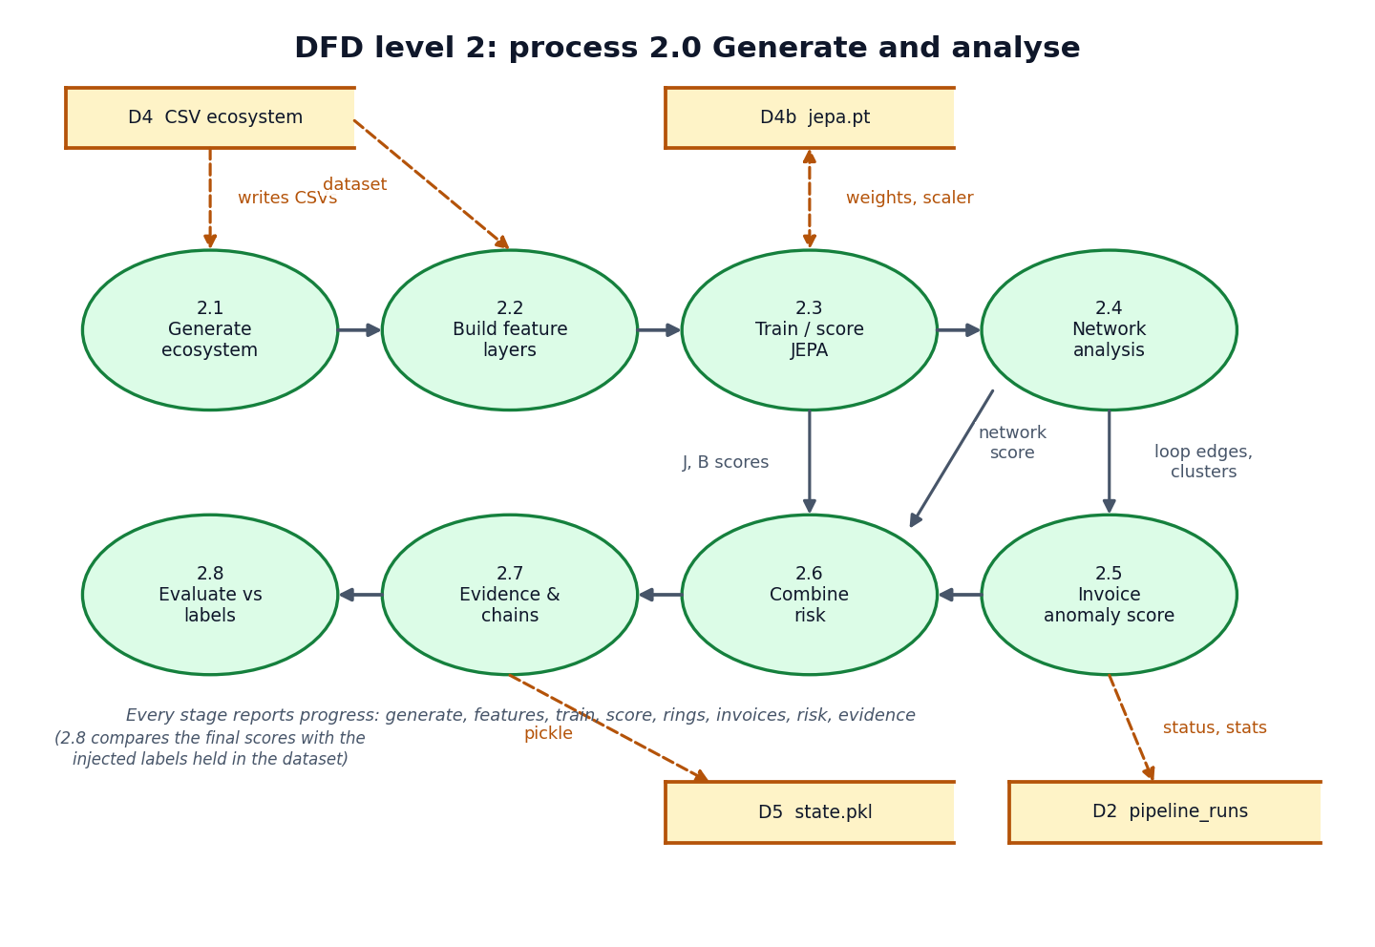
Figure 5.5: Data flow diagram, level 2: Generate and analyse

5.4 UML Diagrams
The class diagram (Fig. 5.6) shows three persistent classes (User, PipelineRun and Explanation), the Store service that holds the pipeline state and starts background runs, the pipeline and explainer modules, and the model classes JEPA, Encoder and RobustScaler. A JEPA instance owns two encoders, the online one and the exponential-moving-average target.
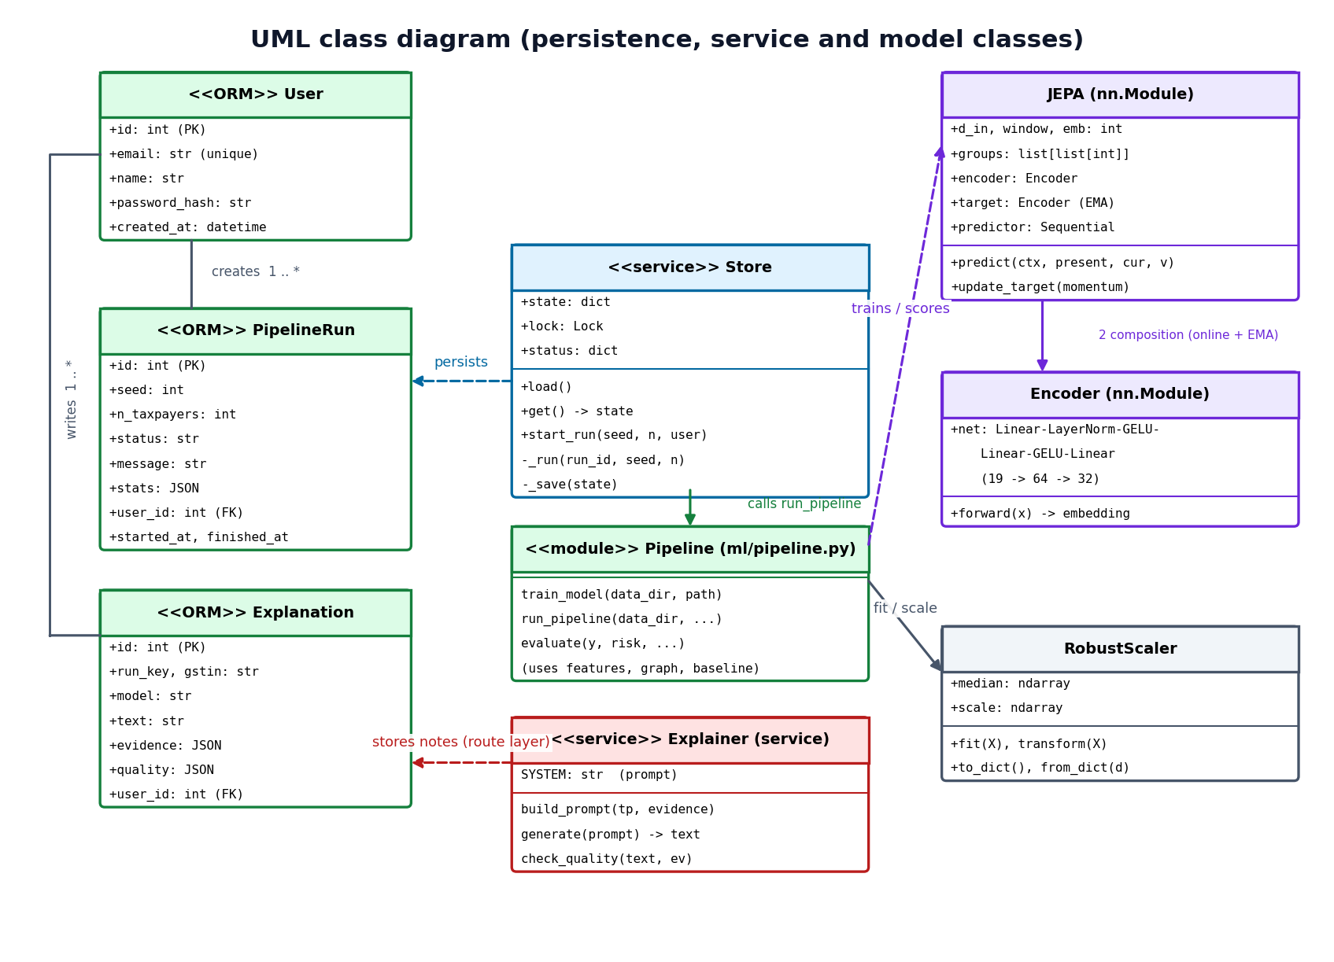
Figure 5.6: UML class diagram
The sequence diagram (Fig. 5.7) follows the main flow: sign-in, generating an ecosystem (the interface polls while a background thread runs the pipeline and updates the run row), opening the top taxpayer, and writing an explanation (the API builds the prompt from the evidence, calls Gemini, checks the grounding of the answer and saves it).
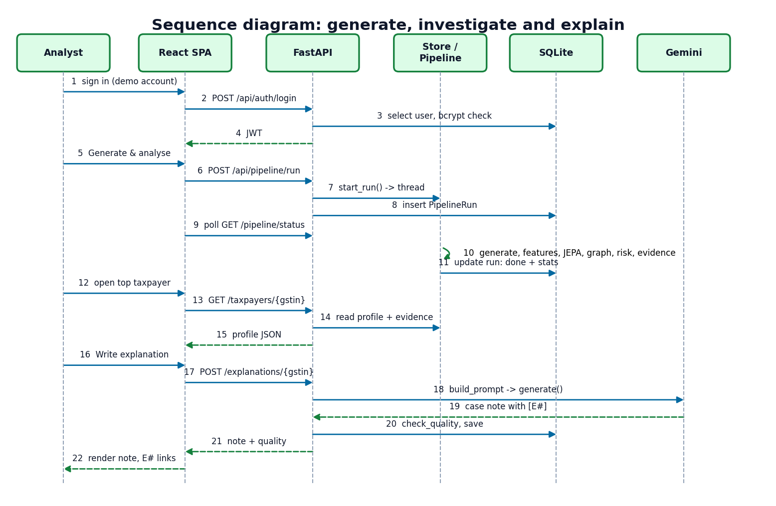
Figure 5.7: Sequence diagram of the main flow
The use-case diagram (Fig. 5.8) has the analyst as the primary actor and Gemini as a secondary actor of the case-note use case.
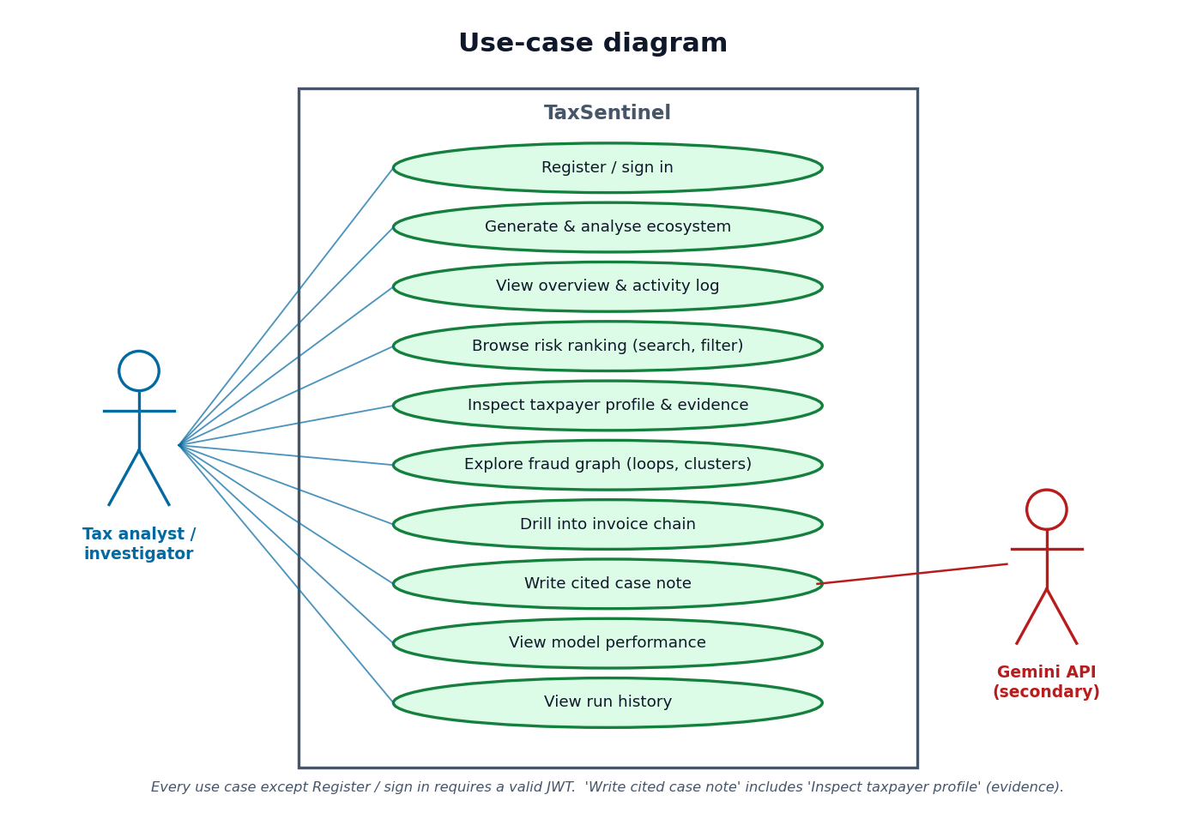
Figure 5.8: Use-case diagram

5.5 Database Design
Application data that changes at run time is stored in SQLite through SQLAlchemy; the analytical dataset is not, because it is read as a whole, is regenerated from a seed and is naturally columnar. Fig. 5.9 shows the three SQL tables and the three CSV entities that they refer to logically.
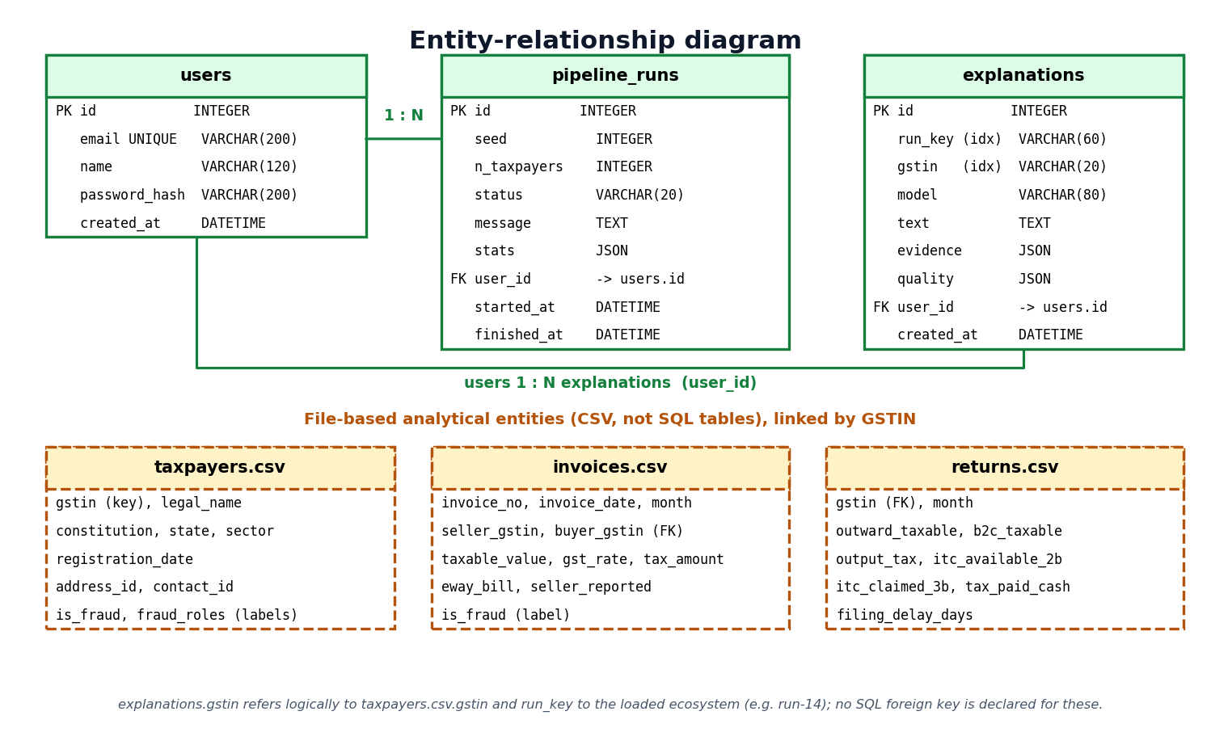
Figure 5.9: Entity-relationship diagram
Table 5.1: SQL tables
Table | Columns | Keys and notes
users | id, email, name, password_hash, created_at | PK id; email unique and indexed; password stored only as a bcrypt hash
pipeline_runs | id, seed, n_taxpayers, status, message, stats (JSON), user_id, started_at, finished_at | PK id; FK user_id to users; status is running, done or failed; stats holds the summary counts
explanations | id, run_key, gstin, model, text, evidence (JSON), quality (JSON), user_id, created_at | PK id; FK user_id to users; run_key and gstin indexed so a note is found for the loaded ecosystem; evidence is stored with the note so the citations stay valid

The CSV entities are taxpayers.csv (GSTIN, legal name, constitution, state, sector, registration date, address and contact identifiers, and the injected labels), invoices.csv (invoice number and date, seller and buyer GSTIN, taxable value, rate, tax, e-way bill flag, whether the seller reported it in GSTR-1, and the label) and returns.csv (monthly outward supplies, output tax, ITC available in GSTR-2B, ITC claimed in GSTR-3B, tax paid in cash and filing delay). The labels are carried in the files so that evaluation can run, but the model never reads them.

5.6 Module Design
Table 5.2: Modules and responsibilities
Module | File(s) | Responsibility
Data generator | scripts/generate_gst_data.py (483 lines) | Seeded ecosystem with GSTIN-format ids, tiered supply network, returns, injected fraud and hard negatives
Feature builder | ml/features.py (169) | Loads the dataset; builds 19 features per taxpayer-month; robust scaler
JEPA | ml/jepa.py (149), ml/train.py (37) | Encoder, EMA target, predictor, sample construction, training, scoring, save and load
Network analysis | ml/graph.py (110) | Trade graph, bounded cycle search and scoring, ring merging, identity clusters, communities
Rule baseline | ml/baseline.py (45) | Rules R1-R5 used as the comparison
Metrics | ml/metrics.py (60) | Precision@k, recall@k, P/R/F1, ROC-AUC, average precision
Pipeline | ml/pipeline.py (530) | Deviation scoring, invoice scoring, risk, patterns, evidence, chains, evaluation
Evaluation | ml/eval.py (133) | Writes experiments/eval/metrics.json including the PaySim transfer and explanation checks
API | backend/app/ (main, auth, config, db, routes, services; 787 lines) | Endpoints, JWT guard, persistence, background runs, explainer
Web application | frontend/src/ (10 pages plus components, 1,415 lines in the pages; 3,774 lines in 36 source files overall) | Screens, charts, graph, navigation, themes

5.7 User Interface Design
The interface is a "control room" for an analyst. Its main design rules are: show the answer before the mechanism (the overview leads with counts, flagged taxpayers and the comparison with the baseline); let every number lead to its evidence (a taxpayer opens a profile, a citation chip jumps to its evidence item, a chain opens its invoices); keep the system status visible (a health card, a stage stepper, an activity log); and respect the user's environment (light and dark themes following the operating-system setting, reduced-motion support, keyboard navigation with a command palette and g shortcuts). The screens are presented in Chapter 8 and Appendix C.
Table 5.3: Screens and their purpose
Screen | Route | Purpose
Landing | / | What the product does; live health card
Sign in / register | /login | JWT sign-in, demo account
Overview | /app | Generate and analyse; counts; flagged taxpayers; patterns; top chains; activity log
Taxpayers | /app/taxpayers | Ranked list with search and filters
Taxpayer profile | /app/taxpayers/:gstin | Signals, evidence, network, invoices
Case | /app/cases/:gstin | Evidence list and the cited case note
Fraud rings | /app/graph | Interactive network; loops and clusters
Invoice chain | /app/chains/:id | Chain graph, parties and invoices
Model performance | /app/performance | Metrics, ablations, per-pattern recall
Run history | /app/runs | Last ten generations and the loaded ecosystem

CHAPTER 6: METHODOLOGY AND SOFTWARE IMPLEMENTATION

6.1 Overall Methodology
The methodology has seven stages that mirror the workflow in Chapter 5. (1) A seeded generator produces a GST ecosystem with injected, labelled fraud and legitimate hard negatives. (2) Three layers of features (invoice, return behaviour and network) are computed for every active taxpayer-month. (3) A JEPA encoder is trained, without labels, to predict the embedding of a month from the embeddings of the previous three months and from the month itself with one feature layer hidden; the prediction error is the deviation score. (4) The trade graph is searched for short recurring cycles and for registrations that share an address or contact number. (5) Every invoice receives a noisy-OR anomaly score from eight weighted signals. (6) The four layer scores are combined into one risk per taxpayer, taxpayers and invoice chains are ranked, and patterns and evidence are derived. (7) Gemini writes a cited case note from the evidence on request, and the result is checked. Evaluation against the injected labels and against a rule baseline is run on the same scores (Fig. 6.1).
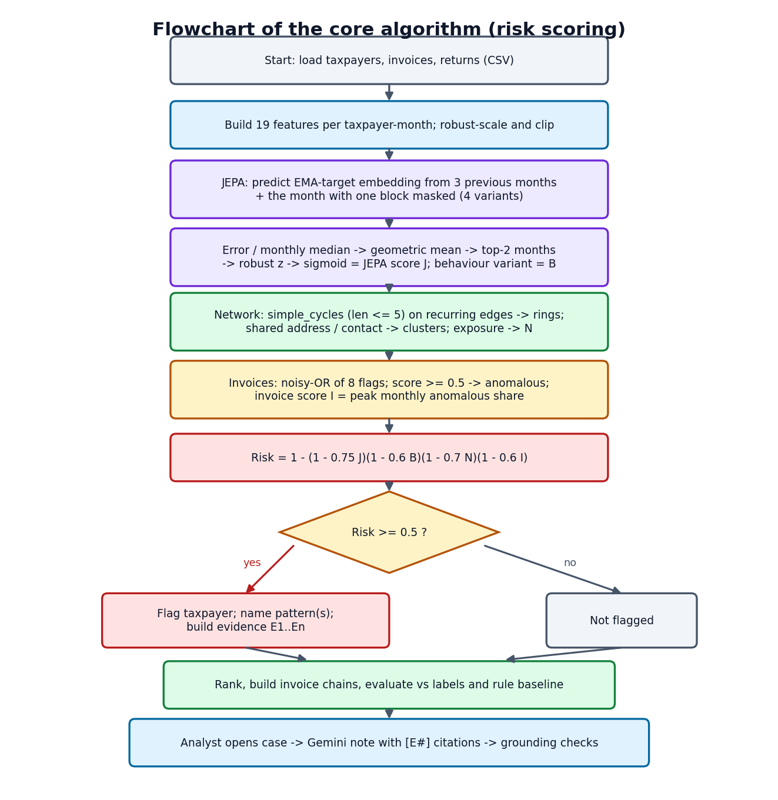
Figure 6.1: Flowchart of the core algorithm (risk scoring)

6.2 Dataset
Real GST returns are not publicly available, so the project uses a seeded synthetic ecosystem generated by scripts/generate_gst_data.py. The bundled ecosystem (seed 42) covers one financial year, April 2025 to March 2026, and contains 600 taxpayers, 64,474 business-to-business invoices and 6,977 monthly returns. Taxpayers are placed in eight states, five sectors (retailer 178, wholesaler 161, manufacturer 116, services 95, raw material 50) and four constitutions (proprietorship 235, private limited 196, LLP 91, partnership 78). Each has a GSTIN in the official format with a valid check character, a legal name, a registration date, an address and a masked contact. Trade follows a tiered supply network (raw material to manufacturer to wholesaler to retailer, with services supplying every tier). Of the invoices, 39,582 carry an e-way bill and 1,071 were not reported by the seller in GSTR-1.
Each month a taxpayer has a return holding outward taxable supplies, output tax, ITC available in GSTR-2B, ITC claimed in GSTR-3B, tax paid in cash from a credit carry-forward ledger and filing delay. Four fraud patterns are then injected, each with ground-truth labels:
Table 6.1: Injected fraud in the bundled ecosystem
Pattern | How it is injected | Taxpayers | Other
Shell entities | Young look-alike firms sharing an address or contact number; layered fake invoices; almost no cash tax; they stop filing | 27 (7 clusters of 3-5) | Fake invoices are part of the 530 labelled invoices
Fake-invoice buyers | Established businesses claiming ITC on invoices bought from shell clusters | 19 | No goods moved
Circular trading | Rings of 3-5 firms passing similar values A to B to C to A in the same months | 21 (5 rings of 3-5) | Ring invoices are labelled
ITC spikes | A month's claim far above both history and GSTR-2B | 12 | One-month events

In total 79 taxpayers (13.2 %) and 530 invoices (0.82 %) are labelled fraud. The generator also builds hard negatives on purpose, so that detection is not trivial: festival seasonality, one-off capital purchases, new registrations, group companies sharing an address, late filers, prior-period credit catch-ups, and naturally reciprocal trade between services and manufacturers. The labels live in the CSV files only so that evaluation can run; the model never reads them. The generator is seeded, so the same seed always produces the same ecosystem; the application can generate others (150 to 1,500 taxpayers) from the Overview page. The data is synthetic sample data and is licensed as part of the product.
A second dataset is used only as a transfer check. PaySim [21] is a synthetic mobile-money transaction simulator published on Kaggle under a CC BY-SA 4.0 licence. A 100,000-row seeded random sample (134 fraud rows) is committed under data/sample/; the full 470 MB file is downloaded on demand and ignored by version control.

6.3 Preprocessing and Feature Layers
Every active taxpayer-month (a month in which a return was filed) becomes one vector of 19 features in three layers (Table 6.2). Counts, turnover and ITC are log-transformed because they are heavy-tailed. Shares are kept in [0, 1]. Ratios are capped (for example ITC to output tax at 5). Features are then robust-scaled: each feature is centred on its median and divided by its robust spread (IQR/1.349, with a floor of half the standard deviation and a small constant), and clipped to [-10, 10]. Months with no return are marked absent; they are not imputed, and the context window handles them with a presence mask.
Table 6.2: The 19 features in three layers
Layer | Features
Invoice (6) | purchase invoices (log count); sales invoices (log count); share of purchase value not reported by suppliers in GSTR-1; share of goods invoices of Rs 50,000 or more without an e-way bill; share of round-value invoices; share of purchases from suppliers registered less than 6 months before the invoice
Behaviour (7) | outward turnover (log); ITC claimed (log); ITC claimed to output tax; ITC claimed above GSTR-2B (signed log of the relative excess); share of output tax paid in cash; filing delay (months); registration age (log)
Network (6) | number of suppliers (log); number of buyers (log); share of new trading partners; share of sales to parties that also supply the taxpayer (reciprocity); largest buyer's share of sales; value added ((outward - purchases) / (outward + purchases))

6.4 Algorithm Choice and Justification
Why a self-supervised predictive model. The abstract requirement is to learn normal behaviour without labels. The usual options are density or distance methods such as isolation forests [14], reconstruction methods such as autoencoders and predictive methods. JEPA [8], [9] was chosen because it is predictive (it asks whether a month is what the history and the other layers would lead one to expect), because it predicts in an embedding space (so noise in heavy-tailed values is not something it must reproduce) and because its masking gives interpretable variants: hiding a whole month tests predictability from history, hiding a feature layer tests consistency between layers. An exponential-moving-average target encoder [11] and a variance term [12] prevent the representation from collapsing to a constant. The project did not run a head-to-head experiment against an isolation forest or an autoencoder, so the choice is justified by design, not by measured superiority; the ablation in Chapter 8 does show that JEPA on its own is not sufficient.
Why explicit network analysis. Circular trading and shell clusters are properties of groups. A per-taxpayer encoder cannot see a loop, and 27 similar shell firms form their own "normal" in feature space. Bounded-length cycle enumeration [17] on a pruned graph is exact, fast on this data (79 candidate cycles were scanned) and gives an interpretable object, the loop, that can be drawn and cited. Graph neural networks [19] were not used because they would need labels and would remove the explicit loop evidence.
Why noisy-OR. The layers are different kinds of evidence, any of which can be strong enough on its own. A noisy-OR [22] treats each layer as an independent cause with a weight: one strong layer raises the risk, several agreeing layers raise it further, and the result stays in [0, 1]. It has four parameters that an analyst can read, unlike a learned combiner that would need labels.
Why a prompted LLM with grounding checks. Writing a note that an officer can read quickly is a language task. The risk of hallucination [24] is controlled in the way retrieval-augmented generation [23] does it, by supplying the facts, and then checked automatically. Fine-tuning would need a corpus of real investigator notes that does not exist here, so the "tuning" of the LLM in this project is prompt engineering plus verification.

6.5 Mathematical Formulation
Features. Let x(i,t) be the 19-dimensional raw feature vector of taxpayer i in month t, and z(i,t) = clip((x - med) / s, -10, 10) its robust-scaled version, where s = max(IQR/1.349, 0.5 std, 10^-3) per feature.
JEPA. Let f(theta) be the online encoder, f(xi) the target encoder (a copy updated as an exponential moving average, with no gradient) and g(phi) the predictor. For a sample (i,t) and a mask variant v in {0, 1, 2, 3}, let k(v) be a binary keep-vector that hides everything (v = 0) or the invoice, behaviour or network block (v = 1, 2, 3), and let m be the presence indicator of the previous W = 3 months. The prediction and the target are
s_hat = g( [ m1 * f(z(t-1)), m2 * f(z(t-2)), m3 * f(z(t-3)), m, f( k(v) * z(t) ), onehot(v) ] ), s = f_target( z(t) ) (1)
and the training loss is the prediction error in embedding space plus a variance regulariser over the embedding dimensions j of a batch,
L = mean( (s_hat - s)^2 ) + lambda * mean_j ReLU( 1 - std_j( f(z) ) ), lambda = 1 (2)
xi <- 0.99 xi + 0.01 theta (after every optimiser step) (3)
Deviation score. After training, the squared embedding error of each variant is e(i,t,v). It is normalised by the median over taxpayers of the same month and variant, r(i,t,v) = e(i,t,v) / median_i' e(i',t,v), and the four variants are combined by a geometric mean,
d(i,t) = exp( (1/4) * sum_v ln r(i,t,v) ) (4)
The taxpayer's raw deviation is the mean of its two largest monthly d values. It is converted to a score in (0, 1) by a robust z-score against all taxpayers and a logistic squash centred at two robust standard deviations,
J(i) = 1 / (1 + exp( -1.5 * ( u(i) - 2 ) )), u(i) = ( ln raw(i) - median ) / ( 1.4826 * MAD ) (5)
The behaviour score B(i) is obtained in the same way from the largest monthly r value of the behaviour-masked variant alone, which responds to a one-month ITC spike that the averaged score smooths away.
Circular trading. For a directed cycle C in the graph of recurring (at least two months), above-median edges, with edge values v(e), purchases P(w) of node w and common trading months M(C),
score(C) = sqrt( min_e v(e) / max_e v(e) ) * min( 1, |M(C)| / 3 ) * sqrt( min( 1, min_(u,w in C) v(u,w) / P(w) ) ) (6)
The three factors are balance (similar values around the loop), recurrence (the whole loop trades in the same months) and concentration (the loop is a large share of every member's purchases). Cycles scoring at least 0.25 are kept and overlapping cycles are merged into rings.
Shared-identity clusters. Registrations linked by a shared address or contact number form a cluster with score 0.4 * mean J + 0.2 * (share registered within a year) + 0.2 * (intra-cluster share of sales) + 0.2 * (share that stopped filing); a cluster is suspicious at 0.4 or more.
Invoice anomaly. With flags f and weights w(f) (unreported 0.30, no e-way bill 0.30, round value 0.15, young supplier 0.20, supplier in a suspicious cluster 0.35, supplier later stopped filing 0.20, edge of a detected loop 0.45, value more than four times the supplier's median 0.15), the anomaly score of invoice a and the invoice-layer score I(i) of a taxpayer are
A(a) = 1 - prod_f ( 1 - w(f) ), I(i) = min( 1, 1.5 * max_t flagged value share(i,t) ) (7)
An invoice is anomalous when A(a) is at least 0.5. The network score N(i) is the largest of twice the peak share of purchases from suspicious clusters (capped at 1), the score of any ring the taxpayer belongs to, and the cluster score if it is suspicious.
Combined risk. The four layer scores are combined by a weighted noisy-OR and a taxpayer is flagged at 0.5 or more,
R(i) = 1 - ( 1 - 0.75 J ) ( 1 - 0.6 B ) ( 1 - 0.7 N ) ( 1 - 0.6 I ), flag if R(i) >= 0.5 (8)
Evaluation. With y the injected label, P@k is the fraction of fraud among the k highest-risk taxpayers, R@k the fraction of all fraud found among them, F1 = 2PR/(P+R) at the flag threshold, and ROC-AUC the probability that a random fraud taxpayer scores above a random legitimate one.

6.6 Model Architecture and Training
The online encoder is a three-layer perceptron, 19 inputs to 64 (linear, layer normalisation [30], GELU [31]) to 64 (linear, GELU) to a 32-dimensional embedding. The target encoder is a copy of it. The predictor is a perceptron from 3 x (32 + 1) + 32 + 4 = 135 inputs (three context embeddings and their presence flags, the embedding of the masked current month and a one-hot of the mask variant) through two hidden layers of 128 with GELU to a 32-dimensional output. The saved model holds 53,420 values: 7,648 in the online encoder, 7,648 in the EMA target copy, 38,048 in the predictor and a 76-value mask buffer; the trainable part is 45,696.
Table 6.3: JEPA training configuration (experiments/metrics.json)
Setting | Value
Samples | 6,977 taxpayer-months (all present months; no labels, no train/test split)
Window / mask variants | 3 previous months / 4 (whole month, invoice, behaviour, network)
Optimiser | AdamW [26], learning rate 1e-3, weight decay 1e-4
Batch size / epochs | 256 / 100
EMA momentum / variance weight | 0.99 / 1.0
Seed | 42 (torch and numpy)
Hardware / time | CPU only; 11.7 s for 100 epochs
Final loss | 0.1115 (the loss rises to a peak of 0.261 at epoch 11 as the EMA target moves, then falls and settles)

The loss curve (Fig. 6.2) is not monotone: it rises over the first ten epochs. This is expected with a moving target, because the online encoder's embeddings first spread out under the variance term and the target follows with a delay. The loss then falls steadily and settles between 0.11 and 0.12 from about epoch 60.
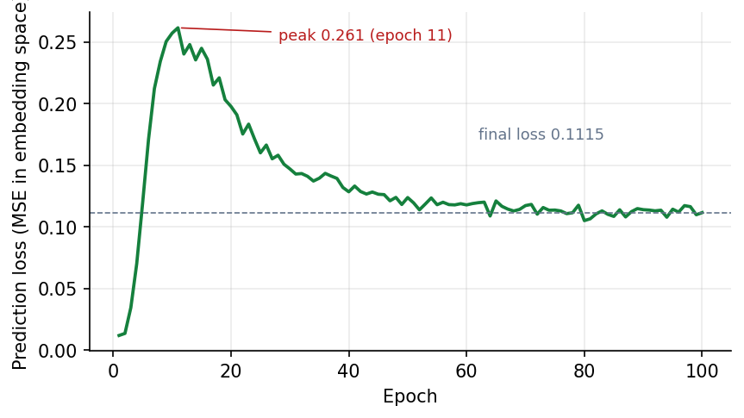
Figure 6.2: JEPA training loss over 100 epochs (final 0.1115)

6.7 Network, Invoice and Risk Pipeline
ml/pipeline.py strings the stages together. After the JEPA scores, it builds the directed trade graph (edge attributes: total value, tax, count, months and unreported value) and runs the bounded cycle search; on the bundled ecosystem 79 candidate cycles were scanned, which merged into 9 rings, 7 of which contain injected-fraud taxpayers. It then builds identity clusters (12 clusters in total, 7 suspicious), scores each invoice, forms the layer scores, combines them and ranks the taxpayers.
Patterns. A flagged taxpayer is given a named pattern from the evidence: circular trading if it belongs to a ring; shell entity if it is in a suspicious cluster and is young, has stopped filing or pays almost no cash tax; fake invoices if it is not a shell entity but buys from suspicious clusters (10 % of purchases or more in some month) or has at least 15 % of purchase value flagged; ITC spike if a month's claim is at least 2.5 times its median, above Rs 1 lakh and at least 1.5 times the available credit; and unusual behaviour if nothing else applies but the JEPA score is at least 0.5.
Evidence. For every taxpayer, up to eleven kinds of evidence item are produced with a layer, a severity and concrete numbers: JEPA deviation with the three largest feature shifts, months where the GSTR-3B claim exceeds GSTR-2B, ITC spikes, low cash payment against the sector median, suspicious purchase and sales invoices, ring membership with the loop path, the shared-identity cluster, exposure to shell suppliers, stopped filing and high turnover soon after registration. Items are sorted by severity and numbered E1 to En.
Invoice chains. Each detected ring and each suspicious cluster (together with its buyers) becomes a chain with a score built from the ring or cluster score and the risk of its members or the anomalous share of its invoices. On the bundled ecosystem there are 16 chains.

6.8 Evidence and Written Explanation
backend/app/services/explainer.py builds a prompt from the taxpayer's profile, scores, suspected patterns and evidence list and sends it to Gemini under a fixed system prompt. The prompt allows only facts in the evidence list, requires a citation such as [E2] after each claim, forbids legal conclusions, keeps amounts in the evidence's format (rupees with L for lakh and Cr for crore), fixes three sections (Summary, Why it was flagged, Suggested next steps) and limits the note to 320 words. The temperature is 0.2. If the primary model is busy or rate-limited the request is retried once after three seconds and then handed to fallback models.
Every note is then checked automatically against the evidence: the number of citations, the number of invalid citations (citing an ID that does not exist), the share of evidence items cited, the share of high-severity items cited, the share of the numbers in the text that also appear in the evidence, the presence of the three sections and the word count. The note, the evidence that backed it and these checks are stored together, so that a stored note can always be audited. This is how the project turns "tuning" of the language model into something measurable.

6.9 Application Architecture
The backend is a FastAPI application. At start-up it creates the SQLite tables, seeds the demo account and loads the pipeline state in a background thread (from the pickle if present, otherwise by running the pipeline on the bundled ecosystem). Five routers expose the API. The Store object holds the current state and the status of the running generation; a generation runs in its own thread, writes a pipeline_runs row with status running, done or failed, and replaces the in-memory state atomically (the pickle is written to a temporary file and renamed). The frontend is a React single-page application with route-level code splitting: each screen is its own bundle, loaded when first visited. Axios calls the API, and the Vite development server proxies /api to port 8105.

6.10 API Design
Table 6.4: REST endpoints (all except register, login and health require a bearer token)
Method | Path | Purpose
POST | /api/auth/register, /api/auth/login | Create an account / sign in; returns a JWT and the user
GET | /api/auth/me | Current user
POST | /api/pipeline/run | Start a generation: seed (0 to 10,000,000), taxpayers (150 to 1,500); 409 if one is running
GET | /api/pipeline/status, /api/pipeline/runs | Progress of the running generation / the last ten runs
GET | /api/overview, /api/overview/monthly | Dashboard data / monthly ITC series
GET | /api/taxpayers | Ranking with q, pattern, flagged, sector, sort, limit (1 to 500) and offset
GET | /api/taxpayers/{gstin} | Profile: scores, evidence, partners, anomalous invoices, monthly series, stored note
GET | /api/chains, /api/chains/{id} | Invoice chains / chain with its invoices and parties
GET | /api/structures, /api/graph | Rings and clusters / graph data (focus, ring, cluster or chain)
POST | /api/explanations/{gstin} | Write and store a cited case note; 400 if no evidence, 502 if Gemini fails
GET | /api/metrics, /api/health | Evaluation and training reports / service status (public)

Requests and responses are JSON. Request bodies are validated by pydantic models, which return HTTP 422 with a description for bad input. Errors use conventional statuses: 401 for a missing or invalid token, 404 for an unknown GSTIN or chain, 409 for a duplicate account or a second concurrent run, 502 for an upstream failure and 503 while the state is still loading.

6.11 Security and Error Handling
- Passwords are hashed with bcrypt [28] with a per-password salt; the plaintext is never stored or logged.
- Sessions are signed HS256 JSON Web Tokens [27] that expire after 720 minutes; an altered signature is rejected (tested). The signing secret is generated by setup.bat and kept in the untracked .env.
- Authorisation. Every analytical endpoint depends on the current_user guard; the public endpoints are register, login and health only.
- Input validation. E-mail format, password length (8 or more), seed and taxpayer-count ranges and paging limits are validated before use. Database access goes through SQLAlchemy with bound parameters, and the search text is only used as a string comparison on in-memory data; SQL-injection-style and script-tag search text were tested and are inert.
- Cross-origin access is limited to the configured frontend origins.
- Secrets. The Gemini key and JWT secret live in .env, which is excluded from version control.
- Failure handling. The Gemini client retries once on a busy or rate-limit response, falls back to alternative models, and finally returns a readable error to the interface; a failed generation is recorded with status failed and its message.
- Not implemented. Rate limiting, account lockout, role-based access control, HTTPS termination (the API is served over HTTP on the local machine) and audit logging of reads are not implemented and would be required for deployment.

6.12 Installation and Execution
On Windows 10 or 11 with Python 3.11 or later, Node.js LTS and free ports 8105 and 5105: run setup.bat once (it creates a virtual environment, installs PyTorch's CPU build and the requirements, writes .env with a random JWT secret, trains the JEPA if the weights are missing and runs npm install), put GEMINI_API_KEY into .env, then run run.bat, which starts the API and the web server, waits for the pipeline to be ready and opens http://localhost:5105. The demo account is demo@taxsentinel.app. The full guide is Appendix B.

CHAPTER 7: SYSTEM TESTING

7.1 Testing Strategy
Testing combines four layers. (1) An end-to-end smoke test (scripts/smoke_test.py) drives the running API through the whole user journey. (2) A set of black-box edge-case and security checks (scripts/docs_build/edge_tests.py) sends invalid, hostile and boundary requests and records the status codes. (3) The evaluation harness (python -m ml.eval) tests the analytical results against injected labels, which is the project's functional test of the model (Chapter 8). (4) Interactive verification of every screen with real data produced the output screens (Chapter 8 and Appendix C). The strategy is deliberately weighted towards the API and the analytics, because those carry the logic; the React screens contain presentation only.
What was not done, stated plainly. The project has no unit-test suite and no coverage measurement; the individual functions of the ml/ package are exercised through the pipeline, not by isolated unit tests. There is no automated browser (end-to-end UI) test suite, no load test beyond sequential calls from one client, and no user-acceptance study with real analysts.

7.2 Unit and Component Testing
There are no isolated unit tests. Component-level confidence comes from three sources: the metric functions in ml/metrics.py are exercised on every run of the evaluation and agree with the values shown in the application; the JEPA training loop is checked by its loss curve and by the downstream results; and the generator's output is checked by the counts it records in meta.json (600 taxpayers, 64,474 invoices, 6,977 returns, 79 fraud taxpayers and 530 fraud invoices, which the evaluation then reads back unchanged). Writing a proper unit-test suite is listed as future work.

7.3 Integration Testing
The smoke test registers a new user, signs in, regenerates ecosystems through the background run, reads every family of endpoints and writes a real Gemini note. All 20 checks passed in a single run of 39.4 s. Table 7.1 lists them.
Table 7.1: Smoke-test checks (all 20 passed)
Check | What it verified
health + pipeline ready | API up; pipeline state loaded
protected routes need login | GET /api/overview without a token returns 401
register | new account created, token returned
login | sign-in works and /api/auth/me returns the same e-mail
generate ecosystem seed=7 n=200 | background run finishes with stage done
overview reflects new ecosystem | 200 taxpayers, seed 7, 28 flagged
generate ecosystem seed=42 n=600 | bundled ecosystem regenerated
overview counts | 600 taxpayers, 64,474 invoices, 78 flagged, 9 rings
risk ranking sorted | top risk 0.9651; descending order
circular-trading taxpayers found | pattern filter returns members
top taxpayer profile has evidence | profile lists evidence items
monthly returns series | 12 months present
graph shows circular-trading loop | focused graph has loop edges (15 nodes, 19 links)
fraud network graph | overview graph is non-empty
rings and clusters listed | 9 rings and 12 clusters
ring graph | ring graph has only loop edges and at least two nodes
invoice chain drill-down | CH-R01 returns its invoices (score 0.8334)
written explanation cites evidence | Gemini note with 14 citations, 0 invalid, evidence coverage 1.0
explanation saved with case | stored note returned with the profile
metrics vs rule baseline | P@79 0.9494 for the model against 0.6203 for the baseline

7.4 Functional Testing
Each functional requirement of Chapter 4 was exercised on the running application with the bundled ecosystem, and the output screens in Chapter 8 are the evidence. FR1 (accounts and sessions) by the sign-in screens and the authentication checks; FR2 and FR3 to FR6 by the generation run shown in the overview screens (JEPA training reached epoch 10 of 100 in the capture, and the run finished with 78 flagged taxpayers); FR7 and FR8 by the ranking and profile screens; FR9 by the fraud graph and chain screens; FR10 by the case screen with a Gemini note whose citations link to evidence; FR11 by the performance screen; FR12 by the run-history screen.

7.5 Security Testing
The checks in Table 7.2 send unauthenticated, forged and hostile requests to the API. The run recorded 41 of 41 edge and security checks (all security and authorisation cases pass). A token whose signature was altered is rejected, every analytical endpoint refuses a request without a token, and SQL-injection-style and script-tag search strings are returned as ordinary empty searches.
Table 7.2: Authentication, authorisation and security checks
Case | Expected | Observed | Result
demo login with correct password | 200 | 200 | Pass
wrong password | 401 | 401 | Pass
unknown e-mail | 401 | 401 | Pass
e-mail is case-insensitive and trimmed | 200 | 200 | Pass
valid registration | 200 | 200 | Pass
no token | 401 | 401 | Pass
garbage token | 401 | 401 | Pass
token with altered signature | 401 | 401 | Pass
GET /api/taxpayers without token | 401 | 401 | Pass
GET /api/chains without token | 401 | 401 | Pass
GET /api/structures without token | 401 | 401 | Pass
GET /api/graph without token | 401 | 401 | Pass
GET /api/metrics without token | 401 | 401 | Pass
GET /api/pipeline/status without token | 401 | 401 | Pass
GET /api/pipeline/runs without token | 401 | 401 | Pass
POST /api/pipeline/run without token | 401 | 401 | Pass
POST /api/explanations without token | 401 | 401 | Pass
SQL-injection-style search text is inert | 200 | 200 | Pass
script tag in search text is inert | 200 | 200 | Pass
health is public | 200 | 200 | Pass

7.6 Validation and Edge Cases
Table 7.3 lists boundary and invalid-input cases: password, e-mail and name validation, malformed JSON, unknown identifiers, paging limits, generation parameter ranges, and the rule that only one generation may run at a time. The small generation (seed 5, 150 taxpayers) completed, and the bundled ecosystem was restored afterwards and again flags 78 taxpayers.
Table 7.3: Validation, edge-case and concurrency checks
Case | Expected | Observed | Result
password shorter than 8 characters | 422 | 422 | Pass
malformed e-mail | 422 | 422 | Pass
empty name | 422 | 422 | Pass
duplicate registration | 409 | 409 | Pass
malformed JSON body | 422 | 422 | Pass
limit=0 rejected | 422 | 422 | Pass
limit above 500 rejected | 422 | 422 | Pass
negative offset rejected | 422 | 422 | Pass
taxpayers below 150 rejected | 422 | 422 | Pass
taxpayers above 1500 rejected | 422 | 422 | Pass
negative seed rejected | 422 | 422 | Pass
non-numeric seed rejected | 422 | 422 | Pass
unknown GSTIN profile | 404 | 404 | Pass
explanation for unknown GSTIN | 404 | 404 | Pass
unknown chain id | 404 | 404 | Pass
search with no match returns an empty page | 200 | 200 | Pass
first run accepted | 200 | 200 | Pass
second run while one is running | 409 | 409 | Pass
small run (seed 5, 150 taxpayers) completes | done | done | Pass
bundled ecosystem restored (seed 42, 600) | done | done | Pass
restored ecosystem flags 78 taxpayers | 78 | 78 | Pass

7.7 Performance Testing
Latency was measured on the development machine described in Chapter 4, with the demo account signed in, by calling each read endpoint 20 times in sequence from a Python client (Table 7.4, Fig. 7.1). Median responses are between 1.7 ms (health) and 12.1 ms (the whole-network graph); the largest single response was 36.6 ms (a monthly-series call). Sign-in took about 261 ms for one call, which is dominated by the deliberately slow bcrypt hash. These are single-client figures: concurrency and load were not tested.
Table 7.4: Read-endpoint latency, 20 sequential calls each (ms)
Endpoint | Median | Maximum
health | 1.7 | 3.5
monthly | 3.5 | 36.6
graph (ring) | 4.3 | 5.0
overview | 4.6 | 13.2
chains | 5.2 | 6.8
structures | 5.3 | 6.8
metrics | 6.9 | 11.4
taxpayers (limit 50) | 8.4 | 12.5
taxpayer profile | 8.5 | 20.2
graph (overview) | 12.1 | 13.9

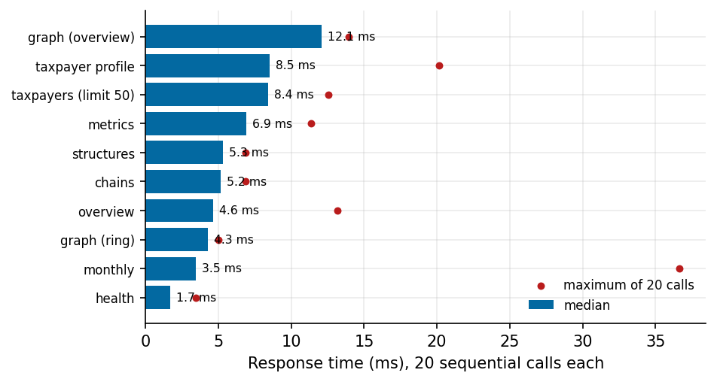
Figure 7.1: API response time per endpoint (median bars, maximum markers)
The cost is in the generation. The analysis stage reported 16.0 s for the 600-taxpayer ecosystem (including the 11.7 s JEPA training measured in the training run), and end-to-end generations recorded in the run history took between 18.6 and 29.0 s for 600 taxpayers and between 5.8 and 9.9 s for 200 taxpayers. Three early development runs took longer (20.2, 52.6 to 54.9 and 274.5 s) while other work was loading the machine, which shows that the figure depends on the free CPU.

7.8 User Acceptance
No formal user-acceptance test with real analysts was carried out, and no usability score was collected. The project team walked the demonstration path (generate, open the top taxpayer, write a note, open the graph, read the performance page) repeatedly while producing the screens. Acceptance by the intended users remains an open item.

7.9 Limits of the Testing Done
- No unit tests, coverage figure or automated UI tests.
- Single-client latency only; no concurrent-user or soak testing; measurements were taken on one machine that was at times heavily loaded.
- The Gemini path was tested with one real call in the smoke test and with the evaluation on 6 of 10 cases; failures from quota and overload are documented rather than avoided.
- Security testing is black-box and limited to the checks listed; there was no penetration test, dependency audit or review of the deployment configuration.
- Accuracy was tested on synthetic data only (Chapter 8).

CHAPTER 8: RESULTS AND OUTPUT SCREENS

8.1 Output Screens
All screens below were captured from the running application at 1440 x 900 with the bundled ecosystem (seed 42, 600 taxpayers) generated through the interface. None is a mock-up. They are described in the order of the analyst's workflow; the remaining screens are in Appendix C.
The Overview during a run. Pressing Generate & analyse starts the background generation; the stepper marks generate and features as done and JEPA training as active, with the epoch and loss (epoch 10 of 100, loss 0.2571, 25 %), and the activity log streams every pipeline message. This is the screen that makes the long-running stage visible instead of leaving the user with a spinner.
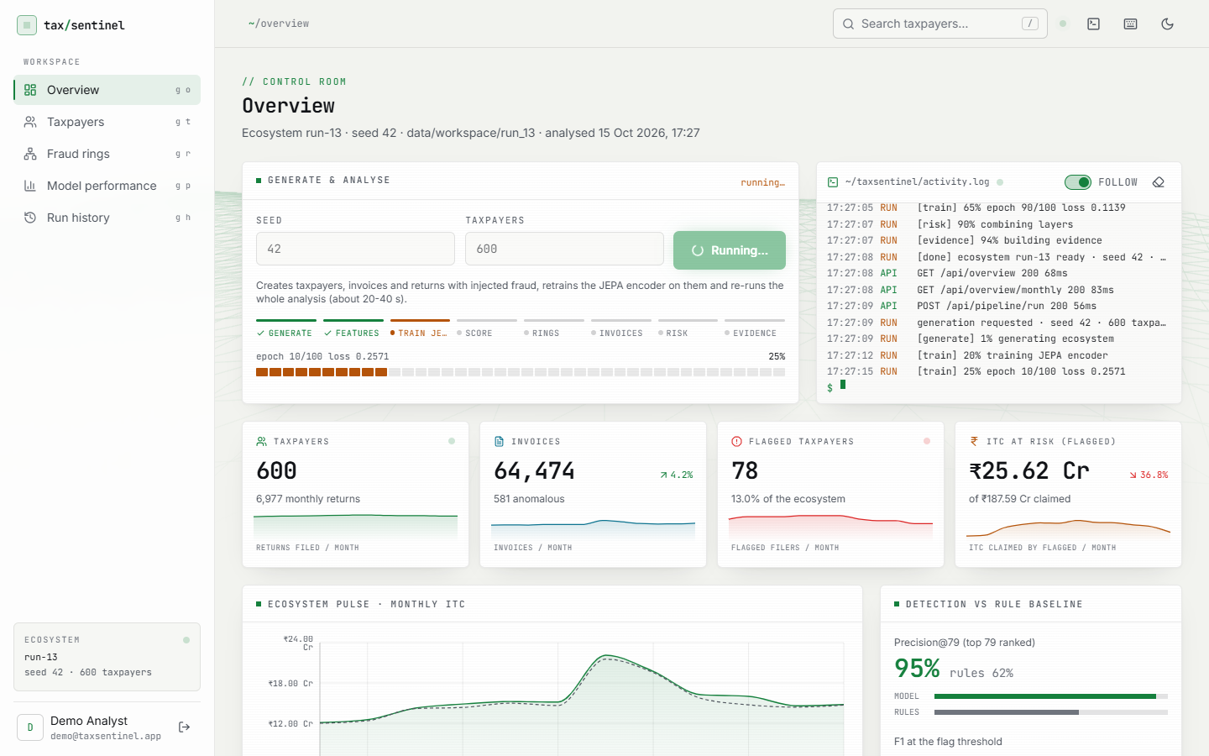
Figure 8.1: Overview while a run is in progress: the stage stepper shows JEPA training at epoch 10 of 100 (25 %) and the activity log streams the pipeline messages.
The Overview after the run. The headline cards show 600 taxpayers with 6,977 monthly returns, 64,474 invoices of which 581 are anomalous, 78 flagged taxpayers (13.0 % of the ecosystem) and Rs 25.62 Cr of ITC attached to flagged taxpayers out of Rs 187.59 Cr claimed. The detection card shows precision@79 of 95 % for the model against 62 % for the rule baseline.
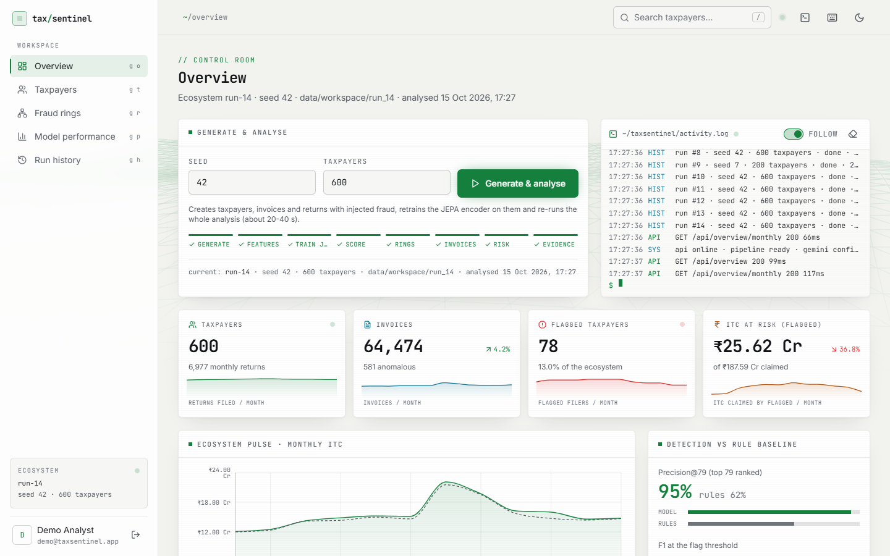
Figure 8.2: Overview after the run completes (seed 42, 600 taxpayers): 64,474 invoices, 78 flagged taxpayers, ITC at risk of Rs 25.62 Cr of Rs 187.59 Cr claimed, and precision@79 of 95 % against 62 % for the rule baseline.
The ranked list. The first rows are circular-trading and shell-entity taxpayers with risks of 0.91 to 0.97 and the layer scores in separate columns. Search, pattern, sector and flag filters and the sort order are kept in the URL so that a view can be shared.
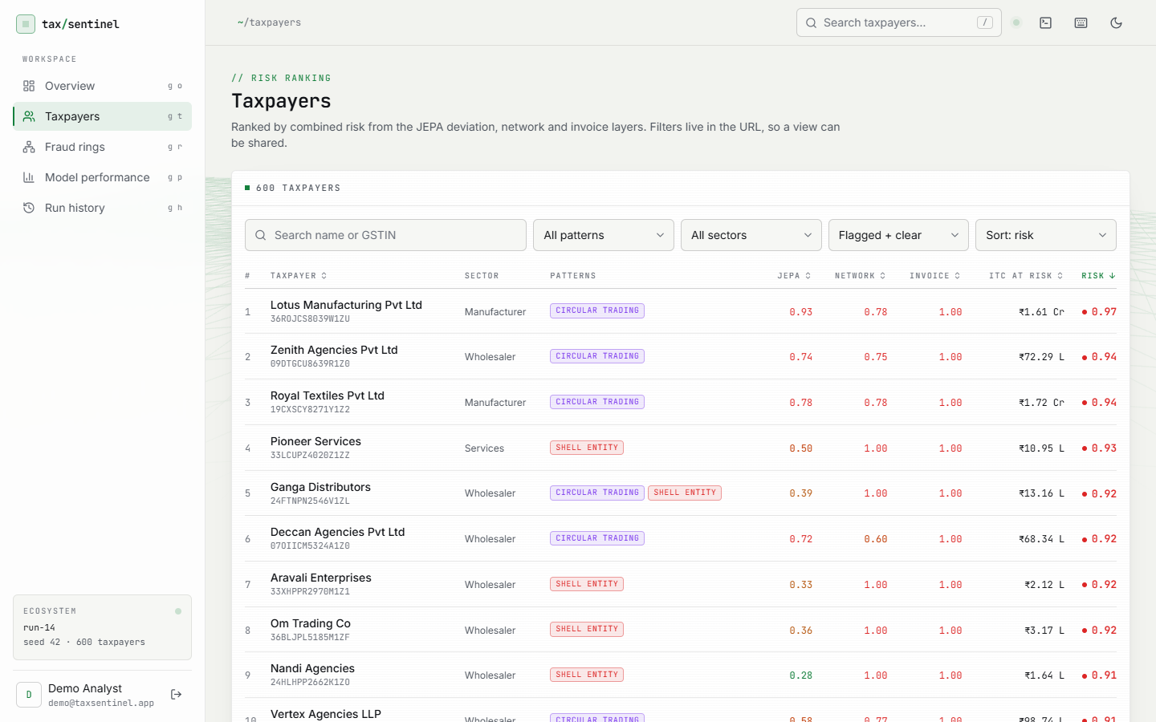
Figure 8.3: Taxpayer risk ranking with search, pattern, sector and flag filters and sort order; the top rows are circular-trading and shell-entity taxpayers.
The profile of the top-ranked taxpayer, Lotus Manufacturing Pvt Ltd (risk 0.97, rank 1, circular trading). The Signals tab shows the four layer scores (JEPA 0.93, behaviour 0.61, network 0.78, invoice 1.00), the rule triggered (R4) and the monthly chart of ITC available in GSTR-2B against ITC claimed in GSTR-3B, with the JEPA deviation line peaking at 25.0 times a typical taxpayer-month in March 2026.
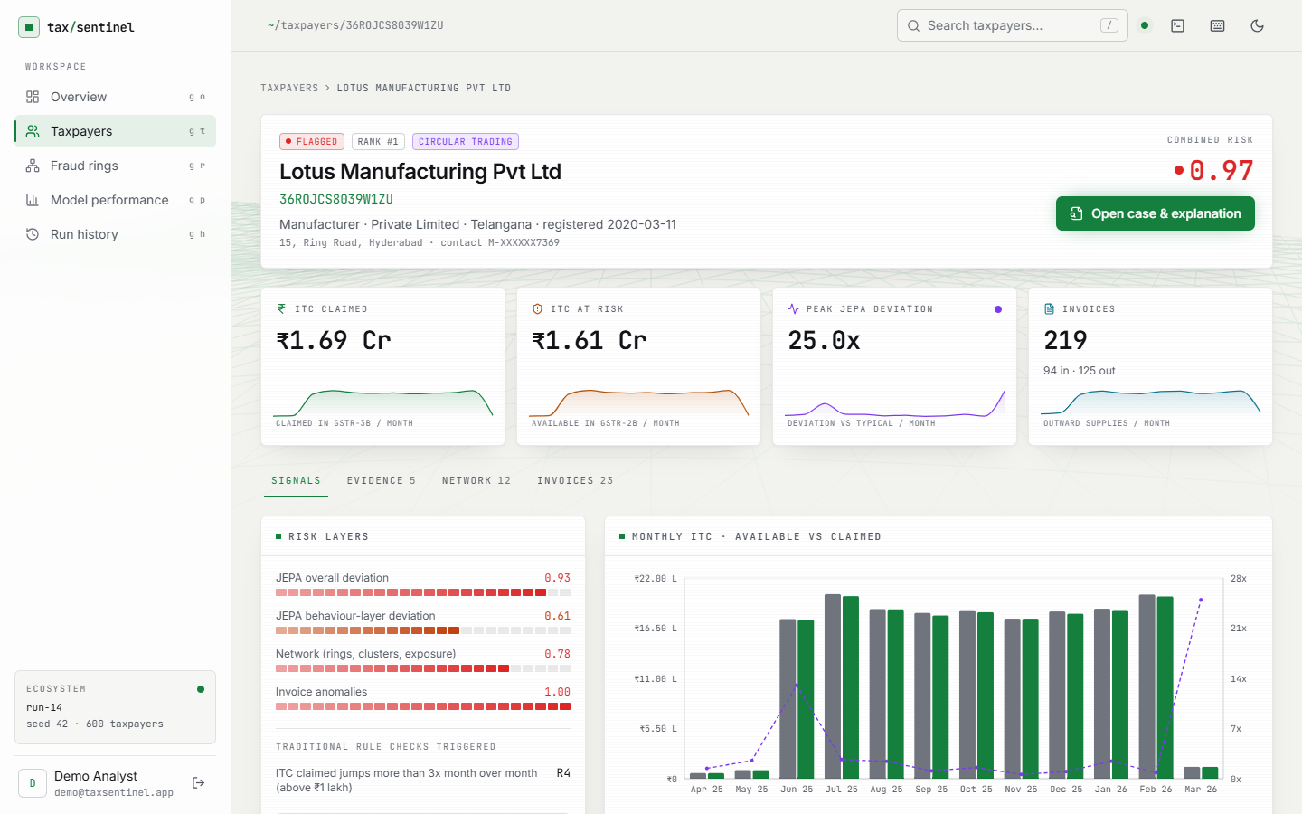
Figure 8.4: Taxpayer profile, Signals tab (Lotus Manufacturing Pvt Ltd, rank 1, risk 0.97): the four risk layers, the rules triggered and monthly ITC available (GSTR-2B) against ITC claimed (GSTR-3B) with the JEPA deviation line.
The Evidence tab. Five numbered items, ordered by severity, each with layer, severity and the concrete figures: JEPA deviation, suspicious purchase invoices (11 invoices worth Rs 8.94 Cr carrying Rs 1.61 Cr of ITC), suspicious sales invoices issued (12 worth Rs 9.15 Cr), membership of ring R01 with the loop path, and almost no tax paid in cash (16.6 % of Rs 2.03 Cr).

Figure 8.5: Taxpayer profile, Evidence tab: the numbered evidence list (E1 to E5) with layer, severity and concrete figures.
The Network tab. The local trading network of the taxpayer is drawn with the circular-trading loop in red and a table of the main trading partners with the value bought from and sold to each and their own risk; the partners in the loop have risks of 0.86 to 0.94.
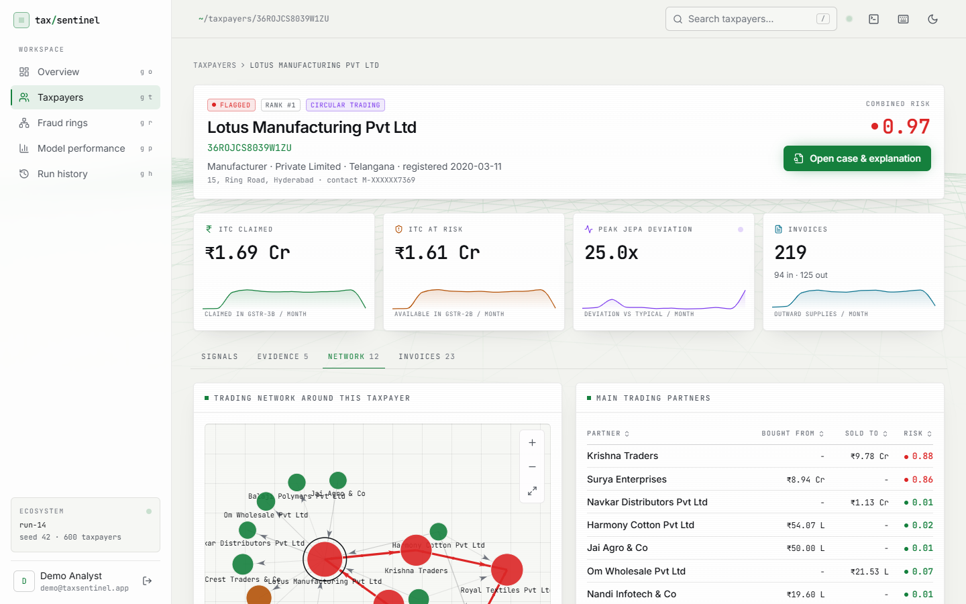
Figure 8.6: Taxpayer profile, Network tab: the local trading network with the circular-trading loop in red and the main trading partners.
A different pattern: Ganga Wholesale, flagged as a shell entity with an ITC spike. The monthly chart shows the GSTR-3B claim rising far above the credit available in GSTR-2B in two months while the JEPA deviation line peaks, which is how the spike is seen.
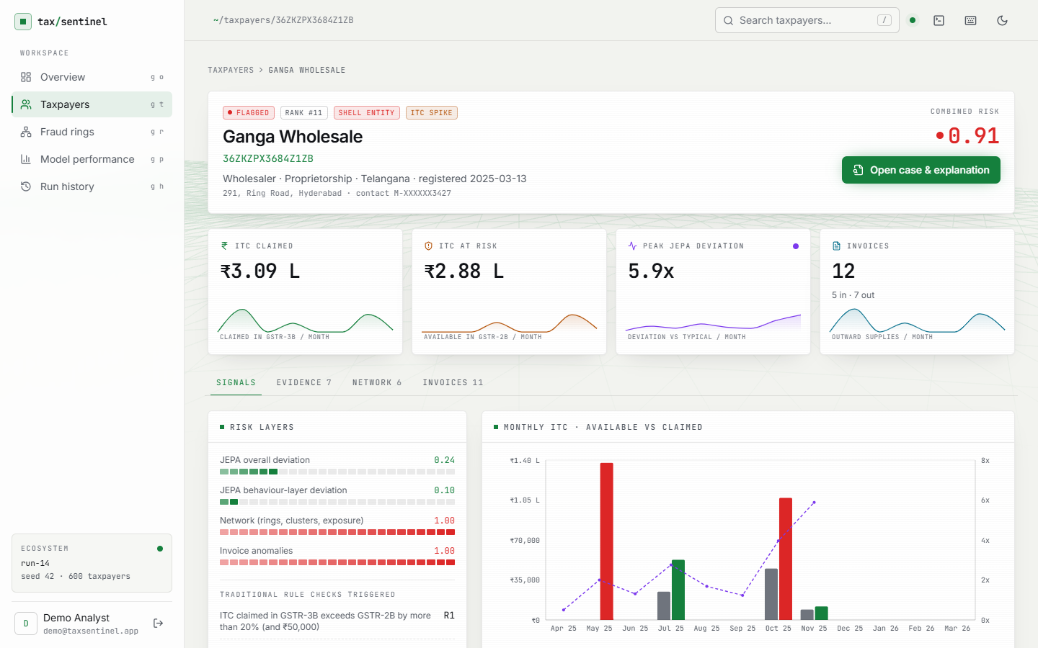
Figure 8.7: Profile of an ITC-spike and shell-entity taxpayer (Ganga Wholesale): the monthly chart shows the claim far above the credit available in GSTR-2B.
The whole fraud network. Loop edges are red, high-risk taxpayers red, watch-list taxpayers amber, shared-identity members are ringed. The cluster of connected red nodes in the middle is the set of five injected rings and their neighbours.
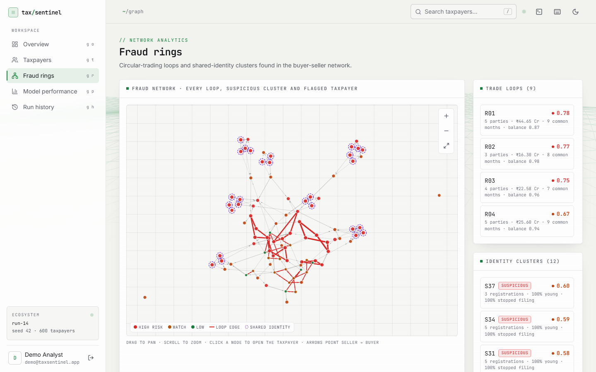
Figure 8.8: Fraud rings: the whole buyer-seller network with loop edges in red and shared-identity members ringed.
Invoice chain CH-R01, the top-ranked chain: a five-party loop (Maa Industries LLP to Surya Enterprises to Lotus Manufacturing to Krishna Traders to Royal Textiles and back) with 98 invoices worth Rs 44.65 Cr passing Rs 9.78 Cr of ITC; 63 % of its invoices are injected fraud in the sample labels.
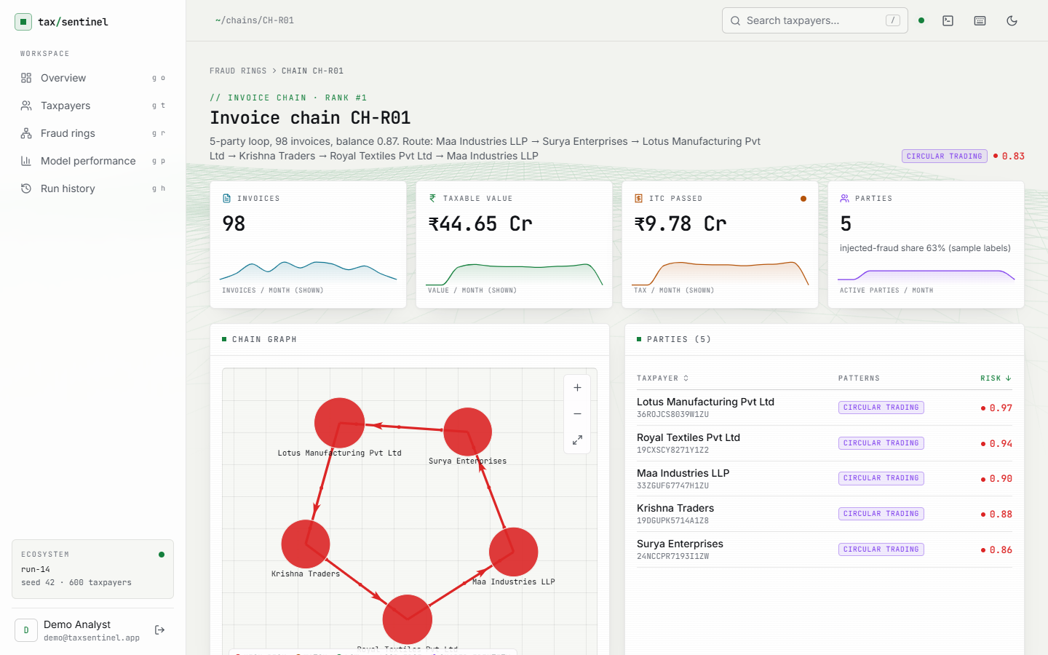
Figure 8.9: Invoice chain CH-R01: a five-party circular-trading loop of 98 invoices worth Rs 44.65 Cr passing Rs 9.78 Cr of ITC.
Invoice chain CH-S37, a shell-supply chain: three linked registrations that bill several buyers, with 100 % of the chain's invoice value anomalous.
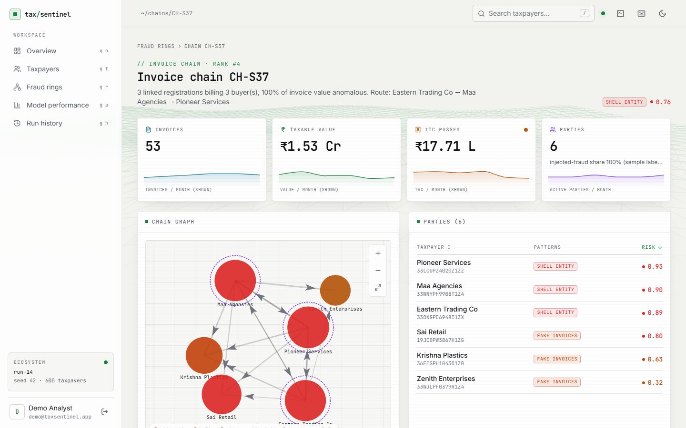
Figure 8.10: Invoice chain CH-S37: a shell-supply chain of three linked registrations billing three buyers.
The case page with the Gemini note. The summary names the taxpayer, its risk and the main pattern; each bullet of Why it was flagged ends in citation chips such as E2 or E4 that scroll to and highlight the evidence item; the evidence list sits beside the note.

Figure 8.11: Case page with the Gemini case note: every claim ends in an [E#] citation chip that links to its evidence item.
Model performance for the loaded ecosystem: precision@79 94.9 %, recall@79 94.9 %, F1 at the flag threshold 0.955 against 0.432 for the rule baseline, and the JEPA final loss 0.1115 with the loss curve. Below are the precision@k and recall@k charts for the model and the baseline and the taxpayer-level table with the ablations.
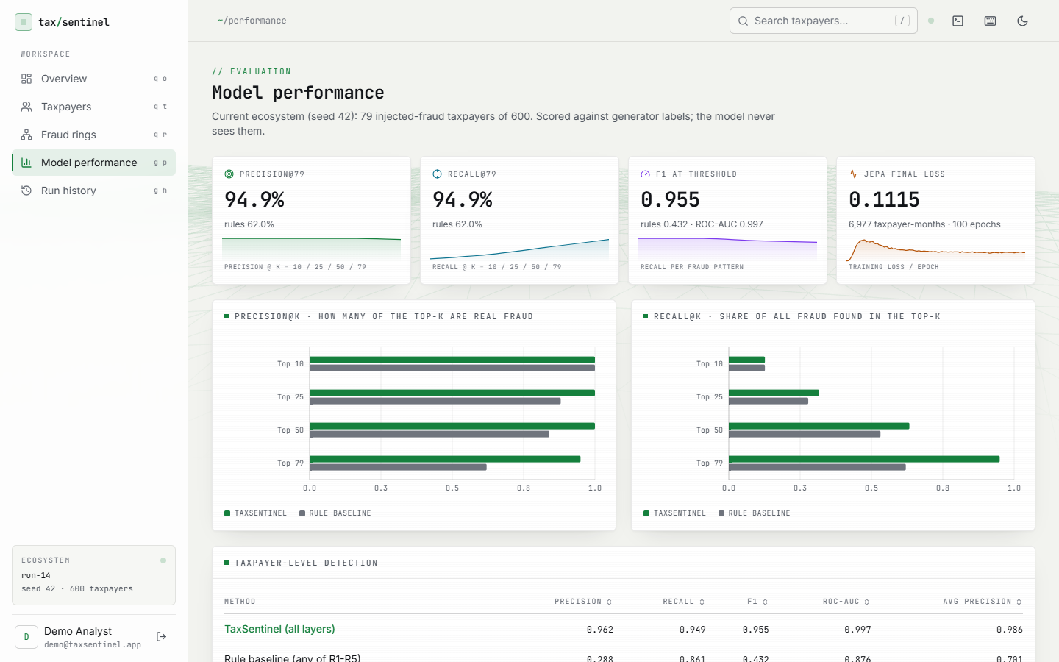
Figure 8.12: Model performance: precision@k, recall@k, F1, ROC-AUC and the JEPA training loss for the current ecosystem.
Run history. The last ten generations with status, seed, taxpayer count, flagged taxpayers and duration, and the ecosystem currently loaded. Every row is a real run made while building and testing this report.
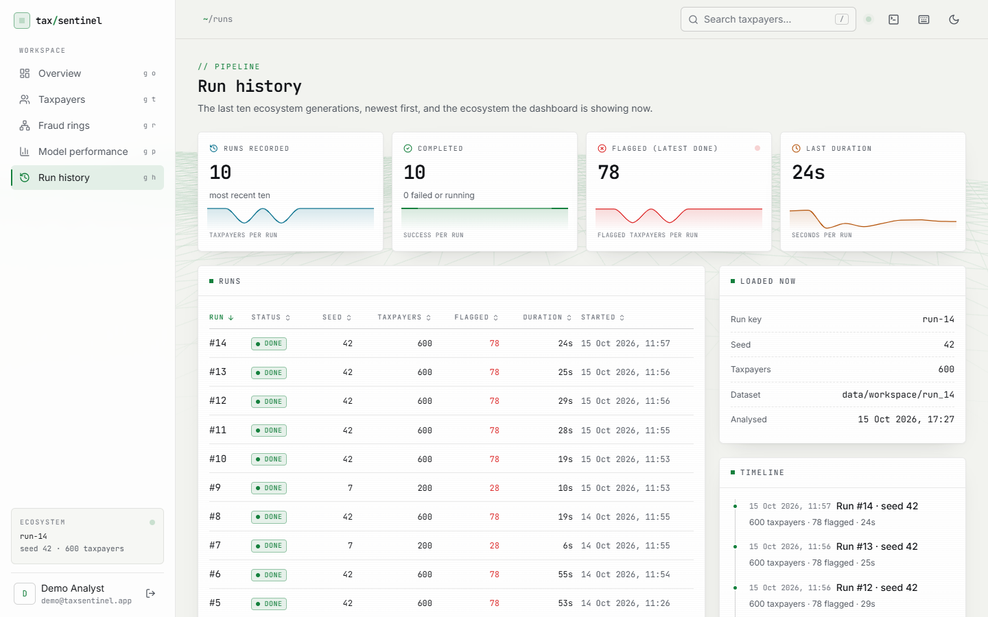
Figure 8.13: Run history: the last ten generations with status, seed, taxpayers, flagged count and duration, and the ecosystem currently loaded.

8.2 Model Performance
All figures below are on the bundled ecosystem (seed 42): 600 taxpayers, 79 of them injected fraud, 64,474 invoices, of which 530 are fraud. The scores are computed without labels and then compared with the injected labels. Because the weights and threshold were chosen on this ecosystem, these are best-case figures; the cross-seed study in Section 8.2.6 shows how they change on other generated ecosystems.

8.2.1 Taxpayer-level detection and ablations
Table 8.1: Taxpayer-level results (seed 42)
Method | P@10 | P@25 | P@50 | P@79 | Prec. | Recall | F1 | ROC-AUC
TaxSentinel (all layers) | 1.00 | 1.00 | 1.00 | 0.949 | 0.962 | 0.949 | 0.955 | 0.997
Rule baseline R1-R5 | 1.00 | 0.88 | 0.84 | 0.620 | 0.288 | 0.861 | 0.432 | 0.876
JEPA + behaviour only | 0.80 | 0.84 | 0.58 | 0.481 | 0.842 | 0.203 | 0.327 | 0.843
Graph + invoice only | 1.00 | 1.00 | 1.00 | 0.848 | 1.000 | 0.798 | 0.887 | 0.940
Without invoice layer | 1.00 | 1.00 | 0.98 | 0.949 | - | - | - | 0.996

TaxSentinel flags 78 taxpayers: 75 are injected fraud and 3 are false alarms, and 4 of the 79 are missed (F1 0.955). The rule baseline flags 236, of which 68 are fraud and 168 are false alarms (F1 0.432). Ranking by risk is clean at the top: the first 50 taxpayers contain no false alarms. Fig. 8.14 and Fig. 8.15 show the same comparison graphically.
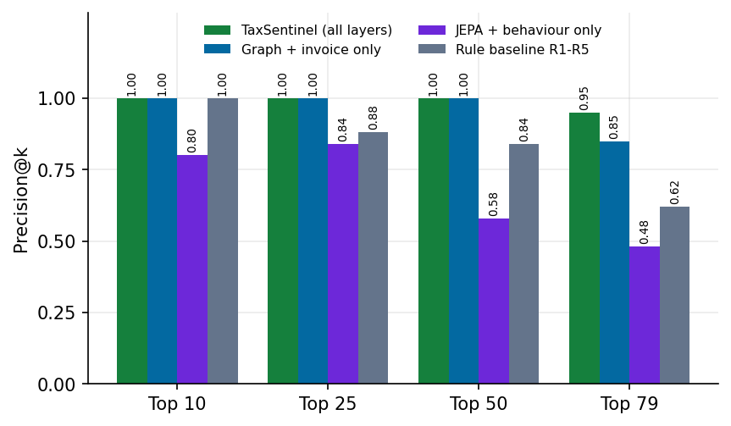
Figure 8.14: Precision@k for the full model, the ablations and the rule baseline (seed 42)
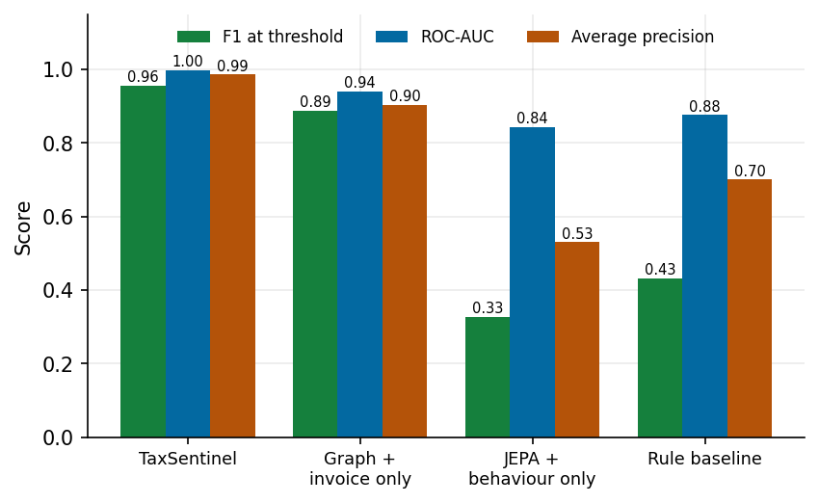
Figure 8.15: F1, ROC-AUC and average precision by method (seed 42)
The ablations are the most informative result. The JEPA with the behaviour variant alone reaches an F1 of only 0.327 (precision 0.842 but recall 0.203): when it flags a taxpayer it is usually right, but it finds one fraud taxpayer in five at the 0.5 threshold. Graph plus invoice evidence alone gives F1 0.887 and precision 1.00, with 16 misses. Combining all layers improves recall to 0.949 at precision 0.962. Removing the invoice layer barely changes P@79 (0.949) and slightly lowers ROC-AUC (0.996 against 0.997): the invoice layer mainly sharpens the middle of the ranking, and the layers overlap. The honest reading is that the JEPA is a useful component but not the whole answer; most of the detection power comes from the network and invoice layers, and the JEPA adds recall on top of them.

8.2.2 Confusion matrices and recall by pattern
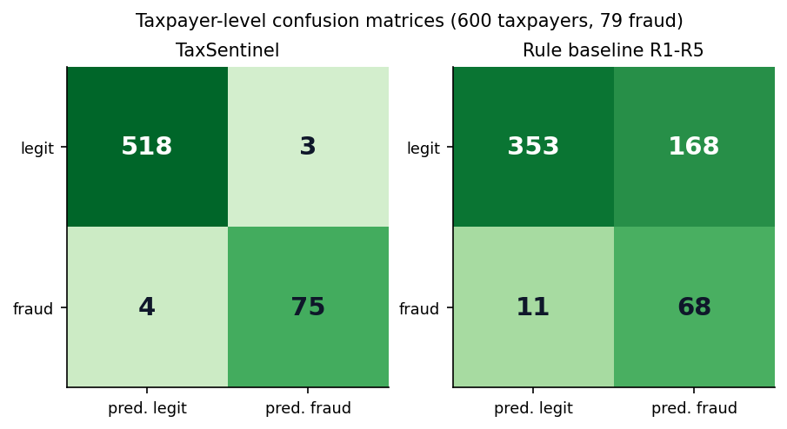
Figure 8.16: Taxpayer-level confusion matrices at the flag threshold (seed 42)
Table 8.2: Recall by injected pattern at the flag threshold (seed 42)
Pattern | Count | TaxSentinel | Rule baseline | Pattern correctly named
Circular trading | 21 | 1.00 | 0.86 | 1.00
Shell entity | 27 | 1.00 | 1.00 | 1.00
Fake-invoice buyer | 19 | 0.89 | 0.58 | 1.00
ITC spike | 12 | 0.83 | 1.00 | 1.00

Recall is 1.00 for circular trading (baseline 0.86) and for shell entities (baseline 1.00), 0.89 for fake-invoice buyers (baseline 0.58) and 0.83 for ITC spikes, where the rule baseline is better (1.00): a one-month claim above 3 times the previous month is exactly what rule R4 tests, while the model's score for a single month is diluted by the taxpayer's other months. In every case where a flagged taxpayer was one of these patterns, the pattern was named correctly.
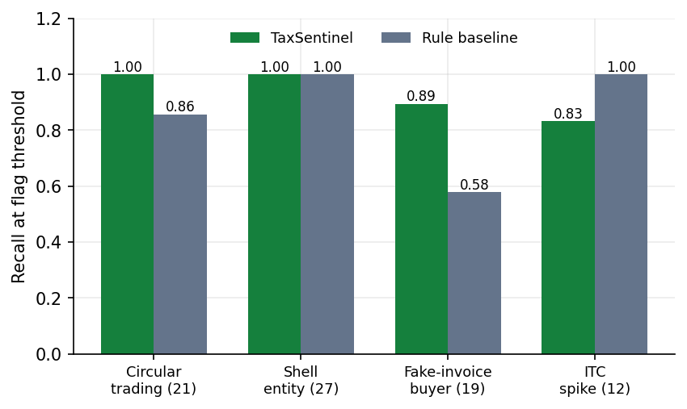
Figure 8.17: Recall by injected fraud pattern, model against rule baseline (seed 42)

8.2.3 Invoice-level detection, rings and chains
Table 8.3: Invoice-level, ring and chain results (seed 42)
Measure | Value
Anomalous-invoice flags (score >= 0.5) | 581 flagged; precision 0.883, recall 0.968, F1 0.924
Invoice ranking | ROC-AUC 1.000; precision@100 1.00, @500 0.936, @530 0.930
Baseline: not reported in supplier's GSTR-1 | 1071 flagged; precision 0.120, recall 0.242, F1 0.160
Injected circular-trading rings recovered | 5 of 5 (at least 80 % of members in one detected ring)
Rings detected | 9 (7 with injected-fraud members, 2 without)
Invoice chains | 16 chains; share of the top 10 that are fraud: 1.00

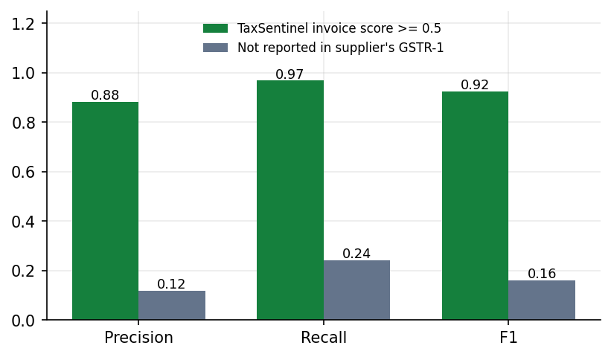
Figure 8.18: Invoice-level precision, recall and F1: invoice score against the GSTR-1 mismatch check (seed 42)
The invoice score has F1 0.924 against 0.160 for the classic mismatch check, which flags 1,071 invoices and finds only 24 % of the fraud. Every injected ring was recovered, but two of the nine detected rings contain no injected-fraud taxpayer: these are legitimate reciprocal trade loops that look like circular trading, and they are discussed in Section 8.5.

8.2.4 Threshold analysis
The flag threshold was fixed at 0.5. Table 8.4 and Fig. 8.19 show what other thresholds would have done on the same scores. F1 is highest between 0.4 and 0.6 and falls on either side: a lower threshold adds false alarms (at 0.2 there are 95), a higher one misses fraud (at 0.8 only 47 of 79 are found). The distribution of the scores (Fig. 8.20) explains the stability near 0.5: legitimate taxpayers pile up at low risk and injected fraud at high risk, with a thin overlap.
Table 8.4: Flag threshold sweep on the seed-42 scores
Threshold | Flagged | TP | FP | FN | Precision | Recall | F1
0.2 | 174 | 79 | 95 | 0 | 0.454 | 1.000 | 0.625
0.3 | 113 | 78 | 35 | 1 | 0.690 | 0.987 | 0.813
0.4 | 85 | 77 | 8 | 2 | 0.906 | 0.975 | 0.939
0.5 | 78 | 75 | 3 | 4 | 0.962 | 0.949 | 0.955
0.6 | 71 | 70 | 1 | 9 | 0.986 | 0.886 | 0.933
0.7 | 57 | 57 | 0 | 22 | 1.000 | 0.722 | 0.838
0.8 | 47 | 47 | 0 | 32 | 1.000 | 0.595 | 0.746
0.9 | 19 | 19 | 0 | 60 | 1.000 | 0.241 | 0.388

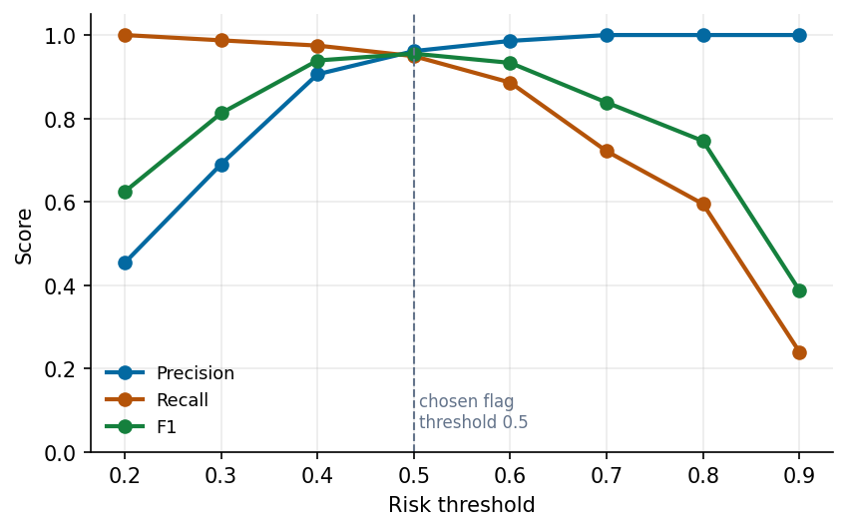
Figure 8.19: Precision, recall and F1 against the risk threshold (seed 42)
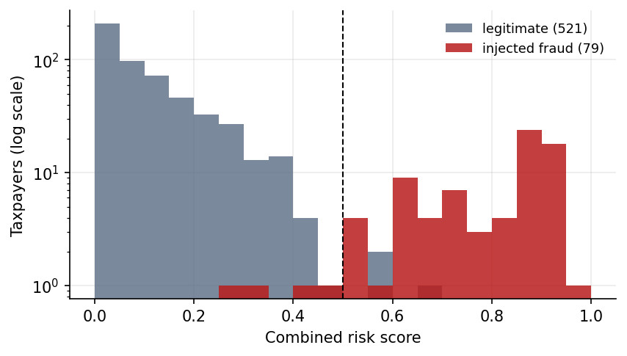
Figure 8.20: Distribution of the combined risk score for legitimate and injected-fraud taxpayers (log scale)

8.2.5 Which layer carries which signal
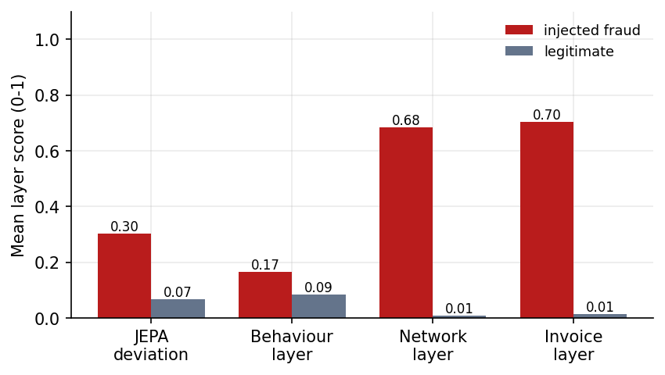
Figure 8.21: Mean layer scores of injected-fraud and legitimate taxpayers (seed 42)
Averaged over taxpayers, the jepa layer scores 0.30 for fraud against 0.07 for legitimate, the behaviour layer scores 0.17 for fraud against 0.09 for legitimate, the network layer scores 0.68 for fraud against 0.01 for legitimate, the invoice layer scores 0.70 for fraud against 0.01 for legitimate. The separation is largest in the network and invoice layers, which agrees with the ablation.

8.2.6 Cross-seed study
To test how far the seed-42 figures generalise, the whole pipeline (generation, JEPA training, scoring, evaluation) was re-run on five other ecosystems of 600 taxpayers, seeds 1, 2, 3, 7 and 11, with the same weights and threshold (Table 8.5, Fig. 8.22). Over these five ecosystems the taxpayer-level F1 has a mean of 0.888 (standard deviation 0.052, range 0.790 to 0.933), ROC-AUC 0.988 (range 0.970 to 0.995) and precision@k 0.888, against a rule-baseline F1 of 0.457 and precision@k of 0.625. Ranking quality is stable (ROC-AUC 0.970 to 0.995) and the advantage over the rule baseline holds on every seed (the model's F1 is higher on all five). What changes is how many of the weaker-signal taxpayers cross the fixed 0.5 line: circular-trading recall is 1.00 and all injected rings are recovered on every seed, shell-entity recall is 0.96 to 1.00, but fake-invoice-buyer recall ranges from 0.33 to 0.81 and ITC-spike recall from 0.42 to 0.92 on the other seeds (0.89 and 0.83 on seed 42). The seed-42 figures are therefore a best case, because the weights and threshold were set on that ecosystem.
Table 8.5: Cross-seed study (600 taxpayers each; same weights and threshold)
Seed | Fraud | Flagged | P@k | Precision | Recall | F1 | ROC-AUC | Baseline F1 | Rings found
1 | 82 | 70 | 0.781 | 0.857 | 0.732 | 0.790 | 0.970 | 0.498 | 5/5
2 | 79 | 70 | 0.924 | 0.971 | 0.861 | 0.913 | 0.995 | 0.472 | 5/5
3 | 76 | 77 | 0.882 | 0.883 | 0.895 | 0.889 | 0.993 | 0.419 | 5/5
7 | 88 | 82 | 0.921 | 0.951 | 0.886 | 0.918 | 0.992 | 0.482 | 5/5
11 | 77 | 73 | 0.935 | 0.959 | 0.909 | 0.933 | 0.992 | 0.412 | 5/5
mean |  |  | 0.888 | 0.924 | 0.857 | 0.888 | 0.988 | 0.457
std |  |  | 0.057 | 0.046 | 0.064 | 0.052 | 0.010 | 0.035

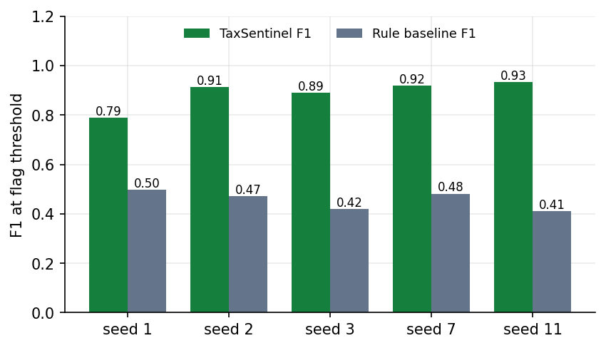
Figure 8.22: F1 at the flag threshold on five other generated ecosystems, model against rule baseline

8.2.7 Transfer check on PaySim
To check that the JEPA module is not tied to the GST generator, the same module (window 0, three feature blocks) was trained without labels on 100,000 PaySim transactions for 15 epochs (6.2 s) and scored by prediction error. Its ROC-AUC is 0.935 against 0.790 for ranking by transaction amount, and its precision@100 is 0.31 against 0.02 (Fig. 8.23). Average precision is low for both (0.090 and 0.013) because only 134 of 100,000 transactions are fraud. This is an out-of-domain sanity check, not a claim about GST.
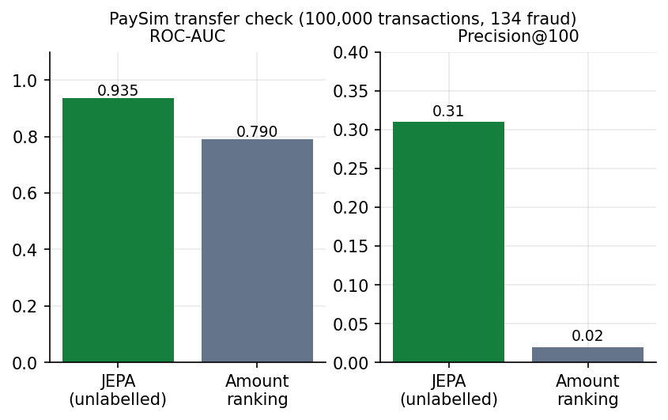
Figure 8.23: PaySim transfer check: unlabelled JEPA against ranking by amount

8.3 Explanation Quality
Gemini notes were generated for the top-ranked flagged cases and checked automatically. Six of the intended ten completed; for the other four the free-tier service returned 503 (overloaded), 429 (quota exhausted) or 504 (timeout) from every model in the fallback chain, and these failures are recorded in the evaluation file. Table 8.6 summarises the six notes.
Table 8.6: Automatic quality checks over six Gemini case notes
Check | Result
Notes evaluated / attempted | 6 / 10
Invalid citations | 0.0 %
Citations per note (mean) | 10.8
Evidence items cited | 100.0 %
High-severity items cited | 100.0 %
Numbers in the text found in the evidence | 84.3 %
All three sections present | 100.0 %
Suspected pattern named | 100.0 %
Words per note (mean) | 311

Citation discipline is perfect on these six notes: no citation points to a non-existent item and every evidence item is cited. The weaker figure is numeric grounding: 84.3 % of the numbers in the text appear in the evidence. The remainder are plausibly derived figures (for example a total of two evidence amounts, a rounded percentage or a month count) that a simple string match cannot confirm; the notes were not audited number by number, so these are unverified rather than known to be wrong. The same case written several times gives different notes (temperature 0.2 is not zero): the stored notes for Lotus Manufacturing across four separate generations during this project had numeric grounding between 0.87 and 0.90 with 13 to 14 citations each. The checks measure grounding, not correctness of the investigative advice; no human judged the notes.

8.4 Sample Inputs and Outputs
Input. A generation request POST /api/pipeline/run with {"seed": 42, "taxpayers": 600}, then GET /api/taxpayers/36ROJCS8039W1ZU for the top-ranked taxpayer.
{ "gstin": "36ROJCS8039W1ZU", "legal_name": "Lotus Manufacturing Pvt Ltd", "sector": "manufacturer", "state": "Telangana",
"risk": 0.9651, "rank": 1, "flagged": true, "patterns": ["circular_trading"],
"jepa": 0.9283, "behaviour": 0.6051, "network": 0.784, "invoice": 1.0,
"itc_at_risk": 16083140, "rules": ["R4"], "rings": ["R01"] }

Output 1: the evidence list built by the pipeline for this taxpayer (Table 8.7); the full detail text of each item carries the figures quoted in the case note.
Table 8.7: Evidence list for Lotus Manufacturing Pvt Ltd
ID | Layer | Severity | Title
E1 | model | high | Deviates from learned normal behaviour
E2 | invoice | high | Suspicious purchase invoices
E3 | invoice | high | Suspicious sales invoices issued
E4 | network | high | Member of circular-trading ring R01
E5 | behaviour | medium | Almost no tax paid in cash

Output 2: the case note written by Gemini from that evidence (model gemini-3.5-flash-lite), with its automatic quality check: 14 citations, 0 invalid, evidence coverage 100%, high-severity coverage 100%, numeric grounding 88.5% (23 of 26 numbers), 290 words.
## Summary
Lotus Manufacturing Pvt Ltd (GSTIN: 36ROJCS8039W1ZU) registered in Telangana as a private limited manufacturer, has been flagged with an overall risk score of 0.9651 [E1]. The taxpayer exhibits high-risk indicators pointing toward circular trading, involving massive anomalous invoice values and heavy reliance on ITC for tax liability offset [E2][E4][E5].

## Why it was flagged
- **Circular-Trading Ring Membership:** The entity is identified as part of circular-trading ring R01 (Maa Industries LLP to Surya Enterprises to Lotus Manufacturing Pvt Ltd to Krishna Traders to Royal Textiles Pvt Ltd and back), moving Rs 44.65 Cr across 9 common months with edge values within 13% of each other [E4].
- **Anomalous Purchase Invoices:** 11 purchase invoices worth Rs 8.94 Cr carry Rs 1.61 Cr of ITC, flagged for being part of the circular-trading loop, exceeding supplier norms, and originating chiefly from Surya Enterprises [E2].
- **Anomalous Sales Invoices:** Issued 12 anomalous sales invoices worth Rs 9.15 Cr, passing Rs 1.65 Cr of ITC to a single buyer [E3].
- **Behavioral Deviation:** The JEPA behavior encoder shows a Mar 2026 prediction error 25.0x a typical taxpayer-month, featuring sharp drops in ITC claimed (Rs 1.29 L vs. usual Rs 18.08 L) and outward turnover (Rs 23.32 L vs. usual Rs 1.16 Cr) [E1].
- **Low Cash Tax Payment:** Paid only 16.6% of its Rs 2.03 Cr output tax in cash, well below the manufacturer median of 57%, offsetting the remainder via ITC [E5].

## Suggested next steps
- Reconcile GSTR-2B with the 11 anomalous purchase invoices totaling Rs 8.94 Cr from Surya Enterprises [E2].
- Verify the physical existence and business operations of all entities in circular-trading ring R01, particularly Surya Enterprises [E2][E4].
- Inspect e-way bills and underlying goods movement for the Rs 44.65 Cr ring transactions and the 12 anomalous sales invoices [E3][E4].

8.5 Success and Failure Analysis

Where the system succeeds
- The top of the ranking is clean. The first 50 taxpayers contain no false alarm; the top 10 chains are all majority-fraud (precision 1.00).
- Circular trading is found completely: recall 1.00 and all 5 injected rings recovered, against 0.86 for the rule baseline. The loop is drawn and cited, so the finding is checkable.
- Shell clusters are found with the help of the network layer: shell-entity recall 1.00, although the JEPA alone finds only about one in five of the flagged shell firms.
- Evidence and notes are grounded: no invalid citations and full evidence coverage over the evaluated notes.
- Far fewer false alarms than rules: 3 against 168.

Where it fails: the 3 false positives (seed 42)
Table 8.8: Legitimate taxpayers flagged at the 0.5 threshold
Taxpayer | Sector | Risk | Patterns | Layers J / B / N / I | Ring
Apex Distributors | wholesaler | 0.56 | behaviour_anomaly | 0.68 / 0.16 / 0.00 / 0.00 | -
Vertex Enterprises LLP | wholesaler | 0.69 | behaviour_anomaly | 0.80 / 0.40 / 0.00 / 0.00 | -
Orbit Industries Pvt Ltd | manufacturer | 0.57 | - | 0.37 / 0.51 / 0.00 / 0.22 | -

All three false alarms are driven by the JEPA and behaviour layers, not by network or invoice evidence: two of them (Apex Distributors and Vertex Enterprises LLP) have a network score and an invoice score of exactly 0 and are flagged as unusual behaviour on a JEPA deviation score of 0.68 and 0.80; the third (Orbit Industries) combines a JEPA score of 0.37 with a behaviour score of 0.51. They are legitimate firms whose month-to-month behaviour was unusual (the generator includes seasonality, one-off capital purchases and credit catch-ups on purpose). The structural detectors did not produce a single false alarm at taxpayer level. At ring level, two of the nine detected rings contain no injected-fraud taxpayer; they are loops of legitimate reciprocal trade with the lowest ring scores (0.30 and 0.27), and they do not push their members over the flag threshold. For a user the consequence is that an unusual behaviour flag with no network or invoice evidence deserves the lowest priority, which the evidence list makes visible.

Where it fails: the 4 false negatives (seed 42)
Table 8.9: Injected-fraud taxpayers missed at the 0.5 threshold
Taxpayer | Injected role | Risk | Rank | Layers J / B / N / I
Eastern Enterprises Pvt Ltd | itc_spike | 0.41 | 84 | 0.36 / 0.31 / 0.00 / 0.00
Metro Manufacturing | fake_invoice_buyer | 0.29 | 122 | 0.02 / 0.03 / 0.31 / 0.11
Global Logistics & Co | itc_spike | 0.47 | 80 | 0.45 / 0.33 / 0.00 / 0.00
Zenith Enterprises | fake_invoice_buyer | 0.32 | 106 | 0.03 / 0.06 / 0.31 / 0.12

The four missed taxpayers are two ITC-spike cases and two fake-invoice buyers whose signals are modest. Their risks are 0.29 to 0.47 and they rank 80th to 122nd of 600, so they sit just below the flag line and well above most legitimate firms, but not among the 79 who would be found by an exact-count cutoff. The spike cases (Eastern Enterprises, Global Logistics) have a JEPA score of about 0.4 and no network or invoice evidence; the fake-invoice buyers (Metro Manufacturing, Zenith Enterprises) have almost no JEPA signal (0.02 to 0.03) and a network score of 0.31, because their purchases from shell clusters are a small share of their total purchases. This is the cost of a single fixed threshold and of weights tuned on one ecosystem; the sweep in Section 8.2.4 shows that a threshold of 0.4 would recover two of the four at the price of five more false alarms (8 instead of 3).

Invoice-level failures
At invoice level there are 68 false positives and 17 missed fraud invoices. The most common flag combinations among the false positives are [no_eway,unreported] (22); [ring_edge,value_spike] (18); [ring_edge,unreported] (12): invoices that carry the ring-edge flag or that combine a missing supplier report with a missing e-way bill, which also occur on legitimate reciprocal trade. The most common combinations among the missed fraud invoices are [shell_cluster,supplier_vanished] (8); [shell_cluster,young_supplier] (3); [ring_edge] (3). The first of these is instructive: a shell-cluster flag (weight 0.35) together with a vanished supplier (0.20) gives a noisy-OR of 1 - 0.65 x 0.80 = 0.48, just under the 0.50 invoice threshold, so these invoices are missed by 0.02. A fake invoice that is reported by its (shell) supplier, has an e-way bill and a plausible value leaves nothing for an invoice-level rule to flag and is caught only through the taxpayer or the network.

Failure of the explanation component
Four of ten requested notes could not be produced because the free Gemini tier was overloaded or out of quota. The product reports the failure and tries fallback models, but the dependence on an external service is a real operational weakness.

8.6 Comparison with the Base Paper
The base paper [1] is a qualitative study and reports no detection model, accuracy or other measured performance, so there is no like-for-like numerical comparison between its results and this project's. The comparison below is therefore on what the paper recommends and on the project's own baseline.
Table 8.10: Base paper recommendations and this project
Base paper [1] position | This project | Status
Fake invoicing, circular trading and shell companies are the main ITC fraud patterns | All three (and ITC spikes) are injected, detected and measured | Implemented
Use data analytics and network analysis for detection | Feature layers, JEPA deviation, trade-graph cycles and identity clusters | Implemented
Dynamic AI-based risk modelling, ideally at registration | Risk scoring of existing taxpayers; registration-time scoring of new applicants was not built (registration age and cluster membership are inputs) | Partly
Quantitative AI-supported fraud detection as future research | Evaluated with precision@k, F1, ROC-AUC, ablations and cross-seed study on synthetic data | Done on synthetic data only
Unified economic intelligence grid across agencies | Single-state, single-source prototype | Not addressed
Forensic capacity of officers | Evidence-backed case notes intended to reduce the effort of reading a case | Supports, not measured
Faster prosecution and recovery | Out of scope | Not addressed

Against the rule-based checks that the paper's setting implies, the quantitative comparison on the same data is: F1 0.955 against 0.432 and P@79 0.949 against 0.620 on seed 42; and a mean F1 of 0.888 against 0.457 over five other seeds.
For context only, TED [7], a supervised heterogeneous-graph model, reports F1 between 76.35 % and 94.96 % on two real tax datasets depending on the share of positive training samples, and Mehta et al. [6] report no accuracy metric for their circular-trading communities. These numbers are not comparable with this project's: the data are real and different, TED is trained with labels and TaxSentinel is not, and the tasks are defined differently. What can be said is that an unlabelled method reaching F1 around 0.8 to 0.95 on a synthetic ecosystem with injected hard negatives is in the range where it is worth validating on real data; it does not show that it would match TED there.

8.7 Limitations of the Results
- Synthetic data: the labels are the generator's, and the detectors partly mirror the generator's fraud logic (loops, shared addresses, young registrations). Real fraud may be messier, which would lower the figures.
- The weights and threshold were tuned on seed 42; the cross-seed F1 is lower (mean 0.888, minimum 0.790).
- No held-out split for the encoder; the cross-seed study is the closest substitute.
- The comparison is with a rule baseline built by the project team from standard scrutiny rules; it is not an official tool.
- Explanation checks measure grounding, not correctness; six notes were evaluated.
- Measurements were taken on one machine under varying load.

8.8 Objectives versus Outcomes
Table 8.11: Objectives and measured outcomes
# | Objective | Outcome | Status
1 | Build a multi-layer GST dataset (invoices, behaviour, network) | Generator with 600 taxpayers, 64,474 invoices, 6,977 returns, 4 fraud patterns, 7 hard-negative kinds; 19 features in 3 layers | Achieved (synthetic)
2 | Learn normal behaviour with a self-supervised JEPA | 53,420-value JEPA trained without labels in 11.7 s; final loss 0.1115 | Achieved
3 | Detect fake invoices, circular trading and shell entities | Recall 0.89, 1.00 and 1.00 at the threshold; 5 of 5 rings; ITC spikes 0.83 | Achieved on seed 42; lower F1 on other seeds
4 | Rank suspicious taxpayers and invoice chains | P@50 = 1.00, P@79 = 0.949, ROC-AUC 0.997; top-10 chains 1.00 | Achieved
5 | Natural-language explanations with a tuned LLM | Cited Gemini notes with checks; prompt-tuned, not fine-tuned | Achieved with a deviation: prompting, not fine-tuning
6 | Evaluate detection accuracy and explanation quality | Full harness, ablations, cross-seed study, PaySim check; 6 of 10 notes evaluated | Achieved, with the gaps listed in Section 8.7

CHAPTER 9: CONCLUSION

9.1 Summary
TaxSentinel is a working prototype of a self-supervised, explainable framework for ITC-fraud detection in GST. It generates a labelled synthetic ecosystem, learns normal behaviour with a 53,420-value JEPA in 11.7 s on a CPU, combines that signal with circular-trading and shell-cluster detection and invoice-level scoring in a noisy-OR risk, ranks taxpayers and invoice chains, and explains each flag with a cited, automatically checked note, all behind a secured web application that was tested end to end.

9.2 Objectives Achieved
All six objectives were met on synthetic data, with one deviation: the LLM is prompted and checked, not fine-tuned (Section 8.8). The system ranks the 600-taxpayer ecosystem with precision@79 of 0.949 and ROC-AUC 0.997, recovers all five injected rings, finds anomalous invoices with F1 0.924, and produces notes with no invalid citations.

9.3 Key Findings
- Several layers beat one. JEPA plus behaviour alone has F1 0.327; graph plus invoice 0.887; all layers 0.955. Self-supervised deviation is a useful but partial signal, strongest as a complement to network and invoice evidence.
- Structure matters more than amounts for circular trading and shells. Balance, recurrence and concentration of a loop, and shared identity of a cluster, find what a per-taxpayer score cannot.
- Rules are good at what they were written for. The rule baseline beats the model on one-month ITC spikes (recall 1.00 against 0.83) but flags 236 taxpayers with 168 false alarms.
- Headline accuracy does not fully generalise. On five other generated ecosystems the mean F1 is 0.888 (range 0.790 to 0.933), lower than 0.955, while the ranking quality (ROC-AUC mean 0.988) and the advantage over rules hold. The fixed weights and threshold are the weak point.
- Citation-constrained generation works, and can be measured. No invalid citations and full evidence coverage in six notes; 84 % numeric grounding shows where the remaining risk lies.

9.4 Practical Applications
- Prioritising audit and enquiry lists in a state tax-administration analytics unit.
- Preparing the starting file for an investigation: ranked evidence, loops and a first-draft note.
- Supplier-network audits by large businesses (a buyer can check whether its suppliers sit in a shell cluster).
- Teaching and evaluation: the seeded generator provides labelled ecosystems for comparing detection methods.

9.5 Known Limitations
The data is synthetic; thresholds and weights need recalibration on real returns; the headline F1 is a best case; the LLM is prompted and depends on an external quota; and testing has no unit, UI or user-acceptance layer (Section 1.8 and Chapter 7). The output is a risk indication for review, never a finding of fraud.

CHAPTER 10: FUTURE SCOPE

10.1 Improvements to the Method
- Head-to-head baselines. Train an isolation forest [14] and an autoencoder on the same 19 features and compare them with the JEPA, so that the choice of JEPA is supported by measurement and not only by design argument.
- Calibration on real returns. Replace the hand-set weights (0.75, 0.6, 0.7, 0.6) and thresholds with values fitted on a small set of confirmed cases, or learn the combination with a few labels (semi-supervised), while keeping the self-supervised encoder label-free. The cross-seed study in Chapter 8 shows that the present weights are not stable across generated ecosystems, which makes this the most important method improvement.
- Longer and richer temporal context. Extend the three-month window, add seasonality features and treat sector-specific norms explicitly, so that legitimate seasonal swings are less likely to look like deviations.
- Learned graph representations. Add node embeddings [18], [19] or a graph-level JEPA to complement the explicit loop and cluster detectors, keeping the explicit loop as the citable evidence.
- Robustness to adaptive fraud. Test the system against fraud that has been generated to avoid its signals (for example loops with unbalanced edge values or irregular months) and strengthen the detectors accordingly.

10.2 Additional Features
- Role-based access. Add reviewer and administrator roles, user management and a configurable threshold page.
- Case management. Let analysts assign, annotate and close cases and feed their decisions back as labels; export a case file (evidence and note) as a PDF.
- More data sources. Incorporate e-invoice (IRN) and e-way-bill records, annual returns (GSTR-9 and 9C), bank and payment data and registration verification history, which the base paper identifies as parts of a unified intelligence grid [1].
- Language support. Generate notes in regional languages used by state tax units.
- Reports and alerts. Scheduled reports and notifications for newly flagged taxpayers or rings.

10.3 Scalability and Deployment
- Storage. Move the analytical data from CSV and a pickle to a columnar store or PostgreSQL, and the application tables from SQLite to a server database.
- State scale. Real state data is several orders of magnitude larger: Mehta et al. [6] work with 77.8 million invoices and 388,448 taxpayers. The present in-memory design and the full cycle search would need sparse graph structures, partitioning by region or sector, incremental updates each filing cycle and bounded cycle enumeration with sampling.
- Operations. Package with containers, add HTTPS, rate limiting, account lockout, audit logging and monitoring, and move the generation to a job queue with workers.
- LLM hosting. Use a paid or self-hosted model for volume and data-residency reasons; the grounding checks and the evidence-only prompt are model-independent.

10.4 Further Research
- Fine-tune a model on real investigator notes with human feedback, and compare it with the prompted approach on the same grounding metrics.
- Run a human evaluation of explanations (clarity, usefulness, effort saved) in addition to the automatic checks.
- Validate the whole framework on real, anonymised returns with the co-operation of a tax administration, and report results with confidence intervals across several periods.
- Study fairness and error costs: which honest taxpayers are most likely to be flagged (for example new registrations, group companies, late filers), and how to limit the burden on them.
- Compare the approach with other jurisdictions' VAT carousel-fraud detection, as the base paper suggests [1].

REFERENCES
[1] S. Datta, H. Thakkar and S. Dabhade, "Combating GST input tax credit fraud in India: Forensic accounting, data analytics, and legal enforcement strategies," Int. J. Manage., Public Policy Res., vol. 5, no. 1, pp. 37-46, Jan.-Mar. 2026, doi: 10.55829/ykz3ea41.
[2] "The role of artificial intelligence and machine learning in enhancing tax compliance and fraud detection in India," J. Informatics Educ. Res., 2025.
[3] "Income tax fraud detection using machine learning," in Proc. 8th Int. Conf. Trends Electron. Informatics (ICOEI), 2025.
[4] "Income tax fraud detection system using AI and machine learning," in Proc. Int. Conf. Comput. Commun. (COMPUTINGCON), 2025.
[5] "Boosting-based machine learning for efficient income tax fraud detection," Int. J. Res. Trends Innov., 2026.
[6] P. Mehta, S. Bhargava, M. R. Kumar, K. S. Kumar and C. S. Babu, "Representation learning on graphs to identifying circular trading in Goods and Services Tax," arXiv:2208.07660, Aug. 2022.
[7] Y. Xu, B. Shi, B. Dong, J. Wang, H. Wei and Q. Zheng, "TED: Related party transaction guided tax evasion detection on heterogeneous graph," arXiv:2605.26984, May 2026.
[8] M. Assran et al., "Self-supervised learning from images with a joint-embedding predictive architecture," in Proc. IEEE/CVF Conf. Comput. Vis. Pattern Recognit. (CVPR), 2023, pp. 15619-15629.
[9] Y. LeCun, "A path towards autonomous machine intelligence," version 0.9.2, OpenReview, Jun. 2022.
[10] A. Bardes et al., "Revisiting feature prediction for learning visual representations from video," arXiv:2404.08471, 2024.
[11] J.-B. Grill et al., "Bootstrap your own latent: A new approach to self-supervised learning," in Adv. Neural Inf. Process. Syst. (NeurIPS), vol. 33, 2020, pp. 21271-21284.
[12] A. Bardes, J. Ponce and Y. LeCun, "VICReg: Variance-invariance-covariance regularization for self-supervised learning," in Proc. Int. Conf. Learn. Represent. (ICLR), 2022.
[13] V. Chandola, A. Banerjee and V. Kumar, "Anomaly detection: A survey," ACM Comput. Surv., vol. 41, no. 3, pp. 1-58, 2009.
[14] F. T. Liu, K. M. Ting and Z.-H. Zhou, "Isolation forest," in Proc. IEEE Int. Conf. Data Mining (ICDM), 2008, pp. 413-422.
[15] V. D. Blondel, J.-L. Guillaume, R. Lambiotte and E. Lefebvre, "Fast unfolding of communities in large networks," J. Stat. Mech., vol. 2008, no. 10, P10008, 2008.
[16] A. A. Hagberg, D. A. Schult and P. J. Swart, "Exploring network structure, dynamics, and function using NetworkX," in Proc. 7th Python Sci. Conf. (SciPy), 2008, pp. 11-15.
[17] D. B. Johnson, "Finding all the elementary circuits of a directed graph," SIAM J. Comput., vol. 4, no. 1, pp. 77-84, 1975.
[18] A. Grover and J. Leskovec, "node2vec: Scalable feature learning for networks," in Proc. 22nd ACM SIGKDD Int. Conf. Knowl. Discovery Data Mining, 2016, pp. 855-864.
[19] T. N. Kipf and M. Welling, "Semi-supervised classification with graph convolutional networks," in Proc. Int. Conf. Learn. Represent. (ICLR), 2017.
[20] A. Paszke et al., "PyTorch: An imperative style, high-performance deep learning library," in Adv. Neural Inf. Process. Syst. (NeurIPS), vol. 32, 2019, pp. 8024-8035.
[21] E. A. Lopez-Rojas, A. Elmir and S. Axelsson, "PaySim: A financial mobile money simulator for fraud detection," in Proc. 28th Eur. Model. Simul. Symp. (EMSS), 2016.
[22] J. Pearl, Probabilistic Reasoning in Intelligent Systems: Networks of Plausible Inference. San Mateo, CA, USA: Morgan Kaufmann, 1988.
[23] P. Lewis et al., "Retrieval-augmented generation for knowledge-intensive NLP tasks," in Adv. Neural Inf. Process. Syst. (NeurIPS), vol. 33, 2020, pp. 9459-9474.
[24] Z. Ji et al., "Survey of hallucination in natural language generation," ACM Comput. Surv., vol. 55, no. 12, pp. 1-38, 2023.
[25] Gemini Team, Google, "Gemini: A family of highly capable multimodal models," arXiv:2312.11805, 2023.
[26] I. Loshchilov and F. Hutter, "Decoupled weight decay regularization," in Proc. Int. Conf. Learn. Represent. (ICLR), 2019.
[27] M. Jones, J. Bradley and N. Sakimura, "JSON Web Token (JWT)," IETF RFC 7519, May 2015.
[28] N. Provos and D. Mazieres, "A future-adaptable password scheme," in Proc. USENIX Annu. Tech. Conf., 1999, pp. 81-91.
[29] D. R. Cressey, Other People's Money: A Study in the Social Psychology of Embezzlement. Glencoe, IL, USA: Free Press, 1953.
[30] J. L. Ba, J. R. Kiros and G. E. Hinton, "Layer normalization," arXiv:1607.06450, 2016.
[31] D. Hendrycks and K. Gimpel, "Gaussian error linear units (GELUs)," arXiv:1606.08415, 2016.

APPENDIX A: IMPORTANT CODE
The listings below are extracted from the source files by function name when this document is built, so they match the product exactly. Long functions are shown in full.

Walkthrough 1: the JEPA model (ml/jepa.py)
The model keeps two copies of the encoder and a predictor. keep is a (variants x features) mask: row 0 hides everything, row k hides feature group k. predict encodes the three previous months (zeroed where a month is absent), encodes the current month with the mask applied, appends a one-hot of the variant and lets the predictor output the embedding of the full current month. update_target implements the exponential moving average.
class JEPA(nn.Module):
def __init__(self, d_in, groups, window=3, hidden=64, emb=32):
super().__init__()
self.d_in, self.window, self.emb = d_in, window, emb
self.groups = [list(g) for g in groups]
keep = torch.ones(len(groups) + 1, d_in)
keep[0] = 0
for k, g in enumerate(self.groups):
keep[k + 1, g] = 0
self.register_buffer("keep", keep)
self.encoder = Encoder(d_in, hidden, emb)
self.target = copy.deepcopy(self.encoder)
for p in self.target.parameters():
p.requires_grad_(False)
n_var = len(groups) + 1
self.predictor = nn.Sequential(nn.Linear(window * (emb + 1) + emb + n_var, 128), nn.GELU(),
nn.Linear(128, 128), nn.GELU(), nn.Linear(128, emb))

@property
def n_variants(self):
return len(self.groups) + 1

def predict(self, ctx, ctx_present, cur, variant):
b = cur.shape[0]
parts = []
if self.window:
h = self.encoder(ctx.reshape(-1, self.d_in)).reshape(b, self.window, self.emb)
h = h * ctx_present.unsqueeze(-1)
parts += [h.reshape(b, -1), ctx_present]
parts += [self.encoder(cur * self.keep[variant]), F.one_hot(variant, self.n_variants).float()]
return self.predictor(torch.cat(parts, dim=1))

@torch.no_grad()
def update_target(self, momentum):
for p, q in zip(self.encoder.parameters(), self.target.parameters()):
q.mul_(momentum).add_(p.detach(), alpha=1 - momentum)

The training loop draws a random mask variant per sample, computes the target with no gradient, adds the variance hinge and updates the target encoder after every step.
def train_jepa(ctx, ctxp, cur, groups, window, epochs=40, batch=256, lr=1e-3, seed=42, ema=0.99,
var_weight=1.0, progress=None):
torch.manual_seed(seed)
np.random.seed(seed)
model = JEPA(cur.shape[1], groups, window)
opt = torch.optim.AdamW([p for p in model.parameters() if p.requires_grad], lr=lr, weight_decay=1e-4)
tc, tp, tx = torch.from_numpy(ctx), torch.from_numpy(ctxp), torch.from_numpy(cur)
n = len(tx)
g = torch.Generator().manual_seed(seed)
history = []
t0 = time.time()
for ep in range(epochs):
perm = torch.randperm(n, generator=g)
tot, nb = 0.0, 0
for s in range(0, n, batch):
idx = perm[s:s + batch]
c, p, x = tc[idx], tp[idx], tx[idx]
variant = torch.randint(0, model.n_variants, (len(idx),), generator=g)
pred = model.predict(c, p, x, variant)
with torch.no_grad():
target = model.target(x)
loss_pred = F.mse_loss(pred, target)
z = model.encoder(x)
loss_var = F.relu(1 - z.std(dim=0)).mean()
loss = loss_pred + var_weight * loss_var
opt.zero_grad()
loss.backward()
opt.step()
model.update_target(ema)
tot += loss_pred.item()
nb += 1
history.append(round(tot / nb, 5))
if progress:
progress(ep + 1, epochs, history[-1])
return model, dict(epochs=epochs, batch=batch, lr=lr, ema=ema, window=window, samples=n,
loss_history=history, final_loss=history[-1], train_seconds=round(time.time() - t0, 1))

Walkthrough 2: from prediction error to a deviation score (ml/pipeline.py)
The error of every variant is normalised by the median over taxpayers of the same month; the variants are combined by a geometric mean; the taxpayer's raw score is the mean of its two worst months; _calibrate turns it into a 0-1 score with a robust z and a logistic.
def _calibrate(log_values, centre=2.0):
"""Robust z-score against the population, squashed to 0-1 (0.5 at `centre` robust SDs)."""
med = np.median(log_values)
mad = np.median(np.abs(log_values - med)) * 1.4826 + 1e-9
return 1 / (1 + np.exp(-1.5 * ((log_values - med) / mad - centre)))

Z = scaler.transform(X)
ii, mm, ctx, ctxp, cur = J.make_samples(Z, present, WINDOW)
errs = J.score(model, ctx, ctxp, cur)
V = errs.shape[1]
E = np.full((n, T, V), np.nan)
E[ii, mm] = errs
ratio = E / np.nanmedian(E, axis=0, keepdims=True) # error relative to a typical taxpayer in that month
with warnings.catch_warnings(): # months with no return are all-nan by design
warnings.simplefilter("ignore", RuntimeWarning)
month_ratio = np.exp(np.nanmean(np.log(ratio), axis=2)) # geometric mean over mask variants
raw = np.array([np.mean(sorted(month_ratio[i][present[i]], reverse=True)[:2]) if present[i].any() else 1.0
for i in range(n)])
logs = np.log(raw)
j_score = _calibrate(logs)
# behaviour-layer deviation: how badly the return figures disagree with what the
# invoice/network layers and the taxpayer's history predict (catches one-month ITC spikes)
b_raw = np.array([np.nanmax(ratio[i, :, 1 + GROUPS.index("behaviour")]) if present[i].any() else 1.0
for i in range(n)])
b_score = _calibrate(np.log(b_raw))

Walkthrough 3: circular-trading detection (ml/graph.py)
Only recurring, above-median edges are kept. simple_cycles with a length bound enumerates the loops; each is scored by balance, recurrence and concentration; overlapping suspicious loops are merged into rings by union-find.
def detect_cycles(G, purchases_total, max_len=5, cap=20000, min_score=0.25):
"""Find short trade cycles and score how much they look like circular trading.

balance - circulated values stay similar around the loop (min/max edge value)
recurrence - the whole loop trades in the same months, month after month
concentration - the loop is a large part of every member's purchases (not incidental)
"""
values = np.array([d["value"] for _, _, d in G.edges(data=True)])
thr = float(np.percentile(values, 50)) if len(values) else 0
H = nx.DiGraph()
H.add_edges_from((u, v) for u, v, d in G.edges(data=True) if len(d["months"]) >= 2 and d["value"] >= thr)
cycles = []
for k, cyc in enumerate(nx.simple_cycles(H, length_bound=max_len)):
if k >= cap:
break
edges = [(cyc[i], cyc[(i + 1) % len(cyc)]) for i in range(len(cyc))]
vals = [G[u][v]["value"] for u, v in edges]
common = set.intersection(*[G[u][v]["months"] for u, v in edges])
balance = min(vals) / max(vals)
recurrence = min(1.0, len(common) / 3)
conc = float(min(G[u][v]["value"] / max(purchases_total[v], 1) for u, v in edges))
score = balance ** 0.5 * recurrence * min(1.0, conc) ** 0.5
cycles.append(dict(nodes=list(cyc), edges=edges, value=float(sum(vals)), balance=round(balance, 3),
common_months=sorted(common), concentration=round(conc, 3), score=round(score, 3)))
suspicious = [c for c in cycles if c["score"] >= min_score]
# merge overlapping suspicious cycles into rings
parent = {}

def find(x):
while parent.setdefault(x, x) != x:
x = parent[x]
return x

for c in suspicious:
for v in c["nodes"][1:]:
parent[find(v)] = find(c["nodes"][0])
groups = defaultdict(list)
for c in suspicious:
groups[find(c["nodes"][0])].append(c)
rings = []
for cs in sorted(groups.values(), key=lambda cs: -max(c["score"] for c in cs)):
nodes = sorted({v for c in cs for v in c["nodes"]})
edges = sorted({e for c in cs for e in c["edges"]})
best = max(cs, key=lambda c: c["score"])
rings.append(dict(id=f"R{len(rings) + 1:02d}", nodes=nodes, edges=edges, score=best["score"],
best_cycle=best["nodes"], balance=best["balance"], common_months=best["common_months"],
value=float(sum(G[u][v]["value"] for u, v in edges)),
tax=float(sum(G[u][v]["tax"] for u, v in edges)), n_cycles=len(cs)))
return dict(n_cycles_scanned=len(cycles), truncated=len(cycles) >= cap, rings=rings)

Walkthrough 4: invoice scoring and the combined risk (ml/pipeline.py)
Each invoice collects flags; its score is the noisy-OR of the flag weights. Taxpayer layer scores are then combined with a weighted noisy-OR.
for r in invoices:
s, b, m, v = r["_s"], r["_b"], r["_m"], r["taxable_value"]
fl = []
if not r["seller_reported"]:
fl.append("unreported")
if goods[s] and v >= 50000 and not r["eway_bill"]:
fl.append("no_eway")
if v % 10000 == 0:
fl.append("round_value")
if (date.fromisoformat(r["invoice_date"]) - reg[s]).days < 180:
fl.append("young_supplier")
if s in susp_cluster_nodes:
fl.append("shell_cluster")
exposure_val[b, m] += v
if vanished[s]:
fl.append("supplier_vanished")
if (s, b) in ring_edges:
fl.append("ring_edge")
if v > 4 * seller_med[s] and v > 200000:
fl.append("value_spike")
sc = 1 - float(np.prod([1 - INVOICE_FLAGS[f][0] for f in fl])) if fl else 0.0
r["anomaly"], r["flags"] = round(sc, 3), fl
for who in (s, b):
total_val[who, m] += v
if sc >= INVOICE_FLAG_THRESHOLD:
flagged_val[who, m] += v
inbound[b].append(r["id"])
outbound[s].append(r["id"])
with np.errstate(invalid="ignore", divide="ignore"):
flagged_share = np.nan_to_num(flagged_val / total_val)
exposure = np.nan_to_num(exposure_val / F["purch_v"])
i_score = np.minimum(1, 1.5 * flagged_share.max(axis=1))

# ---------- combine layers ----------
_progress(progress, "risk", 90, "combining layers")
n_score = np.zeros(n)
for v in range(n):
parts = [min(1.0, 2 * exposure[v].max())]
if ring_of[v]:
parts.append(max(r["score"] for r in ring_of[v]))
if v in cluster_of and cluster_of[v]["suspicious"]:
parts.append(cluster_of[v]["score"])
n_score[v] = max(parts)
risk = 1 - ((1 - RISK_WEIGHTS["jepa"] * j_score) * (1 - RISK_WEIGHTS["behaviour"] * b_score)
* (1 - RISK_WEIGHTS["network"] * n_score) * (1 - RISK_WEIGHTS["invoice"] * i_score))
flagged = risk >= FLAG_THRESHOLD
base_hits, base_score = rule_baseline(ret, reg_age, present)

Walkthrough 5: the grounding check for case notes (backend/app/services/explainer.py)
After Gemini answers, check_quality extracts the citations, counts the invalid ones, computes the evidence and high-severity coverage and the share of numbers in the text that occur in the evidence.
def check_quality(text, evidence):
"""Grounding checks: citation validity/coverage and whether the numbers used appear in the evidence."""
ids = {e["id"] for e in evidence}
cited = re.findall(r"\[(E\d+)\]", text)
valid = [c for c in cited if c in ids]
high = {e["id"] for e in evidence if e["severity"] == "high"}
ev_text = " ".join(e["title"] + " " + e["detail"] for e in evidence)
ev_nums = {n.replace(",", "") for n in NUM_RE.findall(ev_text)}
body = re.sub(r"\[E\d+\]", "", text)
nums = [n.replace(",", "") for n in NUM_RE.findall(body) if len(n.replace(",", "").replace(".", "")) >= 2]
grounded = [n for n in nums if n in ev_nums]
sections = all(h in text for h in ("## Summary", "## Why it was flagged", "## Suggested next steps"))
return dict(
citations=len(cited),
invalid_citations=len(cited) - len(valid),
evidence_coverage=round(len(set(valid)) / len(ids), 3) if ids else None,
high_severity_coverage=round(len(set(valid) & high) / len(high), 3) if high else None,
numbers=len(nums), numbers_grounded=len(grounded),
numeric_grounding=round(len(grounded) / len(nums), 3) if nums else 1.0,
has_sections=sections, words=len(body.split()))

Walkthrough 6: authentication guard (backend/app/auth.py)
Every protected route depends on current_user, which decodes the bearer token, rejects bad or expired tokens with 401 and loads the user.
def current_user(creds: HTTPAuthorizationCredentials = Depends(bearer), db: Session = Depends(get_db)) -> User:
if not creds:
raise HTTPException(401, "Not signed in")
try:
uid = int(jwt.decode(creds.credentials, JWT_SECRET, algorithms=["HS256"])["sub"])
except jwt.PyJWTError:
raise HTTPException(401, "Session expired - please sign in again")
user = db.get(User, uid)
if not user:
raise HTTPException(401, "User not found")
return user

Walkthrough 7: background generation (backend/app/services/state.py)
start_run refuses a second concurrent run, records a run row and starts a thread; _run generates the data, runs the pipeline with progress callbacks, saves the state atomically and records the outcome.
def start_run(self, seed, n_taxpayers, user_id):
with self.lock:
if self.status["running"]:
raise RuntimeError("A generation is already running")
db = SessionLocal()
run = PipelineRun(seed=seed, n_taxpayers=n_taxpayers, status="running", user_id=user_id)
db.add(run)
db.commit()
run_id = run.id
db.close()
self.status = dict(running=True, stage="generate", progress=1, message="generating ecosystem",
run_id=run_id, error=None)
threading.Thread(target=self._run, args=(run_id, seed, n_taxpayers), daemon=True).start()
return run_id

def _run(self, run_id, seed, n_taxpayers):
db = SessionLocal()
run = db.get(PipelineRun, run_id)
try:
out = os.path.join(WORKSPACE, f"run_{run_id}")
generate(seed, n_taxpayers, out)
self._progress("features", 10, "ecosystem generated")
state = run_pipeline(out, train=True, seed=seed, progress=self._progress,
save_model_to=os.path.join(out, "jepa.pt"))
state.update(run_key=f"run-{run_id}", run_id=run_id, generated_at=time.time(),
dataset=f"data/workspace/run_{run_id}")
self._save(state)
run.status, run.stats, run.message = "done", state["stats"], "complete"
self.status.update(running=False, stage="done", progress=100, message="complete")
except Exception as e:
log.exception("Pipeline run failed")
run.status, run.message = "failed", str(e)
self.status.update(running=False, stage="failed", error=str(e), message=str(e))
finally:
run.finished_at = now()
db.commit()
db.close()

APPENDIX B: INSTALLATION AND USER GUIDE

B.1 Requirements
- Windows 10 or 11; Python 3.11 or later (with Add python.exe to PATH ticked); Node.js LTS.
- A Gemini API key for written explanations (free from Google AI Studio); without it everything works except the Write explanation button.
- Ports 8105 (API) and 5105 (web) free.

B.2 Set up (once)
Open the 8.ProjectCode folder and run setup.bat. It creates venv, installs the CPU build of PyTorch and requirements.txt, creates .env from .env.example with a random JWT_SECRET, trains the JEPA encoder if models\jepa.pt is missing and runs npm install in frontend. Then open .env and set GEMINI_API_KEY=your-key-here.

B.3 Start
Run run.bat. It opens two windows (API and web), waits until the API reports the pipeline ready, and opens http://localhost:5105. Sign in with the demo account demo@taxsentinel.app / Demo@1234 or register a new one. To stop, close the two server windows.

B.4 Demonstration walkthrough
- Overview. Press Generate & analyse (seed 42, 600 taxpayers; about 20 to 40 s). The stage stepper and the activity log follow the run; the counts, flagged taxpayers, patterns and chains refresh when it finishes.
- Top-ranked taxpayer. Open it from the list. The Signals tab shows the four layer scores and the monthly GSTR-2B against GSTR-3B chart; Evidence, Network and Invoices are the other tabs.
- Case and explanation. Choose Open case & explanation, then Write explanation. Click an E# chip to highlight the evidence item it cites.
- Fraud rings. Browse every loop, shell cluster and ranked invoice chain; click a chain to see its invoices.
- Model performance. Compare precision@k and recall with the rule baseline, the ablations and per-pattern recall.
- Run history. The last ten generations and the ecosystem currently loaded.
Keyboard. / searches taxpayers or jumps to a screen; g then o, t, r, p, h or l goes to overview, taxpayers, fraud rings, performance, run history or the activity log; ? lists all shortcuts; Esc closes any overlay. The sun/moon button switches between light and dark mode.

B.5 Command line (optional)
venv\Scripts\python scripts\generate_gst_data.py --seed 42 --taxpayers 600 :: regenerate data/generated
venv\Scripts\python -m ml.train :: retrain models/jepa.pt
venv\Scripts\python -m ml.eval :: experiments/eval/metrics.json
venv\Scripts\python scripts\download_data.py :: PaySim sample (Kaggle)
venv\Scripts\python scripts\smoke_test.py :: end-to-end API test (API running)
cd frontend && npm run build :: production build

B.6 Troubleshooting
Table B.1: Common problems
Symptom | Fix
Port 5105 is already in use | Another copy is running; close it or change FRONTEND_PORT in .env
The page cannot reach the API | Start the API window (run.bat) and check http://127.0.0.1:8105/api/health
GEMINI_API_KEY is not set | Add the key to .env and restart the API window
Gemini 429 or quota errors | The free tier is rate limited; wait a minute; fallback models are tried automatically
Start over with a clean state | Stop the servers, delete data\workspace\ and data\app.db, start again

APPENDIX C: ADDITIONAL SCREENS
Screens that are not shown in Chapter 8 are collected here. All were captured at 1440 x 900 from the running application with the bundled ecosystem (seed 42, 600 taxpayers) loaded.
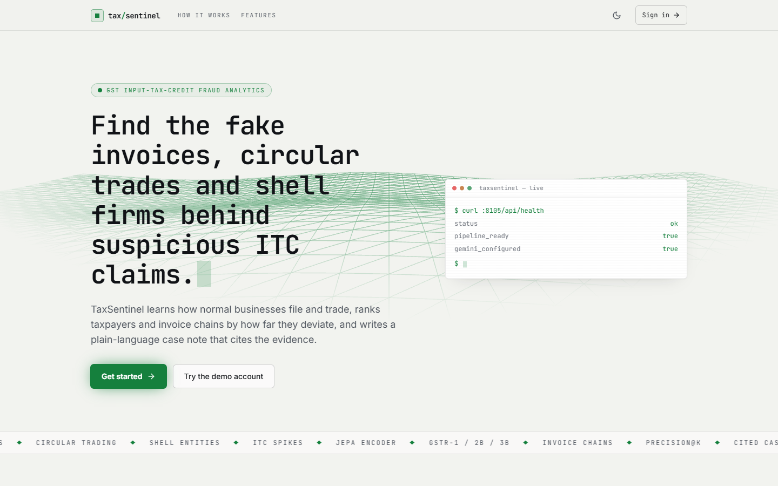
Figure C.1: Landing page: product summary, live health card (API, pipeline and Gemini status) and the call to action.
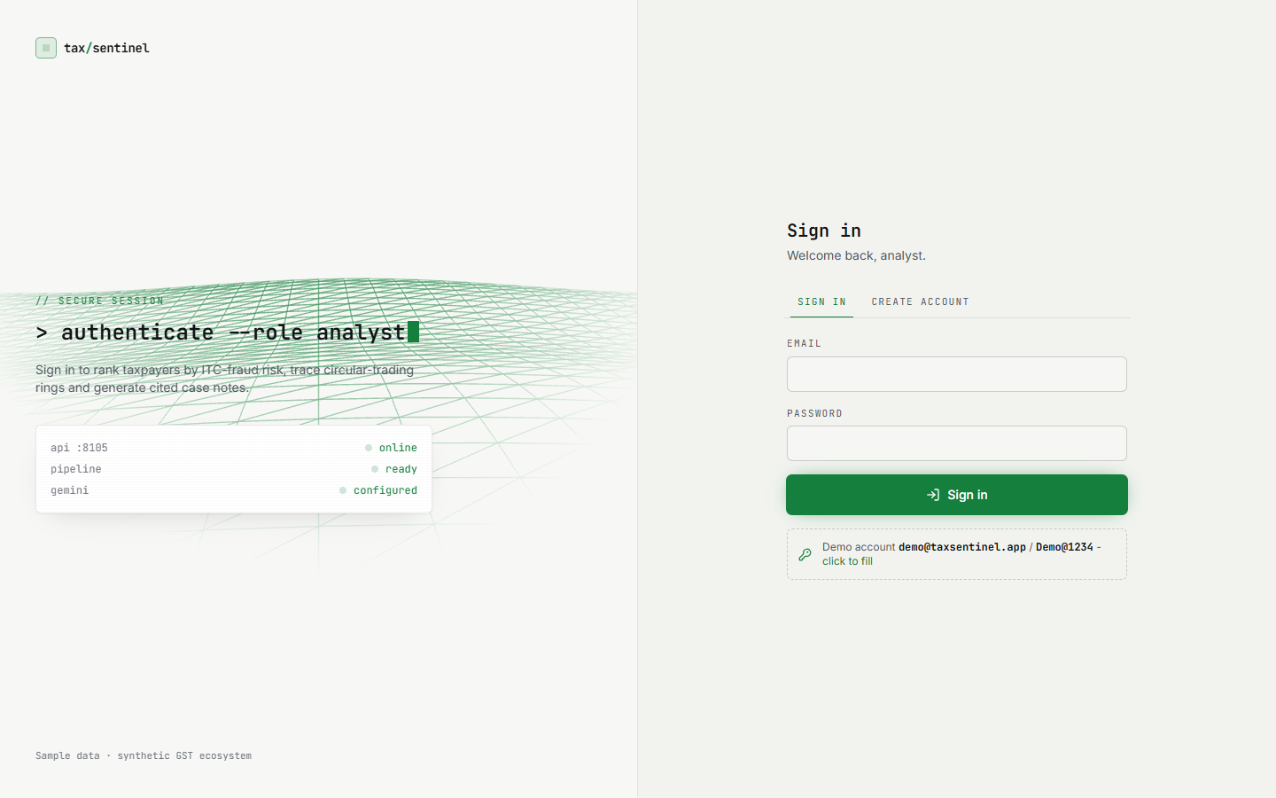
Figure C.2: Sign-in screen with the API, pipeline and Gemini status panel.
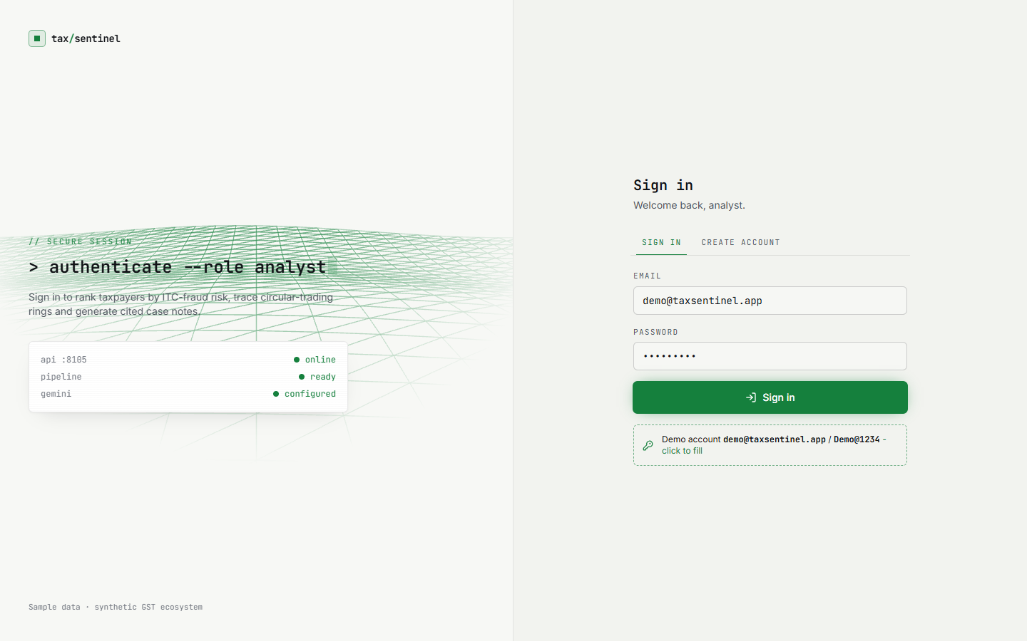
Figure C.3: Sign-in with the demo account filled in by the one-click helper.
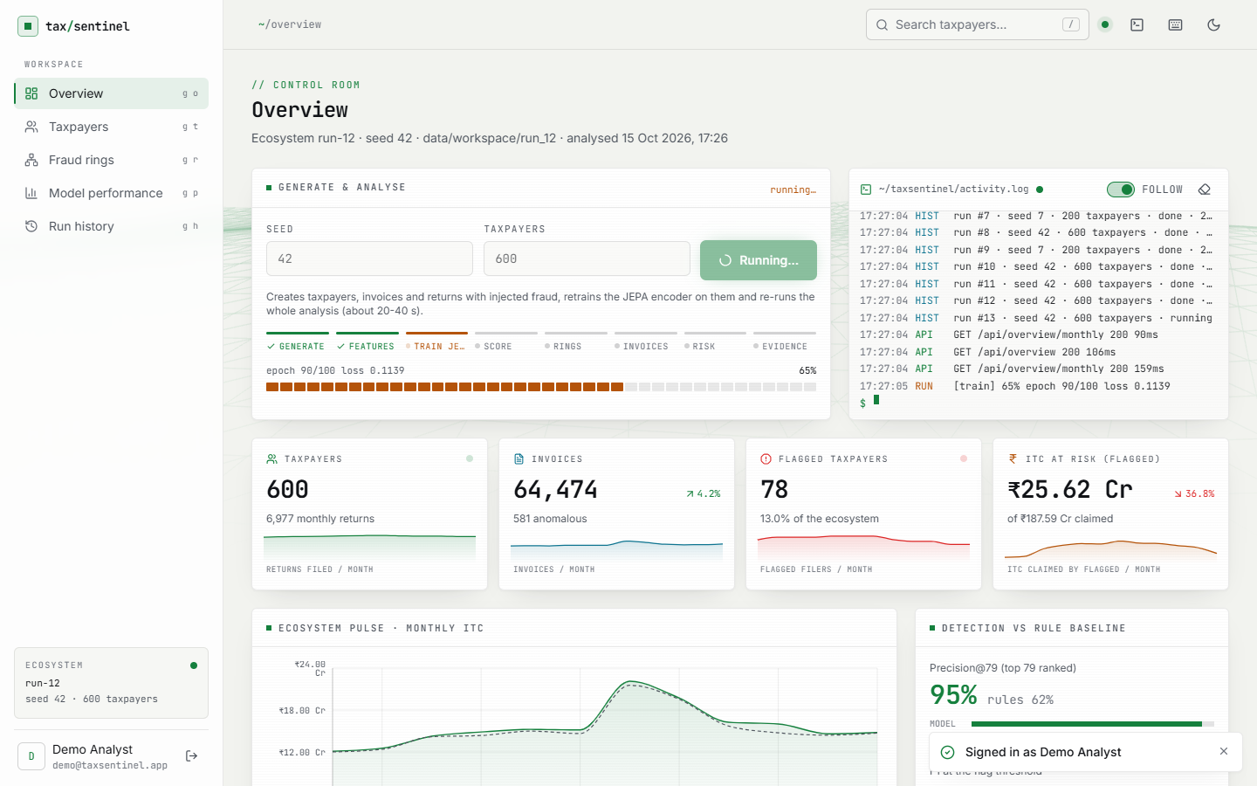
Figure C.4: Overview (control room) before a new generation: generate controls, activity log, headline counts and the monthly ITC pulse.
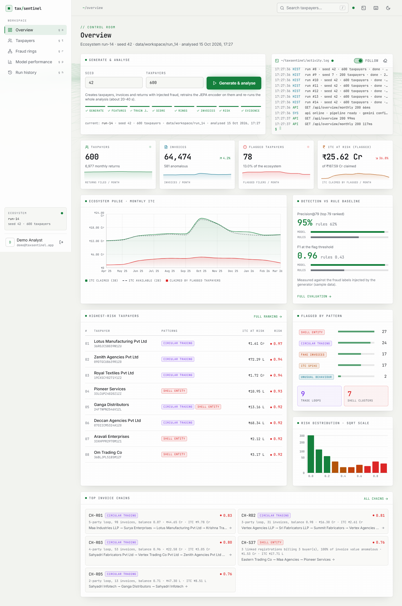
Figure C.5: Full-page overview: detection against the rule baseline, risk histogram, pattern counts, top-ranked taxpayers and top invoice chains.
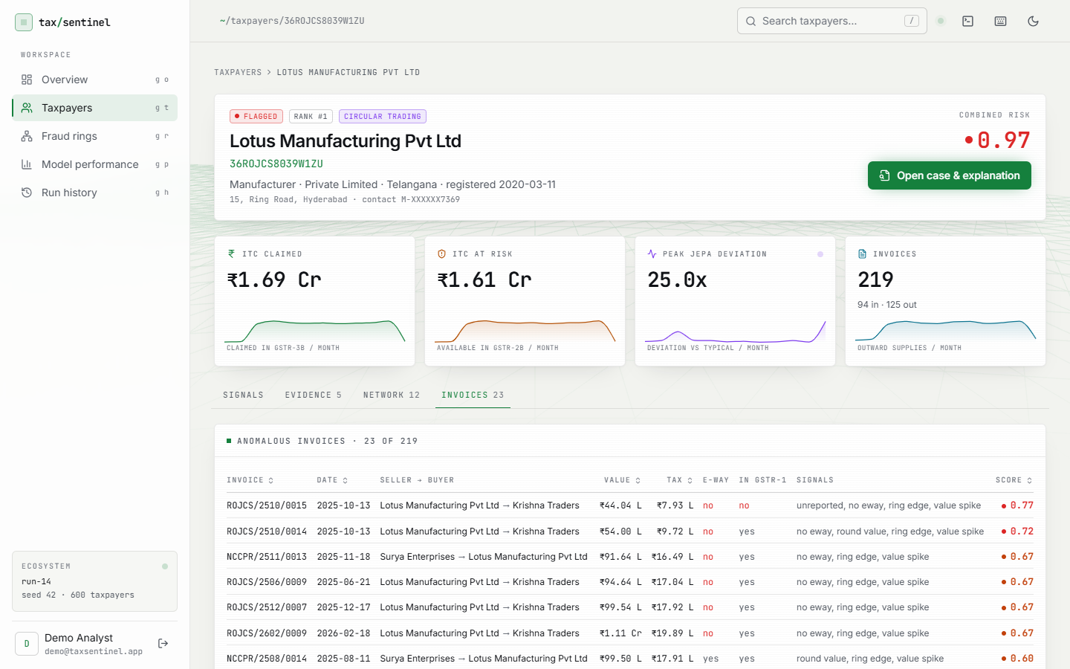
Figure C.6: Taxpayer profile, Invoices tab: anomalous invoices with value, tax, e-way bill, GSTR-1 reporting status and the signals that fired.
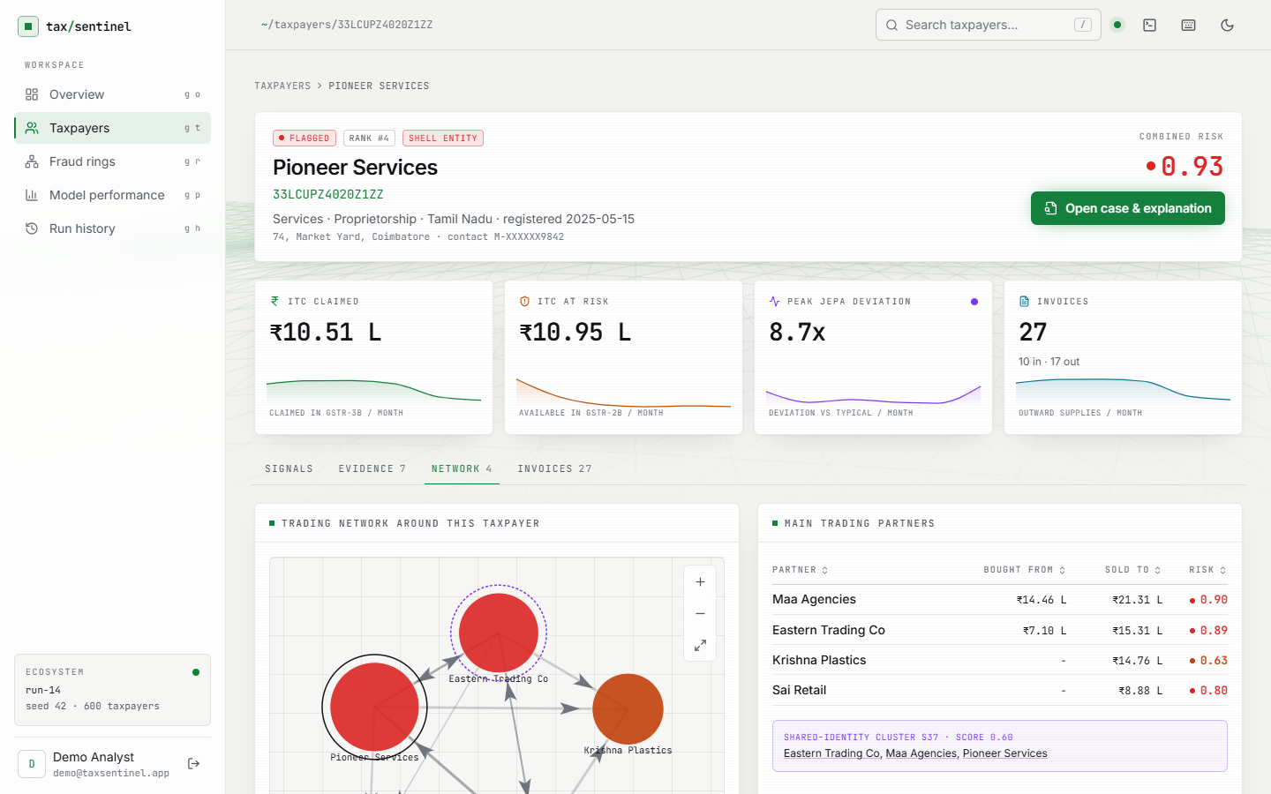
Figure C.7: Profile of a shell-cluster taxpayer (Pioneer Services): the shared-identity cluster S-card and the partners it trades with.
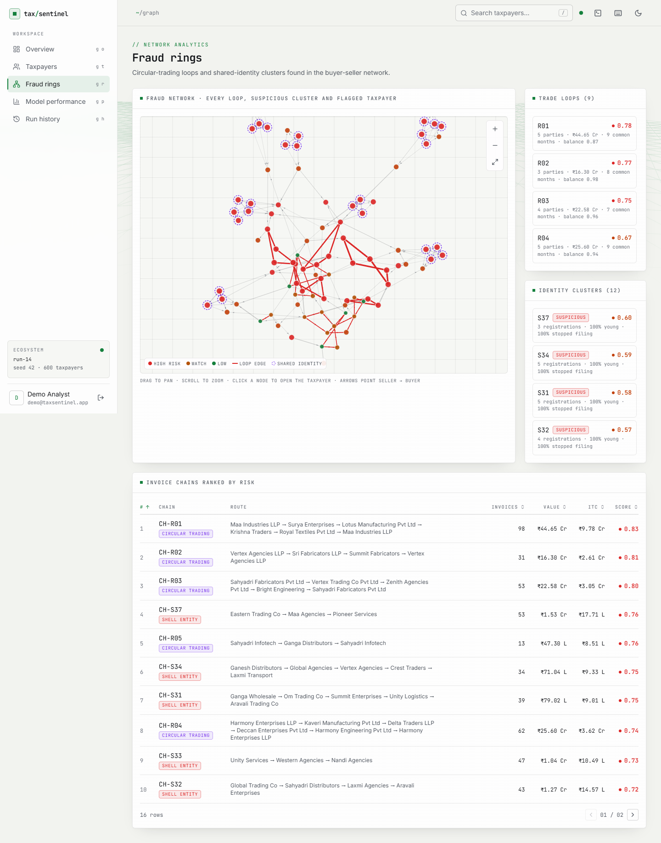
Figure C.8: Fraud rings, full page: the nine trade loops and twelve identity clusters with their scores, and the ranked invoice chains.

Figure C.9: Case page before a note is written: the evidence list is ready and the note is requested on demand.

Figure C.10: Full case page: the three-section note (Summary, Why it was flagged, Suggested next steps) beside the evidence list.
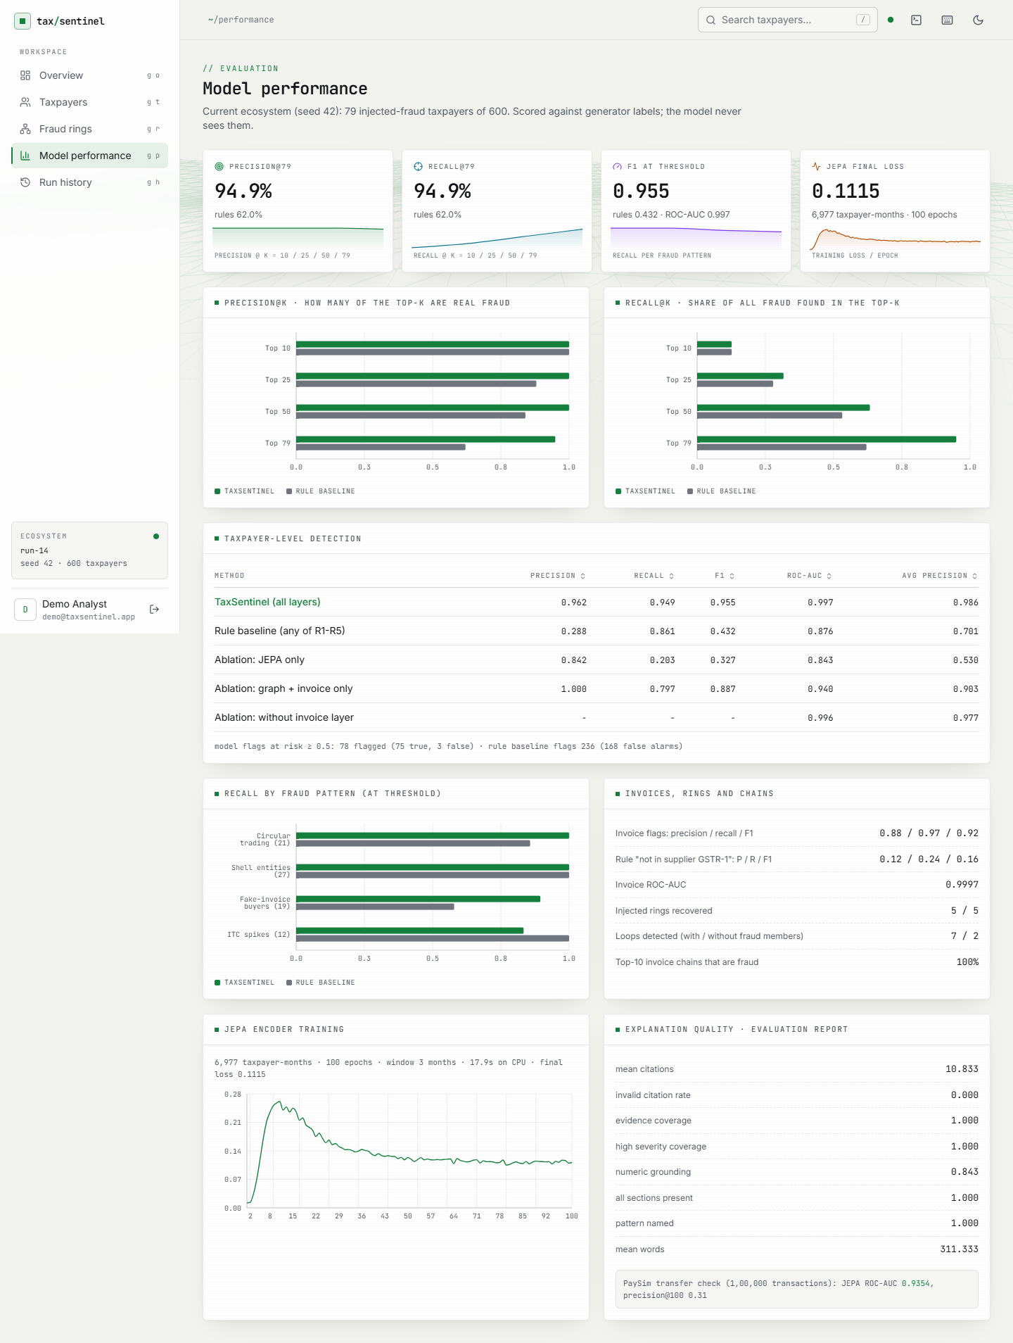
Figure C.11: Full model-performance page: taxpayer-level table with ablations, per-pattern recall, invoice-level and ring results.
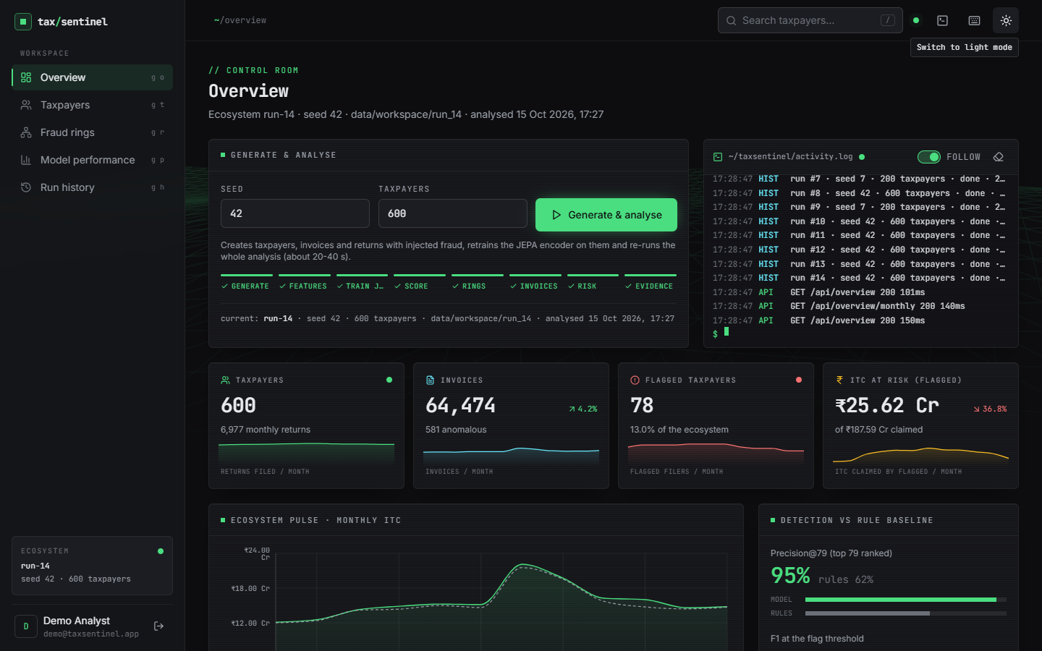
Figure C.12: Overview in dark mode (the theme follows the operating-system setting and can be toggled).
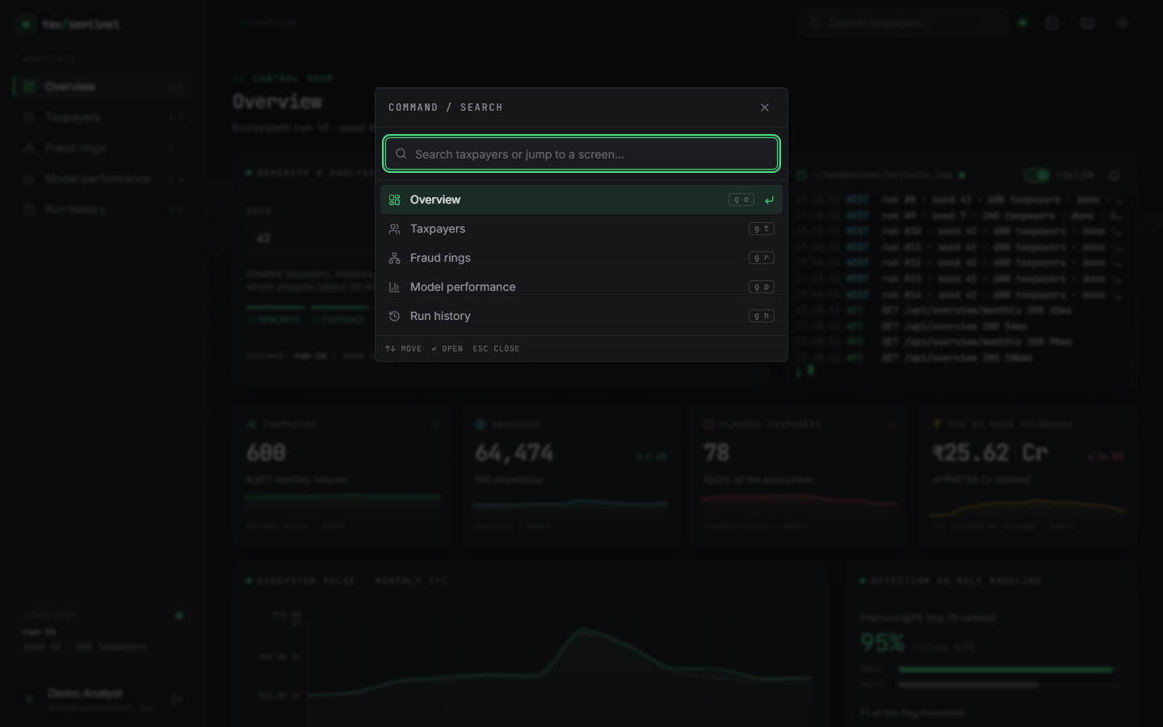
Figure C.13: Command palette (key /): search taxpayers or jump to a screen from the keyboard.

